[Type the company address]
08
Fall
Descriptive Summary from the SDS Marketing and Communications 2015 Pilot Survey
Mary Jo Stahlschmidt, Elise Alexrad, David Lounsbury, & Peter S Hovmand
2016 Winter Policy Council Meeting

Occupation by Conference vs. Random Sample

 | Frequency  Conference | Valid % | Frequency Random | Valid % | Total
Business | 14 | 30% | 19 | 43% | 33
Faculty | 12 | 26% | 16 | 36% | 28
Other | 2 | 4% | 0 | 0% | 2
Student | 13 | 28% | 2 | 5% | 15
Government/Public Sector | 2 | 4% | 2 | 5% | 4
K12 | 0 | 0.% | 2 | 5% | 2
Consultant | 2 | 4% | 1 | 2% | 3
Retired | 0 | 0% | 2 | 5% | 2
Postdoc | 1 | 2% | 0 | 0% | 1
Total | 46 |  | 44 |  | 90

Occupation by Has Attended ISDC vs. Never Attended ISDC

 | Frequency  Attended | Valid % | Frequency Never Attended | Valid % | Total
Business | 19 | 32% | 14 | 47% | 33
Faculty | 19 | 32% | 8 | 27% | 27
Other | 2 | 3% | 0 | 0% | 2
Student | 11 | 19% | 4 | 13% | 15
Government/Public Sector | 3 | 5% | 1 | 3% | 4
K12 | 1 | 2% | 1 | 3% | 2
Consultant | 3 | 5% | 0 | 0% | 3
Retired | 1 | 2% | 1 | 3% | 2
Postdoc | 0 | 0% | 1 | 3% | 1
Total | 59 | 100% | 30 | 100% | 89

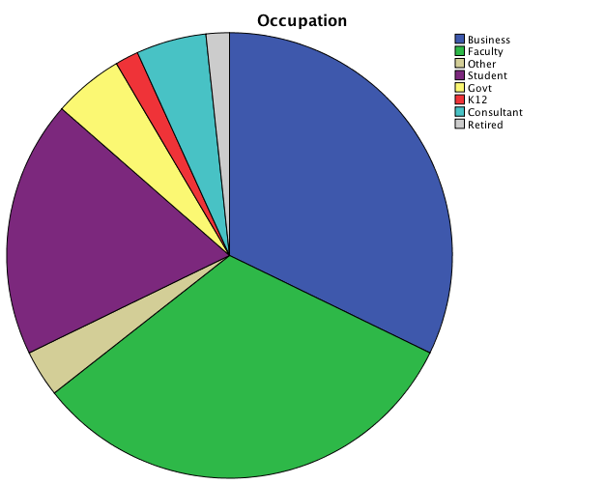
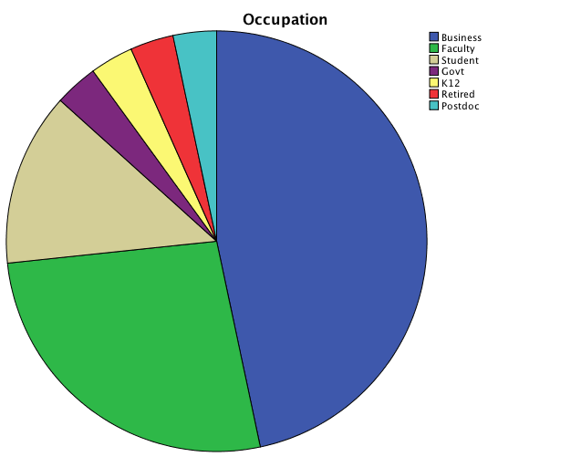
Has Attended ISDC Never Attended ISDC

Highest Degree by Conference vs. Random Sample

 | Frequency  Conference | Valid % | Frequency Random | Valid % | Total
Business | 3 | 7% | 0 | 0% | 3
Faculty | 28 | 60% | 27 | 61% | 55
Other | 15 | 33% | 17 | 39% | 32
Total | 46 | 100% | 44 | 100% | 90

Highest Degree by Has Attended ISDC vs. Never Attended ISDC

 | Frequency  Attended | Valid % | Frequency Never Attended | Valid % | Total
Business | 2 | 3% | 1 | 3% | 3
Faculty | 33 | 56% | 21 | 70% | 54
Other | 24 | 41% | 8 | 27% | 32
Total | 59 | 100% | 30 | 100% | 89

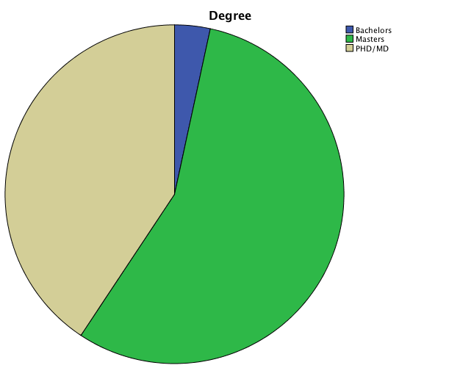
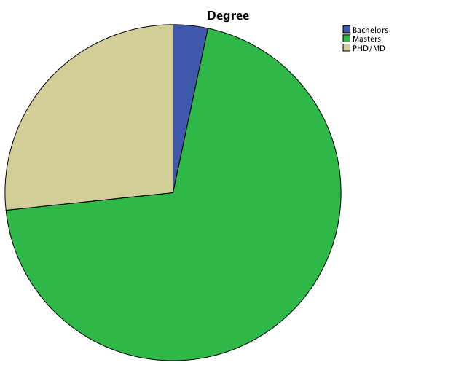
Has Attended ISDC Never Attended ISDC

Home Country by Conference vs. Random Sample

 | Frequency  Conference | Valid % | Frequency Random | Valid % | Total
Europe | 13 | 28% | 19 | 44% | 32
North America | 26 | 57% | 13 | 30% | 39
Asia | 3 | 7% | 6 | 14% | 9
Australasia | 0 | 0% | 4 | 9% | 4
South America | 2 | 4% | 1 | 2% | 3
Africa | 2 | 4% | 0 | 0% | 2
Total | 46 | 100% | 43 | 100% | 89

Home Country by Has Attended ISDC vs. Never Attended ISDC

 | Frequency  Attended | Valid % | Frequency Never Attended | Valid % | Total
Europe | 20 | 34% | 12 | 40% | 20
North America | 32 | 54% | 7 | 23% | 32
Asia | 2 | 3% | 7 | 23% | 2
Australasia | 2 | 3% | 2 | 7% | 2
South America | 2 | 3% | 1 | 3% | 2
Africa | 1 | 2% | 1 | 3% | 1
Total | 59 | 100% | 30 | 100% | 89

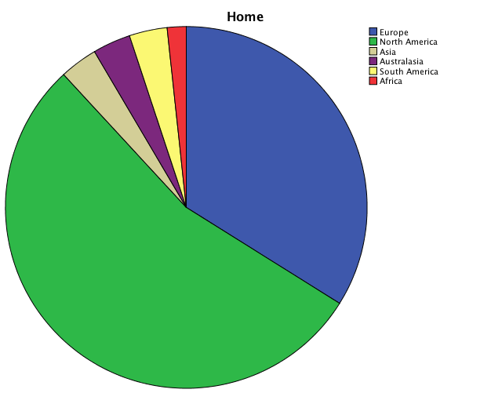
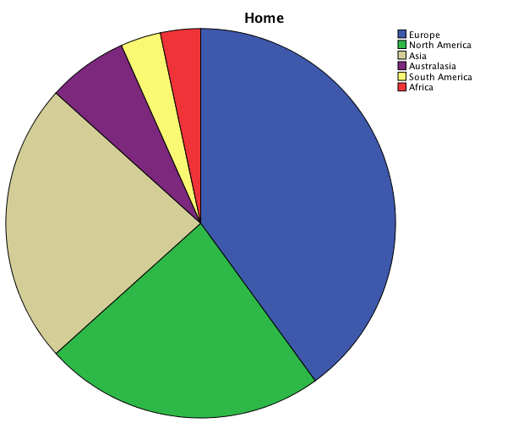
Has Attended ISDC Never Attended ISDC

Gender by Conference vs. Random Sample

 | Frequency  Conference | Valid % | Frequency Random | Valid % | Total
Male | 31 | 67% | 39 | 89% | 70
Female | 15 | 33% | 5 | 11% | 20
Total | 46 | 100% | 44 | 100% | 90

Gender by Has Attended ISDC vs. Never Attended ISDC

 | Frequency  Attended | Valid % | Frequency Never Attended | Valid % | Total
Male | 44 | 75% | 26 | 87% | 70
Female | 15 | 25% | 4 | 13% | 19
Total | 59 | 100% | 30 | 100% | 89

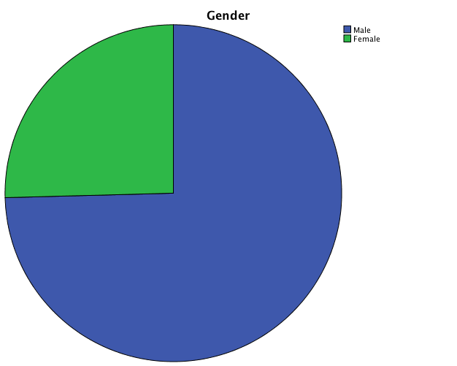
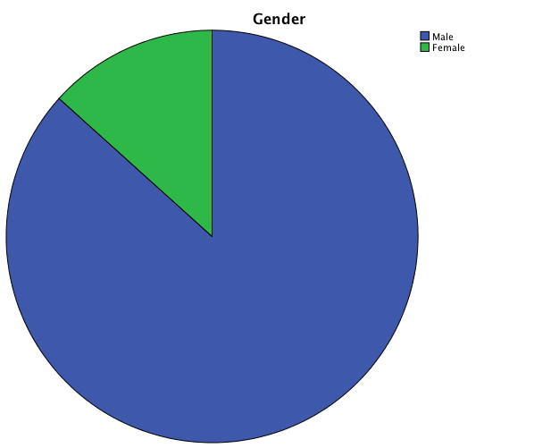
Has Attended ISDC Never Attended ISDC

Age by Conference vs. Random Sample

 | Frequency  Conference | Valid % | Frequency Random | Valid % | Total
Under 25 | 0 | 0% | 1 | 2% | 1
25-29 | 4 | 9% | 4 | 9% | 8
30-39 | 19 | 41% | 13 | 30% | 32
40-49 | 8 | 17% | 12 | 27% | 20
50-59 | 9 | 20% | 6 | 14% | 15
60 or Older | 6 | 13% | 8 | 18% | 14
Total | 46 | 100% | 44 | 100% | 90

Age by Has Attended ISDC vs. Never Attended ISDC

 | Frequency  Attended | Valid % | Frequency Never Attended | Valid % | Total
Under 25 | 1 | 2% | 0 | 0% | 1
25-29 | 3 | 5% | 5 | 17% | 8
30-39 | 20 | 34% | 11 | 37% | 31
40-49 | 13 | 22% | 7 | 23% | 20
50-59 | 10 | 17% | 5 | 17% | 15
60 or Older | 12 | 20% | 2 | 7% | 14
Total | 59 | 100% | 30 | 100% | 89

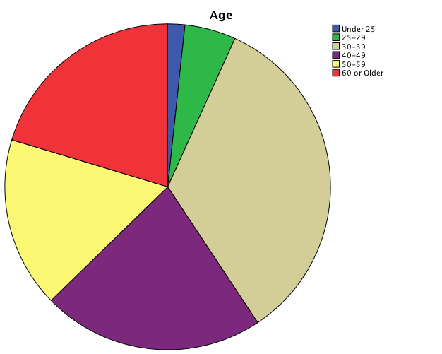
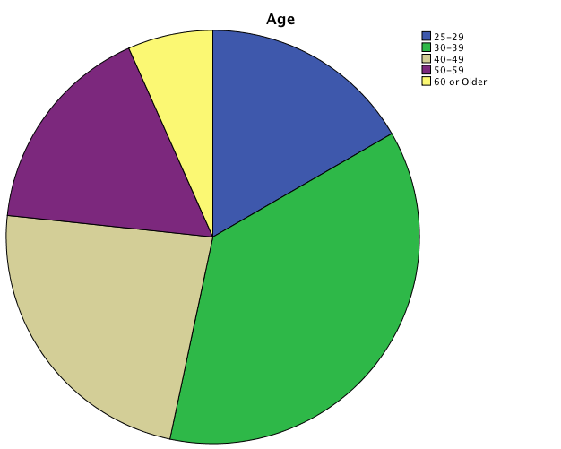
Has Attended ISDC Never Attended ISDC

SDS Member by Conference vs. Random Sample

 | Frequency  Conference | Valid % | Frequency Random | Valid % | Total
Yes | 39 | 85% | 39 | 89% | 78
No | 7 | 15% | 5 | 11% | 12
Total | 46 | 100% | 44 | 100% | 90

SDS Member by Has Attended ISDC vs. Never Attended ISDC

 | Frequency  Attended | Valid % | Frequency Never Attended | Valid % | Total
Yes | 57 | 97% | 20 | 67% | 77
No | 2 | 3% | 10 | 33% | 12
Total | 59 | 100% | 30 | 100% | 89

Years ISDC Member by Conference vs. Random Sample

 | Frequency  Conference | Valid % | Frequency Random | Valid % | Total
1 | 7 | 18% | 5 | 13% | 11
2 | 6 | 15% | 3 | 8% | 9
3 | 3 | 8% | 10 | 26% | 13
4 | 3 | 8% | 2 | 5% | 5
5 | 1 | 3% | 1 | 3% | 2
6 | 0 | 0% | 1 | 3% | 1
8 | 2 | 5% | 1 | 3% | 3
9 | 0 | 0% | 1 | 3% | 1
10 | 4 | 10% | 6 | 16% | 1
11 | 2 | 5% | 1 | 3% | 10
12 | 0 | 0% | 1 | 3% | 3
13 | 1 | 3% | 2 | 5% | 1
14 | 1 | 3% | 2 | 5% | 3
15 | 2 | 5% | 1 | 3% | 3
16 | 1 | 3% | 0 | 0% | 3
18 | 3 | 8% | 0 | 0% | 1
20 | 1 | 3% | 1 | 3% | 3
30 | 1 | 3% | 0 | 0% | 2
31 | 1 | 3% | 0 | 0% | 1
Total | 39 | 100% | 38 | 100% | 77

Years ISDC Member by Has Attended ISDC vs. Never Attended ISDC

 | Frequency  Attended | Valid % | Frequency Never Attended | Valid % | Total
1 | 6 | 11% | 6 | 30% | 12
2 | 6 | 11% | 3 | 15% | 9
3 | 6 | 11% | 6 | 30% | 12
4 | 3 | 5% | 2 | 10% | 5
5 | 2 | 4% | 0 | 0% | 2
6 | 0 | 0% | 1 | 5% | 1
8 | 3 | 5% | 0 | 0% | 3
9 | 0 | 0% | 1 | 5% | 1
10 | 10 | 18% | 0 | 0% | 10
11 | 2 | 4% | 1 | 5% | 3
12 | 1 | 2% | 0 | 0% | 1
13 | 3 | 5% | 0 | 0% | 3
14 | 3 | 5% | 0 | 0% | 3
15 | 3 | 5% | 0 | 0% | 3
16 | 1 | 2% | 0 | 0% | 1
18 | 3 | 5% | 0 | 0% | 3
20 | 2 | 4% | 0 | 0% | 2
30 | 1 | 2% | 0 | 0% | 1
31 | 1 | 2% | 0 | 0% | 1
Total | 56 | 100% | 20 | 100% | 76

Chapter Member by Conference vs. Random Sample

 | Frequency  Conference | Valid % | Frequency Random | Valid % | Total
Yes | 23 | 60% | 17 | 44% | 40
No | 15 | 40% | 22 | 56% | 37
Total | 38 | 100% | 39 | 100% | 77

Chapter Member by Has Attended ISDC vs. Never Attended ISDC

 | Frequency  Attended | Valid % | Frequency Never Attended | Valid % | Total
Yes | 30 | 53% | 9 | 47% | 39
No | 27 | 47% | 10 | 53% | 37
Total | 57 | 100% | 19 | 100% | 76

SIG Member by Conference vs. Random Sample

 | Frequency  Conference | Valid % | Frequency Random | Valid % | Total
Yes | 27 | 71% | 20 | 64% | 47
No | 11 | 29% | 19 | 36% | 30
Total | 38 | 100% | 39 | 100% | 77

SIG Member by Has Attended ISDC vs. Never Attended ISDC

 | Frequency  Attended | Valid % | Frequency Never Attended | Valid % | Total
Yes | 36 | 64% | 10 | 50% | 36
No | 20 | 36% | 10 | 50% | 20
Total | 56 | 100% | 20 | 100% | 76

Did You Renew Membership by Conference vs. Random Sample

 | Frequency  Conference | Valid % | Frequency Random | Valid % | Total
Yes | 29 | 74% | 25 | 64% | 54
No | 10 | 26% | 14 | 36% | 24
Total | 39 | 100% | 39 | 100% | 77

Did You Renew Membership by Has Attended ISDC vs. Never Attended ISDC

 | Frequency  Attended | Valid % | Frequency Never Attended | Valid % | Total
Yes | 40 | 70% | 13 | 65% | 53
No | 17 | 30% | 7 | 35% | 24
Total | 57 | 100% | 20 | 100% | 77

What Motivated You to Initially Join the System Dynamics Society?

 | Frequency-Has Attended ISDC | Frequency-Has Never Attended ISDC
Learn New Tools | 24 | 8
Encouraged by a Professor | 10 | 8
Friendship with Other Members | 11 | 5
Learn System Dynamics | 35 | 16
Conferences | 31 | 16
Quality of the Work | 7 | 4
Learn About New Ideas | 25 | 10
Networking | 28 | 12
Mentoring | 4 | 1
Access to SDR | 1 | 0

What Motivated You to Renew Your System Dynamics Society Membership?

 | Frequency-Has Attended ISDC | Frequency-Has Never Attended ISDC
Learn New Tools | 12 | 3
Encouraged by a Professor | 0 | 1
Friendship with Other Members | 14 | 1
Learn System Dynamics | 19 | 9
Conferences | 26 | 4
Quality of the Work | 8 | 1
Learn About New Ideas | 17 | 5
Networking | 21 | 6
Mentoring | 6 | 0
Access to SDR | 0 | 0

Fourteen participants provided information on why they chose not to renew their SDS memberships. Two themes emerged. Some participants chose not to renew due to cost or budget issues (n=3). A second group reported they no longer felt connected to the SDS or that it not adding value. Two mentioned it was dominated by academics, another mentioned it was dominated by consultants. Another stated that members “came to SDS to massage their egos.” Two also reported they failed to renew their membership due to laziness.

Have You Ever Attended ISDC by Conference vs. Random Sample

 | Frequency  Conference | Valid % | Frequency Random | Valid % | Total
Yes | 35 | 76% | 24 | 56% | 59
No | 11 | 24% | 19 | 44% | 30
Total | 46 | 100% | 43 | 100% | 89

Have You Participated in an ISDC Workshop by Conference vs. Random Sample

 | Frequency  Conference | Valid % | Frequency Random | Valid % | Total
Yes | 30 | 86% | 16 | 67% | 46
No | 5 | 14% | 8 | 33% | 13
Total | 35 | 100% | 24 | 100% | 59

What motivated you to attend the International System Dynamics Conference?

Frequency-
Has Attended ISDC
Learn New Tools | 22
Encouraged by a Professor | 13
Friendship with Other Members | 23
Learn System Dynamics | 35
Quality of the Work | 8
Learn About New Ideas | 33
Networking | 40
Mentoring | 10
Present and/or Get Feedback | 27

Other Conferences Attended by Participants
- Credit union and banking industry  - EURO Conference for Operations Research  - International conferences in the fields of industrial ecology, resource recovery and waste management  - European Meeting of Cybernetics and Systems (EMCSR)  EUROCAST  - Int'l development conferences  - American Water Resource Association  - Euroma  - DGSD annual Meeting  - European SD Workshop  - Association of American Geographers  - American Geophysical Union  - The events that the occur in Brazil.  - Academy of Management (less frequently)  - Strategic Management Society  - Decision Analysis conferences  - American Society for Quality (ASQ)  - International Leadership Association (ILA)  - Association for Training + Development (ATD)  - North American Simulation + Gaming Association (NASAGA)  - Serious Games Conferences  - Serious Play  - Organization Development Network (local + national) (ODNET)  - Creative Leadership Exchange (CLE)  - American Management Association (AMA) | - Academy Health  - INFORMS  - IIE  - ASQ  - Quality  - Six Sigma,  - DSS  - TRIZ  - IEEE  - NDIA  - INCOSE  - ACM conferences  - Airline Conferences  - World Business Forum  - World Economic Forum  - GITEX  - Society of Range Management  - Soil and Water Conservation Society  - American Collegiate Schools of Planning  - A Community on Ecosystem Services (ACES)  - UKSim 5th European Modelling Symposium on Computer Modelling and Simulation  - Fourth International Conference on Internet Technologies and Applications (ITA 11)  - The 4th International Conference on Developments in eSystems Engineering (DeSE2011)  - Modelling Symposium (AMS), 2012 Sixth Asia  - Academy of Management and other management related conferences.  - Decision Sciences Institute  Institute of Industrial Engineers  - AOM, EGOS, INFORMS  - Institute of Coaching (Harvard)  - EGPA Europe

Papers Submitted to SDR and % Accepted During the Last 5 Years by Conference vs. Random
 | Frequency  Conference | Frequency Random | Total
Total Number Papers Submitted to SDR | 21 | 10 | 31
Total Number Papers Accepted By SDR | 14 | 7 | 21
Percent Papers Accepted by SDR | 67% | 70%
Papers Submitted to SDR and % Accepted During the Last 5 Years by Has Attended ISDC vs. Never Attended ISDC
 | Frequency  Attended | Frequency Never Attended | Total
Total Number Papers Submitted to SDR | 30 | 7 | 37
Total Number Papers Accepted By SDR | 21 | 4 | 25
Percent Papers Accepted by SDR | 70% | 57%

Papers Submitted to Other Journals and % Accepted During the Last 5 Years by Conference vs. Random
 | Frequency  Conference | Frequency Random | Total
Total Number Papers Submitted to Other Journals | 133 | 101 | 243
Total Number Papers Accepted By Other Journals | 103 | 72 | 175
Percent Papers Accepted to Other Journals | 77% | 71%
Papers Submitted to Other Journals and % Accepted During the Last 5 Years by Has Attended ISDC vs. Never Attended ISDC
 | Frequency  Attended | Frequency Never Attended | Total
Total Number Papers Submitted to Other Journals | 197 | 42 | 239
Total Number Papers Accepted By Other Journals | 146 | 33 | 179
Percent Papers Accepted to Other Journals | 74% | 79%

Reviewed for SDR by Conference vs. Random
 | Frequency  Conference | Valid % | Frequency Random | Valid % | Total
Yes | 13 | 30% | 9 | 21% | 22
No | 30 | 70% | 33 | 79% | 63
Total | 43 | 100% | 42 | 100% | 85

Reviewed for SDR by Has Attended ISDC vs. Never Attended ISDC
 | Frequency  Attended | Valid % | Frequency Never Attended | Valid % | Total
Yes | 17 | 30% | 5 | 19% | 22
No | 40 | 70% | 22 | 81% | 62
Total | 57 | 100% | 27 | 100% | 84
Forty participants provided feedback on how SDR could be improved. Four themes emerged: 1) include more articles featuring successful practical applications of SD, 2) including more articles that will appeal to a wide audience in ode to increase the exposure of SD in other fields, 3) improve logistics around making the journal open access of making online access easier, and ) that SDR is in “good shape” and doesn’t need to be changed.

The most prominent theme was that SDR should accept and publish more articles on case studies of practical applications using SD (n=9). One suggestion was to create another journal for practical applications of SD.

Many participants also felt that SDR should publish more articles that would appeal to a wider audience (n= 5). For example, one participant stated SDR should “accept/encourage articles that would be of direct interest to other academic disciplines to increase the exposure of SD beyond our own community. We're too insular.” Another stated SDS should “explore opportunities to partner with other like disciplines to become more broadly recognized and accepted.” One suggested it should publish articles trying out applications in new fields.

A third group (n= 3) suggested removing barriers to accessing SDR online, including increasing access to the models in the articles. One stated “It would be really nice to be able to search and read the current and past issues online, and have direct online or browser access to working models from papers so as to more easily explore the behaviors in the papers.” Another suggested using DLBP indexing, while another suggested making the journal open access.

Finally, several participants reported (n=5) that they felt that no changes should be made to the journal.

Several participants provided unique suggestions. These included:
- Broadening the definition of system dynamics to include mathematical modeling practices that include major concepts such as feedback loop or stock-flows and being more open to short papers/notes.
- Dedicate more space to model building and simulation software tools and techniques.
- Papers could be classified as: improvement/ generating more theoretical knowledge (e.g., g: value to the SD theory progress), diffusing SD knowledge / practice (vg: value to the practitioner), widening / spreading SD practice (vg: value to business) (not mutually exclusive), and giving a final section of every paper and make clear statement on how it provides value based on any of the three (or whichever) categories suggested above.”
- Charge money to submit - pay reviewers. Follow the finance journals or Journal of Environmental Economics and Management: See http://www.elsevier.com/journals/journal-of-environmental-economics-and-management/0095-0696/guide-for-authors. This is a much better system and much faster. SD review should go open access - just use the platform that Ecology and Society uses. We're basically just paying for server maintenance and copyediting, correct? Elsevier has higher margins than Apple, Inc. This would massively increase readership and visibility and would get people to submit, acknowledging the SD review is outside their field, but knowing there is a large readership.”
- Better Appearance.

Forty-seven participants responded to the question “what would make you more motivated to submit papers to SDR?” The majority of respondents reported their motivation would increase if the journal accepted more papers on practical applications of SD (n=13). Seven participants reported that they felt their work was not advanced enough to be published in SDR, usually because they considered themselves beginners or novice modelers. For example, one participant stated, “my view of SD Review is that it's a journal for a small group of eminent/experience system dynamists and well-published authors, I am still a beginner in System Dynamics and I don't feel that SD Review encourages new researchers to submit work that is not yet seminal.”

Another group of participants (n=5) reported that their motivation would increase if the journal had more visibility or was read by individuals in other fields. Finally, others reported the journal should accept more papers from around the world and publish more papers outside of the field of management.

Other Journals Listed by Participants
- JAMA  - AJPH  - American Journal of Epidemiology  - Health Education and Behavior  Psycho-Oncology  - Cancer  - Children and Youth Services Review  - Educational Policy  - Systems Research and Behavioral Sciences  - JASSS  - Management Science  - Journal of Industrial Ecology  Resources  - Conservation and Recycling  - Waste Management  - Waste Management and Research  - Journal of Cleaner Production  - Journal of Asthma, Allergy and Immunology  - Journal of Safety Research  - Journal of Industrial Medicine  - Joint Commission Journal of Quality  - ASQ  - Organization Studies  - SMJ  - AJS  - Journal of Marketing  - PNAS  - Science  - The Journal of Business Models  - Intelligent Manufacturing  - PLoS ONE  Journal of Environmental Management  - Energy for Sustainable Development  - Energy Research and Social Science | - Kybernetes  - Cybernetics and Systems  - Journal of Operations Management  - International Journal of Logistics Management  - Ecological Economics  - Sustainability  - Journal of American Water  - Resources Association  - EJOR  - POM  - IJPE  - iJPR  - PPC  - EAR  - JoMaC  - Decision Sciences  - Ecology and Society  - Global Environmental Change  - PNAS  - Journal of Industrial Ecology  - Science of the Total Environment  - Energy Economics  - Tech Forecasting and Social Change  - Water Resource Planning  - Energy Journal  - Ecology and Society  - Journal of the American  - Planning Association  - Journal of Planning Education and Research  - Nature  - Frontiers in Ecology and the Environment  - Science  - Proceedings of the National Academy of Sciences  - Management Science  - J. Op. Res. Soc.  - Energy Policy | - Sustainability: Science, Practice, Policy  - Mitigation and Adaptation  - Strategies for Global Change  - Systems Research and Behavioral Science  - Academy of Management Review  - Journal of Management  - Systems Research and Behavioral Science  - Agroforestry Systems  - Land Use Policy  - Ecological Economics  - Environmental Management  - Environmental Modelling & Software  - Futures  - Journal of Environmental Studies and Sciences  - Agriculture Systems  - Ecology and Society  Systems  - Organizational Behavior and Human Decision Making  - Climatic Change  - Journal of Agricultural Sciences  - Global Food Security  - Simulation & Gaming  - IEEE  - Royal Aeronautical Society, UK  - European Journal of Operational Research  - Journal of Engineering Management  - IEEE  - Transactions on Engineering Management  - JAAMAS  - Computational and Mathematical Organization Theory

What Originally Drew You to System Dynamics?

 | Frequency-Has Attended ISDC | Frequency-Has Never Attended ISDC
Observed Someone Using It | 3 | 2
Got Drawn In | 2 | 3
Improve Business or Management | 3 | 3
Way of Making Systems Thinking/Mental Models Explicit | 10 | 4
Able to Model Hard and Soft Factors | 0 | 2
Fits With Engineering Background | 2 | 1
Making Sense of Complexity/Chaos | 5 | 3
Course In SD | 2 | 5
Beer Game | 2 | 0
Philosophy of SD | 3 | 1
Someone Suggested It | 1 | 1

Several participants reported that a specific person or work drew them to system dynamics, including Meadows (n=2), Forrester (n=2), Senge (n=2), Morrison (n=1), Sterman (n=1), Morecroft (n=1), Paich (n=1), and Deming (n=1). Participants who reported being “drawn in” by system dynamics described experiences such as having a “mind-opening experience” and “finding SD was like coming home.”

How Do You Plan to Use System Dynamics in the Next Five Years?

 | Frequency-Has Attended ISDC | Frequency-Has Never Attended ISDC
Business | 9 | 5
Research | 9 | 4
Teaching | 8 | 4
Consulting | 1 | 2
Promoting SD | 5 | 5
Decision-making | 4 | 1
Policy | 3 | 3
Child-rearing | 1 | 2

How did You First Hear About SD? by Conference vs. Random Sample

 | Frequency  Conference | Valid % | Frequency Random | Valid % | Total
SD Course | 15 | 33% | 12 | 27% | 27
Colleague | 9 | 20% | 8 | 18% | 17
Other | 4 | 9% | 2 | 5% | 6
Mention of SD in  Other Course | 4 | 9% | 6 | 14% | 10
Work | 6 | 13% | 3 | 7% | 9
Book | 2 | 4% | 3 | 7% | 5
Web | 2 | 4% | 2 | 5% | 4
Conference | 0 | 0% | 3 | 7% | 3
Journal | 0 | 0% | 3 | 7% | 3
Don't Remember | 1 | 2% | 2 | 5% | 3
Magazine or Newsletter | 1 | 2% | 0 | 0% | 1
Family Member | 1 | 2% | 0 | 0% | 1
Friend | 1 | 2% | 0 | 0% | 1
Total | 46 | 100% | 44 | 100% | 90

How did You First Hear About SD? by Has Attended ISDC vs. Never Attended ISDC

 | Frequency  Attended | Valid % | Frequency Never Attended | Valid % | Total
SD Course | 16 | 27% | 11 | 37% | 27
Colleague | 13 | 22% | 4 | 13% | 17
Other | 5 | 8% | 1 | 3% | 6
Mention of SD in Other Course | 7 | 12% | 3 | 10% | 10
Work | 4 | 7% | 5 | 17% | 9
Book | 3 | 5% | 2 | 7% | 5
Web | 3 | 5% | 1 | 3% | 4
Conference | 3 | 5% | 0 | 0% | 3
Journal | 1 | 2% | 1 | 3% | 2
Don't Remember | 1 | 2% | 2 | 7% | 3
Magazine or Newsletter | 1 | 2% | 0 | 0% | 1
Family Member | 1 | 2% | 0 | 0% | 1
Friend | 1 | 2% | 0 | 0% | 1
Total | 59 |  | 30 |  | 89

Other Feedback for System Dynamics Society

When asked what the System Dynamics Society could do to improve the field of SD, participants provided a wide variety of suggestions. Several participants discussed keeping the quality of work in the field high and that the SDS should be the gatekeeper for keeping low-quality work out of the conference. For example, one stated, “The conferences are overwhelmingly European students who never seem to become practitioners or do anything with SD. They frequently present terrible quality work that is totally publishable or applicable to anything. Need much stronger conception of "policy implications" in SD - seems like folks don't really understand how policy is made or what it means to "change Policy." So many SD interventions sort of ‘assume away’ my entire field.” Another said, “Stop accepting low quality papers at the conference and for the review. I prefer 10 high quality papers than 250 low quality.”

Another theme focused on the field’s elitist or exclusionary quality. Comments included “The field still suffers from an "ivory tower" dynamic. There is an "inner circle" of long-term folks in the field and it is difficult for outsiders to break in, especially if they didn't formally study SD at MIT or WPI,” and I believe the society is fallen into the trap of "Success-to-the-Successful" archetype. There are practitioners out there who are interested in advancing SD in real world applications, graduate education and university curriculum but who are not at institutions or organizations with strong SD programs (e.g., MIT, WPI, Albany, Bergen), because of this, their work is not highlighted strongly enough at the conference.”

Several mentioned more mentoring opportunities for those learning SD. Other unique responses are listed below:

- The conference helps us keep in touch with one another, but it's more slanted to academics. Find other ways to keep us in touch and well-networked. ("us" = people with knowledge and skills in this area)
- Certification really would enhance the professionalism of the field. Local chapters or groups that can connect professionals and provide support and mentors for newer modelers.”
- Myself, have been an advocate of the SDS/SDR, however, throughout the years I've seen how many papers "say nothing" at all. As if just people for undergraduate courses would be simulating and writing them. If we want that SD recovers its value, more people from outside (government, schools, businesses) are the ones to be writing cases, with real impact. I'm not saying that theoretical papers are valueless but they cannot be the centre of the SDR, for example. Let alone, low quality/low value form supposedly practical papers.
- Develop a really, really good set of Massive Open Online Course that don't just teach the SD methodology but which are also very strong on application. The WPI videos that I have seen are good - but WPI is expensive and has some barriers to entry. The competitive advantage of WPI is that you interact with actual people and get personal feedback for the exercises you submit.”
- Enter into multiple direct collaborations with other academic disciplines. Psychology is a good start. Expand to leadership studies, social work, sociology, broaden collaborations w/ economics, human development, education + learning... basically all social sciences.
- Continue to expand collaborations on sustainability, medical/health care.
- Expand opportunities to create demand for the services of SD experts for organizational effectiveness. Develop a SIG for info brokers of insights from SD models + to create demand for development of models to inform decisions. Focus on ways to develop requirements for models rather than trying to "sell" models to people who don't think they need them.
- There is too much work that is published and presented that is more politically correct than scientifically based. An infinite number of models can demonstrate a predetermined result. There needs to be much more emphasis on discovery of phenomena.
- Try to act less like the Cult of Jay Forrester

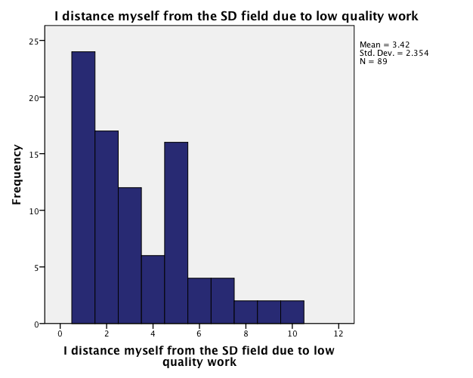
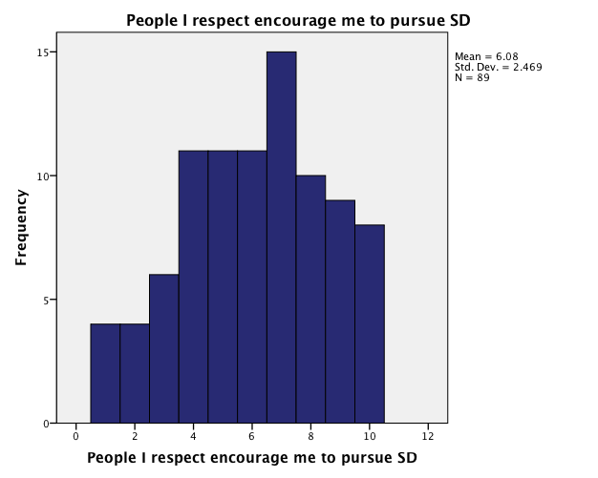
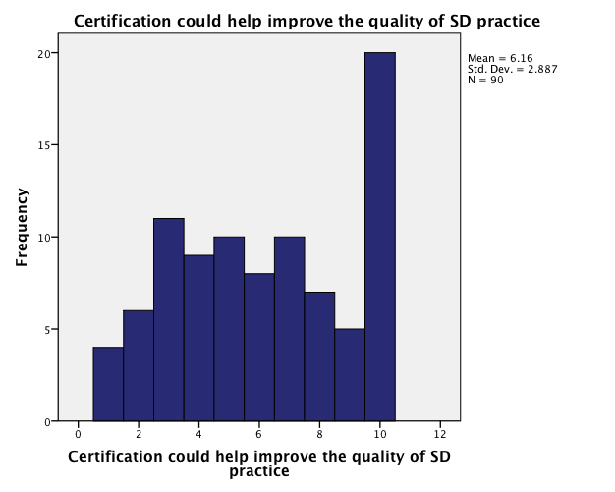
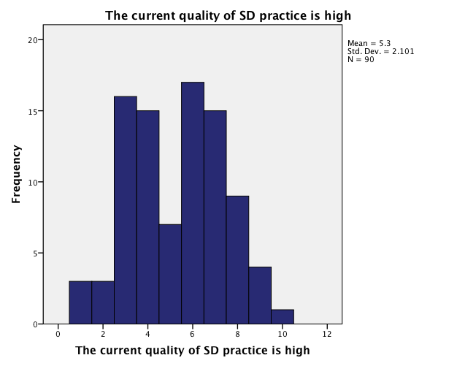
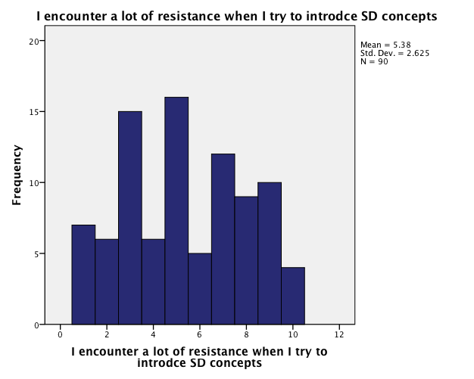
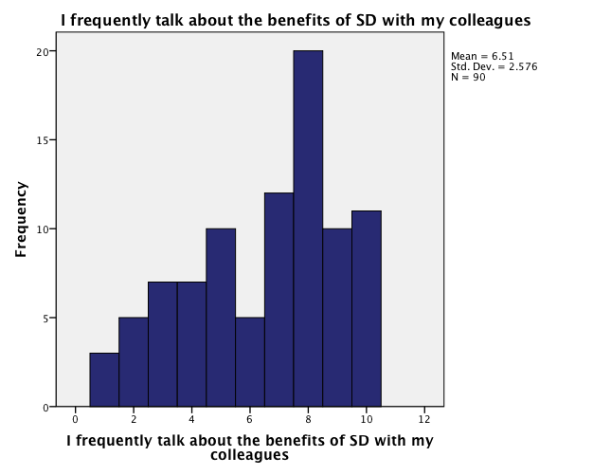
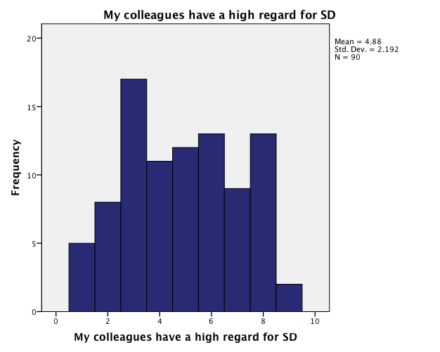
Histograms for Likert Scale Items, Entire Sample

Correlations, Means, and Standard Deviations for Survey Items

Question | M | SD | 1 | 2 | 3 | 4 | 5 | 6 | 7
- I frequently talk about the benefits of SD with my colleagues | 6.51 | 2.58
- The current quality of SD practice is high | 5.30 | 2.10 | .501**
- Certification could help improve the quality of SD practice | 6.16 | 2.89 | .365** | .494**
- My colleagues have a high regard for SD | 4.89 | 2.19 | .634** | .401** | .385**
- I distance myself from the SD field because of low quality | 3.42 | 2.35 | .140 | -.127 | -.15 | .006
- People I respect encourage me to pursue SD | 6.08 | 2.47 | .548** | .509** | .359** | .546** | .93
- I encounter a lot of resistance when introducing SD concepts | 5.38 | 2.63 | .295** | .244** | .272** | -.82 | .236** | .39

** p<.001

Means and Standard Deviations by Group Conference vs. Random Sample

 | Sample | N | Mean | Std. Deviation
I frequently talk about the benefits of SD with my colleagues | Conference | 46 | 6.72 | 2.656
 | Random | 44 | 6.30 | 2.502
The current quality of SD practice is high | Conference | 46 | 5.20 | 2.187
 | Random | 44 | 5.41 | 2.027
Certification could help improve the quality of SD practice | Conference | 46 | 5.67 | 2.813
 | Random | 44 | 6.66 | 2.909
My colleagues have a high regard for SD | Conference | 46 | 4.78 | 2.280
 | Random | 44 | 4.98 | 2.118
I distance myself from the SD field due to low quality work | Conference | 45 | 3.24 | 2.442
 | Random | 44 | 3.59 | 2.275
People I respect encourage me to pursue SD | Conference | 45 | 6.31 | 2.391
 | Random | 44 | 5.84 | 2.551
I encounter a lot of resistance when I try to introduce SD concepts | Conference | 46 | 5.13 | 2.864
 | Random | 44 | 5.64 | 2.354

Means and Standard Deviations by Has Attended ISDC vs. Has Never Attended ISDC

 | Attended ISDC | N | Mean | Std. Deviation
I frequently talk about the benefits of SD with my colleagues | Yes | 59 | 6.49 | 2.687
 | No | 30 | 6.53 | 2.432
The current quality of SD practice is high | Yes | 59 | 5.32 | 2.145
 | No | 30 | 5.27 | 2.083
Certification could help improve the quality of SD practice | Yes | 59 | 5.95 | 2.776
 | No | 30 | 6.70 | 3.030
My colleagues have a high regard for SD | Yes | 59 | 5.03 | 2.228
 | No | 30 | 4.57 | 2.161
I distance myself from the SD field due to low quality work | Yes | 59 | 3.08 | 2.152
 | No | 29 | 3.90 | 2.498
People I respect encourage me to pursue SD | Yes | 58 | 5.95 | 2.516
 | No | 30 | 6.30 | 2.437
I encounter a lot of resistance when I try to introduce SD concepts | Yes | 59 | 5.31 | 2.756
 | No | 30 | 5.60 | 2.387

