Appendix. Formal model description

Based on the proposed dynamic hypothesis, the mathematical formalization of the model is carried out to enable simulations. The simulation period covers the years 2000 to 2040. The software used was Powersim Studio 10, with a first-order Euler integration method and a simulation time step of one month. The details of this mathematical formalization process are presented in Appendix A.

Mining Cycle, value chain, and formalization modules

The mining cycle is based on the work of Naill (1992) and follows the terminology established by the Committee for Mineral Reserves International Reporting Standards (CRIRSCO), which classifies minerals based on their economic feasibility for extraction (resource or reserve) and the certainty of their productive potential in each district (CRIRSCO, 2024). Given that the analysis period extends to 2040, the model focuses on mineral reserves, i.e., resources already located and confirmed to be economically viable for extraction with current technological advancements. These reserves are divided into three categories, represented as stock-type variables: probable reserves, proven reserves, and reserves in development. Table 2 presents the fundamental equations that describe these modules.

Table 2. Fundamental equations for modelling Mining Cycle, value chain, and formalization modules.

Variable | Comments
Probable Mineral Reserves (Pb)  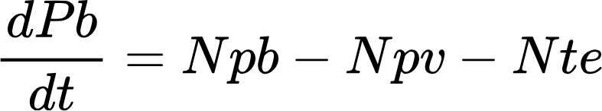  Level [ton] | The estimated proportion of a mineral resource remains uncertain regarding the available quantity. This proportion increases with the addition of New Probable Reserves (Npb) and decreases due to the Discovery Rate of Reserves (Npv) and non-titled extraction (Nte), particularly in areas affected by informal mining.
Proven Mineral Reserves (Pv)  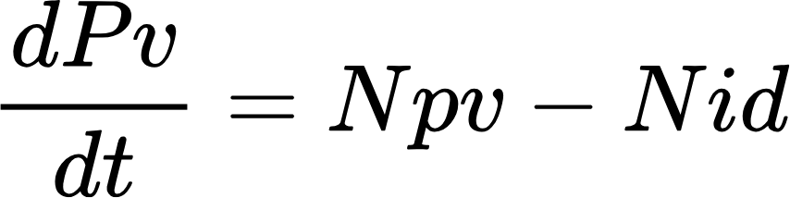  Level [ton] | The portion of a measured mineral resource that can be economically extracted with current technology is backed by a high level of geological confidence (CRIRSCO, 2024). It grows with the Discovery Rate of Reserves (Npv) and declines with the Development Rate of Mineral Reserves (Nid).
Mineral Reserves in Development (Id)  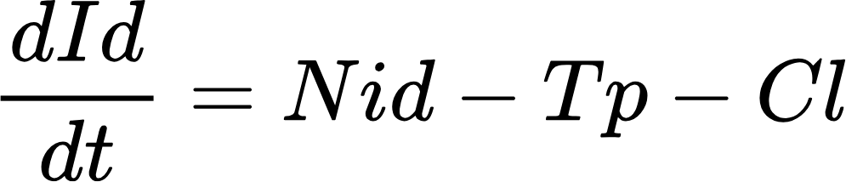  Level [ton] | Proven reserves are ready for exploitation, with all necessary infrastructure, permits, and economic viability in place. This increases via the Development Rate of Mineral Reserves (Nid) and decreases due to Titled Mineral Production (Tp) and Mine Closure (Cl), which accounts for decommissioned capacity.
Production capacity (Pc)  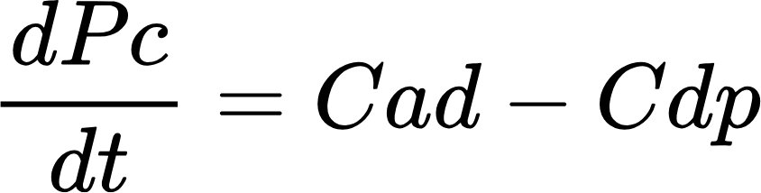  Level [ton] | Mining operations determine the maximum annual mineral extraction limit. Capacity expands (Cad) as desired production rises and depreciates (Cdp) as mines end their operational life.
New probable reserves (Npb)  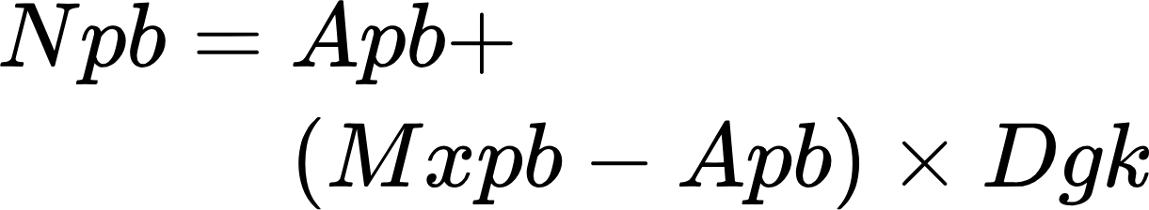  Flow [ton/year] | Changes in probable reserves due to improved geological knowledge. It is calculated using an average rate of new probable reserves (Apb) and a maximum potential (Mxpb) based on historical data and geological projections. Mxpb-Apb represents the potential unexplored or undiscovered probable resources that can be converted into new probable reserves, influenced by Geological Knowledge Development (Dgk), scaled from 0 to 1.
Discovery rate of reserves (Npv)  Flow [ton/year] | Exploration activities drive the annual transition of minerals from probable to proven reserves. This depends on the required new reserve discoveries (Rqr) to meet long-term production goals, Market Conditions for Exploration (Mce), and Investment Attractiveness (Atr).  Market conditions assess profitability, with values below 1 indicating favorable pricing: the mineral’s sale price exceeds total costs and royalties.  Investment attractiveness, based on factors like conflict levels, legal stability, and infrastructure, is derived from the Fraser Institute's Annual Mining Survey (Mejía & Aliakbari, 2024). Atr values above 1 signal favorable conditions for exploration.
Development rate of mineral reserves (Nid)  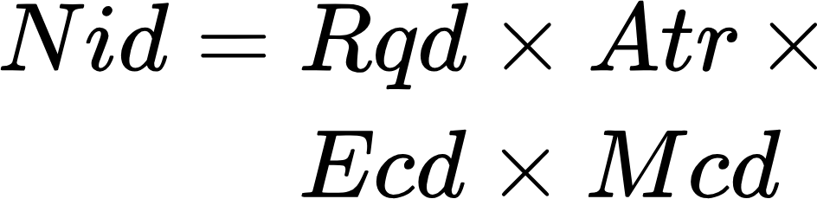  Flow [ton/year] | The annual minerals shift from proven to developed reserves is contingent on infrastructure and permits. This depends on the New Development Required (Rqd), Market Conditions for development (Mcd), Investment Attractiveness (Atr), and the effect of social conflicts in mine’s development (Ecd). Ecd values above 1 indicate favorable conditions for development.
Titled mineral production (Tp)  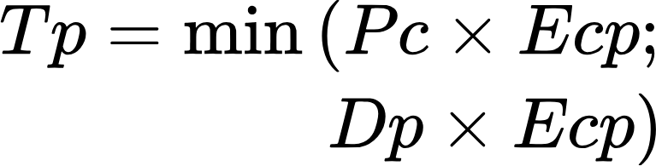  Flow [ton/year] | The annual extraction of minerals from developed reserves by legally operating mining companies is limited by production capacity (Pc) and desired production (Dp). Both are influenced by social conflicts in the region that affects production (Ecp) . The model includes auxiliary variables to differentiate production by type (underground/open pit) and scale (large/medium/small/subsistence) for detailed analysis in other modules.
Non-titled mineral production (Ntp)  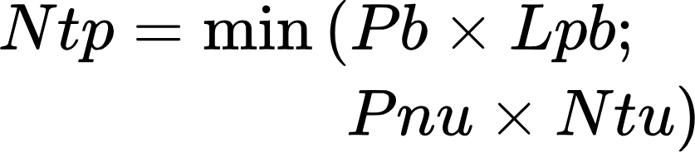  Flow [ton/year] | For minerals subject to informal extraction, this represents the annual amount extracted from probable reserves by non-titled Mining Production Units (Ntu). It is constrained by probable reserves (Pb), extraction limits (Lpb), non-titled unit productivity (Pnu), and their total number. This flow determines the effective material sold by non-titled units to third parties.
Refined gold production (Rgp)  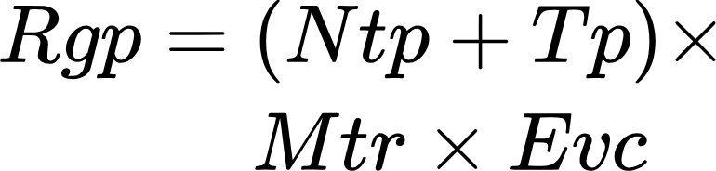  Variable [ton/year] | The development of productive chains was calculated as a percentage (Mtr) of titled and non-titled production (Tp and Ntp) transformed into higher-value-added products within the supply chain, generating jobs and increasing profits in the mining sector. This percentage varies according to the programs or strategies designed to strengthen productive chains in the districts. It can be increased through associativity and formalization, represented by the variable Effect of the Sectoral Context on the Transformation of Mineral for Chains (Ect).
Non-ttitled mining production units (Ntu)  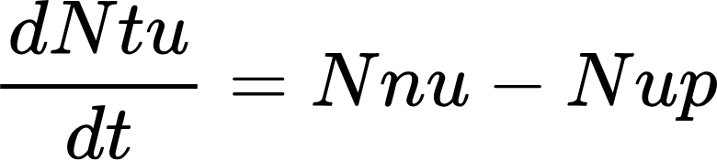  Level [ton] | Non-titled Mining Production Units were obtained from the latest Mining Census (Ministerio de Minas y Energía, 2012), including national and departmental data. These increase according to a constant annual growth rate (Nnu), influenced by market conditions that can promote or reduce informality. They decrease due to new units in formalization (Nup).
Titled mining production units (Tu)  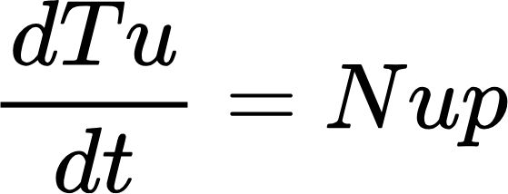  Level [ton] | Titled Mining Production Units grow as a function of new units in the formalization process (Nup).
New mining production units in the process of formalization (Nup)    Flow [ton/year] | New PMUs in formalization are calculated by multiplying the non-titled PMUs by the formalization rate (Fr), considering a delay due to administrative times, which vary according to state efficiency. The formalization rate can increase with the articulation of actors and decrease due to the presence of illegal armed groups.
Financial module
This module starts with the unit price and titled production of each mineral to estimate total annual revenue. Similarly, annual costs are calculated from titled production and unit development and production costs. In addition, it includes exploration, development, and production costs, which drive mining investment. The exploration cost reflects the unit value of activities such as mapping, surveying, and drilling during exploration. It increases as resources are depleted and finding minerals becomes more complex (Naill, 1992). Development cost represents the investment needed to build a mine with all its infrastructure. This cost tends to increase with the development progress, as observed in countries such as Australia (Shafiee et al., 2009). Production costs include mine operating expenses such as wages, maintenance, energy, and other necessary costs. For minerals for export, transport to the port is also considered. Table 3 presents the principal equations that describe this module.
Table 3. Principal equations for modelling financial module.

Variable | Comments
Mining Income (Mi)  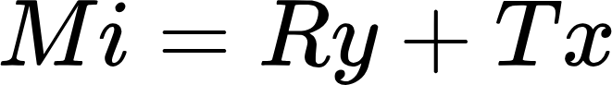  Variable [MUSD/year] | Corresponds to the sum of royalties (Ry) and taxes (Tx) paid annually by the mining sector to the Colombian State.
Royalties (Ry)  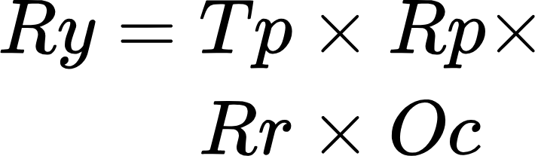  Variable [MUSD/year] | Royalties are calculated by multiplying the titled production (Tp), the base price for the liquidation of royalties (Rp) (UPME, 2024b), and the percentage of royalties established by Law 756 of 2002 (Rr) (Congreso de Colombia, 2002, p. 756). Both royalties and taxes assume that 100% of the amount required by law is not collected due to limitations in state oversight capacity (Oc).
Taxes (Tx)  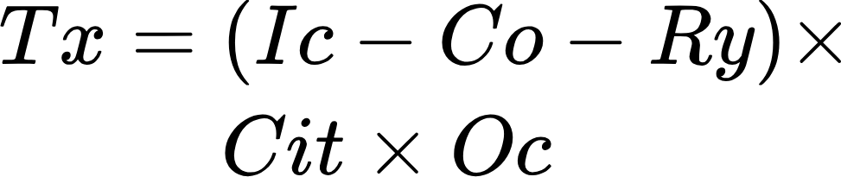  Variable [MUSD/year] | If there are profits, they are calculated by subtracting the costs (Co) and royalties (Ry) from the income (Ic) and then applying the current percentage of the income tax for legal entities (Cit) and considering the state's oversight capacity (Oc).
Social module
This module focuses on social conflict, which arises when two or more groups have opposing interests, values ​​, or needs. In mining, disagreement can occur between those who promote mining and those who oppose it. The impact of citizen participation in decision-making is assessed: whether companies and the State consider the community's opinions on the most appropriate social investment projects for their municipalities. In addition, large-scale mining triggers conflict, as it is often associated with significant negative impacts (Muñoz-Duque et al., 2020), generating unrest in the population, even before exploration or exploitation activities begin. Table 4 presents the key equations that describe this module.
Table 4. Key equations for modelling social module.

Variable | Comments
Social Conflict (Sc)  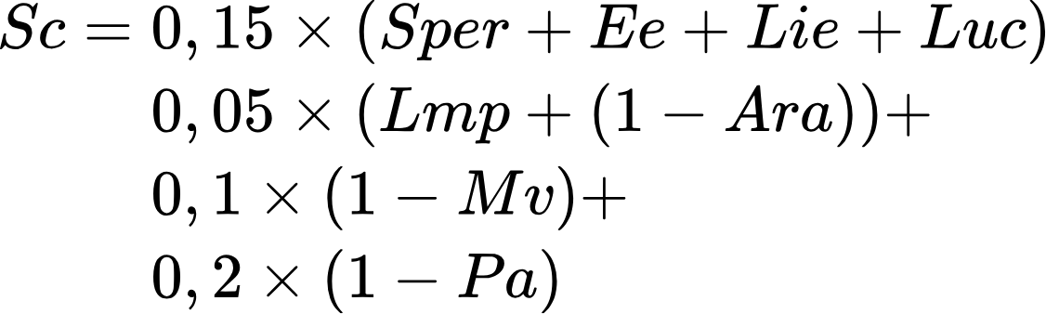  Variable [unitless] | Social conflict is a weighted average of several variables, which take values ​​between 0 and 1: Perception of environmental risk (Per), Employment effect (Ee), Local investment effect (Lie), Conflict over land use (Luc), Proportion of large-scale mining (Lmp), Articulation of actors (Ara), Mining vocation (Mv), and Citizen participation (Pa).  The variables Ara, Mv, and Pa are inversely proportional to the conflict; the greater the articulation, mining vocation, or participation, the lower the conflict.
Employment Effect on Conflict (Ee)  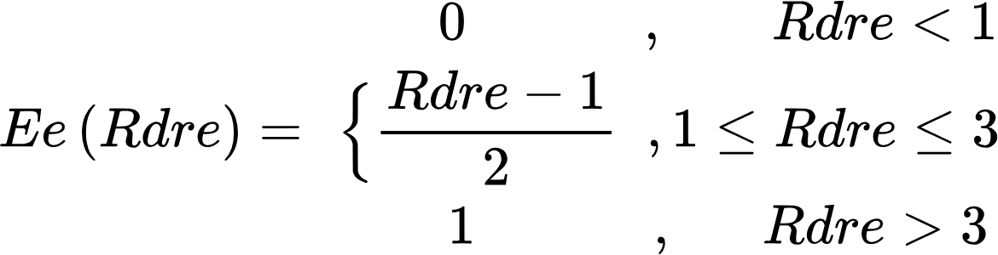  Variable [unitless] | It was modeled using a sectional function. The direct formal employment generated by mining is compared with the expected employment, estimated by the demand for each mineral (Rdre). If simulated employment is lower or equal than expected (Rdre ≥ 1), social conflict is encouraged, as the population perceives little or no economic benefit. Conflict increases proportionally up to 100% when expected employment is three times higher than simulated employment.
Local Investment Effect on Conflict (Lie)  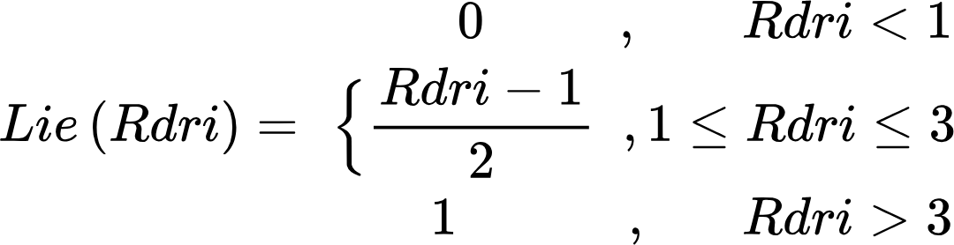  Variable [unitless] | Total local investment is the sum of business investment and local public spending. If this investment is lower than expected, social conflict increases as the population perceives fewer benefits from mining. Local business investment is equivalent to 1% of the net profits of large-scale mining companies, according to Law 2045 of 2020.  State investment is calculated from mining income (royalties and taxes), following the distribution established in Law 2056 of 2020: 60% is allocated to local and regional public spending (25% to mining departments and municipalities, 34% to regional projects, and 1% to environmental conservation). In addition, if the municipality has Unmet Basic Needs higher than the national average, an additional 15% is allocated to local investment.
Mining Vocation (Mv)  Variable [unitless] | Represents the disposition of a territory towards mining, with values ​​between 0 and 1. It reflects the importance of mining in the region's economic, social, and cultural identity. Mining is more likely to generate conflicts in areas with low mining vocation.  It starts from an initial mining vocation (Imv), which varies according to the effect of the vocation on social conflict (Evs). Emv is an average of accumulated production, associativity, and proportion of mining jobs concerning the district's total.
Associativity indicator (Asi)  Variable [unitless] | Measures the capacity or predisposition of mining operations to form associations or cooperatives, strengthening the sector's cohesion and development. It is estimated from the proportion of mining with association potential (subsistence, small and medium scale) (Lsm) and the articulation of actors (Ara).
Environmental module
This module assesses two key aspects: environmental impacts and resource use in mining. GHG emissions, the production of suspended solids that affect water quality, and the emission of particulate matter into the air are considered. Variables that compare the simulated impacts with established legal limits (national or international) are included. Exceeding these limits intensifies environmental impacts, increasing the perception of community risk and generating or aggravating social conflicts. Table 5 describes the central equations that describe this module.
Table 5. Central equations for modelling environmental module.

Variable | Comments
GHG emissions (Em)  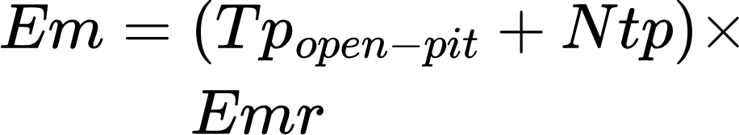  (variable) [unitless] | GHG emissions are calculated by multiplying titled (open pit mines) and non-titled (Ntp) mining production by an emission rate per ton produced (Emr). The same method is applied to estimate particulate matter emissions and suspended solids discharges. In addition, an environmental management variable (between 0 and 1) is included, which reflects the reduction of impacts thanks to prevention and mitigation measures.
Resources consumption (water and energy) (Rc)  Variable [Mm3/year] o [GWh/year] | Water and energy consumption is estimated by multiplying total production (titled and non-titled) by a resource use factor per tonne produced (Ruf) for each mineral. These impacts and consumption are calculated only for the production stage.
Cyanide (Cy) (or mercury)  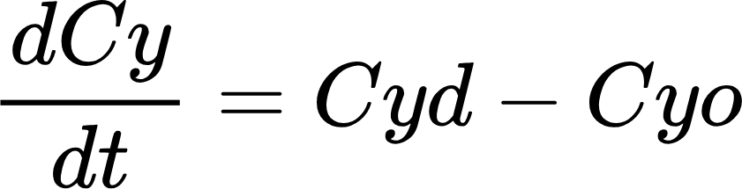  Level [µg/m3] | Gold’s mercury and cyanide dumpings are modeled after mineral processing. Both substances accumulate in water bodies and are naturally purified over time. They are represented as level variables, where dumpings (Cyd) are offset by natural purification (Cyo).
Cyanide Dumping (Cyd)  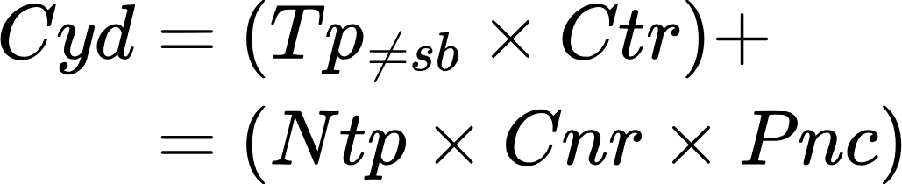  Flow [µg/m3/year] | It is estimated using differentiated rates for titled (Ctr) and non-titled (Cnr) production. For titled production (Tp), small, medium, and large-scale mining is included, excluding subsistence mining. For non-titled production (Ntp), a percentage using cyanide (Pnc) is considered.
Mercury Dumping (Med)  Flow [µg/m3/year] | Since the use of mercury is prohibited in Colombia (Congreso de Colombia, 2013), its impact is calculated only for non-titled gold production. A dumping rate (Mdr) is applied to a percentage of non-titled production (Pnm).
Territorial module
This module represents the number of hectares in the district assigned to different land uses. The levels correspond to categories such as mining areas, conservation areas, etc., while the flows allow the transition of hectares between these uses. These dynamics are connected to other modules through the variable Land Use Conflict, which assumes that the conflict generated by mining is inversely proportional to the mining vocation of the territory and is related to the soil degradation caused by this activity. Table 6 presents the principal equations that describe this module.
Table 6. Principal equations for modelling territorial module.

Variable | Comments
Total area (At)  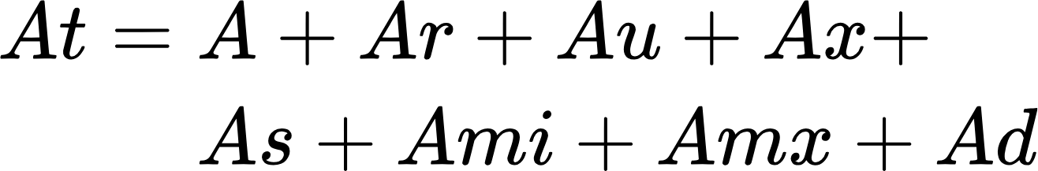  Variable [ha] | The total area of ​​the mining district (At) includes: Area available for economic activities (A), Restored area (Ar), Urban area (Au), Excludable area (Ax), Restricted subtracted area (As), Mining exploitation area for included minerals (Ami) and excluded minerals (Amx), Degraded area (Ad).
Available area (A)  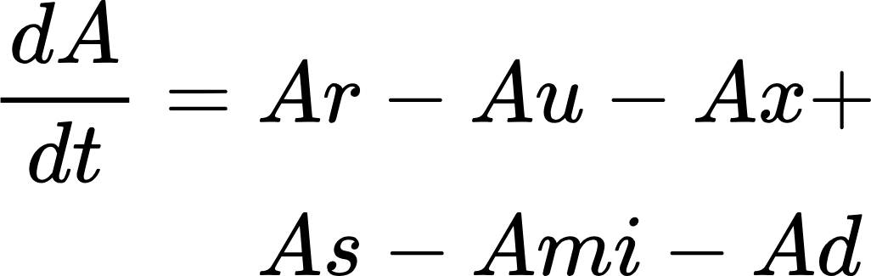  Level [ha] | The area available for economic activities (including mining) (A) is the difference among the total area and the areas already allocated (titled, excludable, restricted and populated centers).
Mining exploitation area (Ami)  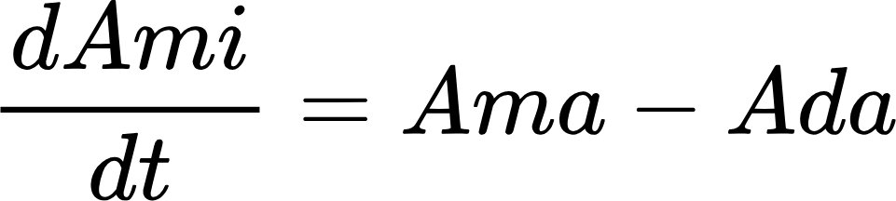  Level [ha] | The available area decreases as the mining title increases, driven by the Added Mining Production Area Flow (Ama). This flow depends on the development rate (mining cycle), which indicates the annual amount of mineral entering the reserves under development and the average area needed to exploit a unit of mineral. Mining generates environmental impacts, such as damage to the landscape and new degraded areas (Ada).
Degraded area (Ad)  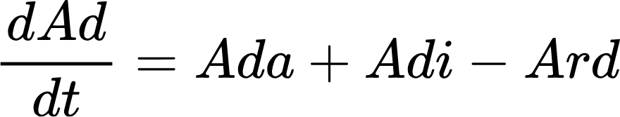  Level [ha] | The degraded area increases due to formal mining (Ada) and non-titled exploitation by informal actors (Adi). It decreases thanks to the restoration of degraded areas (Ard).
Restored Area (Ar)  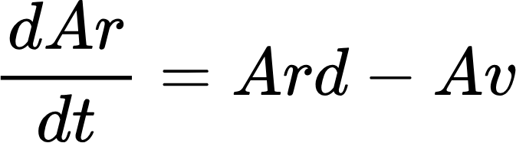  Level [ha] | The flow New Restored Areas (Ard) reduces the degraded area according to an annual percentage, which varies according to the restoration programs evaluated. The restored areas are again available for other economic activities (Av).

