Behavioral Change Modeling in Infectious Diseases: A Review of Reviews

Abstract
Modeling the spread of an infectious disease is highly complex. Drawing the boundaries of the model and what to consider endogenously can be confusing; an element to consider is behavior. The intertwined relationship between human behavior and disease is necessary to capture the mechanics of infection. Our behavior affects the unfolding of a pandemic; In the same sense, the course of an outbreak drives sociological behavior changes in our daily lives. While most successful modelers acknowledge this feedback loop, only a few represent it accordingly. Due to the interdisciplinary nature of the issue, there are vast differences in approaches and ways of incorporating behavior. To bring these ideas together, we conducted a review of review articles analyzing 14 papers for the final synthesis. By doing so, we discuss the challenges of capturing dynamics of behavior in infectious disease models and argue how a more holistic view of these approaches can be beneficial. Finally, we introduce two new classifications based on interrelationships of behavior within itself and how they interact with the disease. These classifications help us move past the limitations of previous classes and see the behavioral feedback loop differently, which may be the key to several current global concerns.
Keywords: Human Behavior, Behavioral Modeling, COVID-19, Infectious diseases, Epidemiology, Review

Introduction
The ongoing outbreak of COVID-19 reminded us that the pictures of empty streets, wearing face masks, and quarantines are not only headlines on television screens and front pages, but they could also be a reality that alters how we live our lives. Similar to other global concerns, if not taken seriously and not studied thoroughly, these adverse changes may be irreversible. Many of these challenges society is facing today are not determined only by individuals’ actions, but by behaviors that are embedded in complex networks of their governing systems (Will et al., 2020).

Human actions are at the core of the onset of epidemics. Yet, it is not only how we act that affects the disease, but our behavior is also governed by the changes in the state of the disease. From the non-pharmaceutical interventions that may force us to stay at home to how we socially distance ourselves from individuals we perceive as high risk (Rahmandad et al., 2022b). The demand for integrating the interplay between behavior and the dynamic of infectious diseases is increasing, and scholars have been offering theoretical models in response to the heightened demand. (Bedson et al., 2021).

Earlier models mostly saw behavior as an exogenous factor, only considering how different actions lead to different outcomes in the course of an outbreak. Relatively little investigation has been done into how behavioral changes can affect disease dynamics. (Ferguson, 2007; Funk et al., 2010) Also, combining the models with ideas from other fields such as psychology and sociology have been slow as these concepts are still underappreciated in pandemic forecasting, given that very few models made explicit references to psychological health behavior change theories (Carlin et al., 2021; Weston et al., 2018). A continuous challenge for modelers have been the question of what data to gather and how to gather it, such that the link between behavior and disease can be validated (Funk et al., 2015). Lack of access to this quality data was a factor in the developed models to be more abstract and lack prediction power. A review on the subject noted that only 15% of the papers are based on empirical data, most models being ‘‘purely theoretical and lacking representative data and a validation process’’ (Verelst et al., 2016). COVID-19 gave us the perfect opportunity to gather detailed and insightful data around the globe. Yet even though we have had an increased amount in both high quality data and theories, we still lack a validated theory to describe the feedback loop Capturing the relationship between human behavior and infectious diseases. This is an ongoing key challenge in epidemiology (Perra, 2021).
In the following sections, we identify and analyze models that apply a behavioral approach to infectious disease transmission by reviewing previous review papers. We provide a background for these models and their assumptions, while explaining how they were categorized so far in the literature, constructing the understanding and framework to build on. We are then able to create and propose new categorizations, capturing new developments and distinguishing how assumptions, methods, disease and transmission-specific applications and implications have changed over time. Furthermore, we discuss how and why it is necessary to expand the previous classifications and what limitations we were able to remove. In addition, possible pitfalls and opportunities are identified to support the development of more advanced behavioral feedback loop modeling.

Method
A scoping approach was adopted for this study. Although the research does not cover all the material exhaustively as a systematic literature review would, the procedure is still algorithmic and replicable ensuring that the findings are genuine.

We searched PubMed and Web of Science (WoS) for records published any time prior to the beginning of the study: 23 November 2022. After discussing and defining the inclusion and exclusion criteria, we obtained our search query which we used in PubMed and WoS: (behavio* OR decision*) AND (infect* OR epidemi* OR pandemi* OR outbreak) AND model* AND review.

Filtering for review articles only, we would still have a large pool of results. Thus, we decided to screen the results in order of citations. First, the top 200 results of the search query were screened based on title and abstract in accordance with the following pre-specified eligibility criteria:

- Type of article: Reviews (systematic, scoping and narrative) and meta-analysis.
- Infectious diseases: Only records considering infectious diseases are included in the selection. Infectious diseases are defined using the World Health Organization definition. (WHO, 2016)
- Model: Records should consist of a mathematical model for a coupled model combining behavioral change and infectious disease transmission.
- Humans: We are only interested in the infectious disease dynamics in humans; therefore, we eliminated the results that were otherwise
- English language: Excluding articles written in other languages.
After the elimination process was done based on our criteria, the remaining articles’ full texts were screened to confirm eligibility, independently. Furthermore, we used forward and backward citation searching based on the most known and cited review articles, to make sure we follow the progression of the research correctly. Adding everything together, a total of 14 articles were fully analyzed and considered in this paper.

Background
The intent to model infectious diseases is not something reserved for recent years. Since the early stages of human civilization, we have been battling with pandemics and ways to limit their damage. The understanding of the role of how human interaction in the spread of the disease is evident in history based on early measures taken e.g., quarantining. The first mathematical models were, however, introduced after the deadly 1918 influenza pandemic where more than 50 million lives were lost. A simple and one of the earliest models developed is the SIR (susceptible–infected–recovered) model (Kermack & McKendrick, 1927) which is the basis of almost all the disease models developed since. In the SIR model, the population is divided into three compartments, where susceptibles (S) can be infected by those already infected (I) and subsequently recover (R), at which point they gain immunity or are otherwise removed from the population. A simple representation of the model is shown in figure 1.
In the simplest SIR model, the flows between these compartments are all assumed to have a rate that is proportional to the number of individuals in those compartments, also constant rates of infection and recovery. In this simple case, the dynamics of the system can be described by the following set of ordinary differential equations (Anderson & May, 1991).
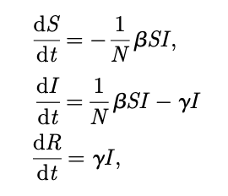
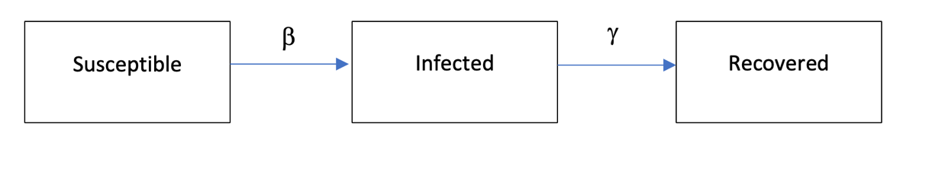
Figure 1. Representation of the SIR compartmental model with infection rate β and recovery rate γ

Where N is considered as a constant and is the addition of individuals in each compartment.
This is one of the earliest implementations of a system dynamics approach in modeling infectious diseases. A more sophisticated version of this model, adds another stock to the chain that differentiates exposed from infected, further reflecting the dynamics of infectious disease as there is a delay for an exposed individual to become infectious and infect others (Li & Muldowney, 1995). Even though this model may provide insight into how the infection unfolds, it is still very limited as due to its structural formulation, it only produces a single wave of infection. In other words, it fails to capture the multiple wave nature of most pandemics. this important missing structure can be the behavioral feedback loop (Rahmandad et al., 2022a).
As mentioned before, in the course of a pandemic regardless of non-pharmaceutical interventions, a significant proportion of the population react by adapting their behavior and taking preventive measures such as social distancing or reducing contact with risky individuals (Jones & Salathé, 2009; Rubin et al., 2009). Moving forward, we refer to models incorporating this behavioral adaptation as ‘behavioral change models’ (BCMs) (Verelst et al., 2016), which enables models for disease transmission to replicate real life dynamics. The use of this term is suggested by another review paper to create a common term in literature for the coupled behavior and disease relationship. To elaborate, a BCM is a model in which behavior is considered to change as a response to external information regarding the disease, with adaptation to take more preventive measures to reduce the chance of contracting the disease. This information can be global (equally available and relevant to all individuals) or local (individual availability with relevance determined by physical or social proximity to the information source). Also, this information can be specified in terms of actual risks derived from the progression of the disease (‘prevalence-based’) or based on perceptions of these risks (‘belief-based’), as well as a mixture of all the above (Funk et al., 2010; Verelst et al., 2016).
It is a fact that the way we receive information is important and plays a role in our final behavior, yet how the model considers the processing of information is also as important. Two individuals may receive the same information yet make completely different decisions and display vast differences in their behavior. Differential equation models, for instance, focus on the population rather than the individual, considering homogeneity among the population; however, there are times where modeling individuals separately might provide another perspective and set of insights. A prime example of such modeling approach is agent-based modeling (ABM) that introduces more heterogeneity. The challenge here is to find a balance between model complexity and computational boundaries, as more rules are set for individuals in ABM, the more complex the model becomes (Fenichel et al., 2011; Rahmandad & Sterman, 2008; Willem et al., 2017).
Furthermore, the structure in which information is transferred is also a determining factor. The networks in which humans interact, whether being nodes of neighboring contacts, news from mass media, or the online social group can shape the way a model approaches incorporating behavior (Wang et al., 2015). Technically, these networks can be considered in three subgroups: individual level, population level, and meta-population level. In individual levels, diffusion of information is considered to be person to person, unlike in population level that people are considered to be homogeneous and have similar reactions. In meta-population studies, sub groups of a population are studied, each sub group having homogenous characteristic but the groups compared to one another show different settings (Verelst et al., 2016).
Another popular approach is game theory, where individuals are considered to be rational players trying to maximize their utility through described by their utility function. In earlier models incorporated in infectious diseases, the basis of the idea was personal utility maximization regardless of other players; however, we have seen that players are not always ‘rational’ as the term defines. This means actions that are not selfish, either based on altruistic goals or imitation and peer pressure. More recent game theory models have been developed to capture this (Chang et al., 2020).
This background lays the ground for further analysis in the next section, where we synthesis these approaches and compare them with the perspective provided by our new classifications.

Results
We present our results in two separate classifications. The idea for a new classification is to bring more clarity. As the past approaches that have been used to tackle the interaction of behavior and infectious disease are vast and numerous, a good way to summarize and synthesis the works is through classification. Therefore, we tried to provide an understandable framework where one can gain insight form differences in modeling approaches.

Component-based classification

The first classification is based on components of behavior. Many times, behavior has been used without discussing its boundaries and what is meant by it. furthermore, within the formation of behavior, there are multiple components at play that affect each other; therefore, differentiating these components helps us see the process of behavior systematically, understand it better, and then analyze its relationship with the disease with more clarity.
    - Risk perception

Risk perception is the basis of behavior formation. It is the first step of processing information and is responsible for triggering the fight or flight response in the human brain. It should be noted that the perception of information may be different from what the actual reality is. For instance, one might assume the existence of a threat where in reality there is none. Risk perception is directly connected with the way information is received. In the case of infectious diseases, the framework proposed by another review (Funk et al., 2010) is highly influential. Considering the spread of information based on the prevalence of the disease, the modeler can determine the perception of risk based on the number of deaths or cases; however, if the perception is through personal beliefs that do not correlate with how the outbreak is unfolding, the modeler needs to utilize other approaches such as contact structure analysis to determine the risk perception according to the spread of information through the neighboring nodes of the individual belief group. Another factor to consider in analyzing risk perception is the psychological aspects of human decision making. In the book thinking fast and slow (Kahneman, 2011) the author describes how emotional factors affect our behavior and decisions. The inability to grasp exponential growth, psychic numbing where the same number of deaths that used to be horrific become a norm, and reliance on emotional news rather than rational are examples of how psychological factors can play a huge role in how we perceive the risk in epidemiology.

    - Adherence fatigue

Many studies consider the information link and its effects statically, capturing the state of the disease in a single moment and analyzing behavior according to that time only. Yet, as the disease is changing over time, so is behavior. Over time, the measures taken either individually or as a policy to limit the spread of the pandemic change the quality of life and create discomfort, whether through economic challenges or personal utility. All this contributes to building up fatigue in public. This fatigue later influences other behavior such as compliance with preventative measures, contact reduction, and willingness to vaccinate. These are all factors that we consider next.

    - Compliance with preventative measures

As explained before, by viewing the problem dynamically, we would be able to incorporate preventative measures endogenously. Once a measure has been taken, it does not guarantee that it would be effective over time the same way as it has been on the first day. The two previously mentioned behavior components, namely risk perception and adherence fatigue, directly influence how individuals are willing to comply with these measures. How strictly the government sets these measures is also an important factor to consider.

    - Mobility

Mobility is an alternate term for measuring the number of contacts. The reason we have selected the name mobility as representative of this behavioral component is because of the massive access to new mobility data during COVID-19 pandemic and modern technological infrastructure to capture this data accurately.

We adjust our contacts based on our perception of overall risk and how risky a specific interaction can be. These decisions have been studied mostly in the field of contact structures where individuals are modeled through game theory models. Based on this approach, individuals outweigh the benefits of keeping their contacts versus the risk of getting infected. Agent based modeling approaches and models based on the physics of contacts have been used as well (Wang et al., 2015).

Mobility can also be determined based on risk perception and fatigue. people reduce their contacts if they perceive more risk; Yet, over time, mobility patterns are subject to change due to fatigue.

    - Willingness to vaccinate
The final component that is equally important in studying infectious diseases is the willingness to vaccinate. Vaccination is used in various modeling approaches as a determining factor for controlling the spread of the disease. From compartmental models where a vaccinated individual moves out of the susceptible group, to information diffusion models where trust in government is the deciding factor for an individual to vaccinate or not. In general, several game theoretical approaches along with agent based modeling approaches have been used to design a ‘vaccine game’ where individuals vaccinate according to their utility. This utility can be consisted of multiple factors. How an individual sees the risks, the level of trust in government and its proposed measures, and number of rounds of vaccinations are some ideas.

Modeling approach classification

How is the transfer from information to behavior modeled? How then this behavior affects the disease? We have discussed the importance of information in forming behaviors, yet the question of how models manage this link is remaining. A previous classification (Funk et al., 2010) offers a classification based on the where effect of behavioral change is seen:
1) changes in disease state of individuals (e.g., form susceptible to immune by vaccination)
2) changes in model parameters (e.g., changes in infection rate because of social distancing)
3) changes in contact structure (e.g., removing a contact because of risk perception)
This classification is correct; however, it does not convey much insight. Another approach (Verelst et al., 2016) classifies the decision-making process of individuals and how they translate information into behavior. We believe this approach to be more insightful; thus, our classification builds on this previous framework, while also modifying parts of it when necessary.
Traditionally, behavior formation models used a game theoretical approach in which individuals had perfect information on disease related data and prevention effectiveness. Individuals were then assumed to use this information rationally to maximize their utility by comparing the expected costs of infection with the expected costs of the prevention measure. However, more advanced models have been developed since with more sophisticated translation links of information, behavior and disease. We identified three main categories for characterizing the decision-making process of individuals.

Exogenous
There are several studies where there is no two-way interaction between forming behavior and the disease transmission model. These models are relatively less common and most often focus on short-term policy implementations and how behavior affects disease transmission in that time period.
We can provide two examples in which this way of modeling is applied. The first case (Brauer, 2011) assessed disease model implications of a constant fractional reduction in the number of contacts. Another example (Joshi et al., 2015) uses a time-dependent education function that moves susceptible individuals into lower susceptibility classes with lower transmission rates, independent of disease dynamics.
These models would not be able to capture the dynamical feedback loop of behavior and the disease; Thus, we move on to the next category which considers this relationship endogenously.

Endogenous
We identified four different modeling approaches where information is seen within the loop of behavior and disease.
      - Information threshold
There are some studies in which behavior change is modeled according to a predefined switch in information. If, for instance, the number of cases surpasses a certain amount then a certain behavior will be formed, e.g., social distancing (Xiao et al., 2012)
These models do not explain how behavior is rationally concluded by relevant sets of information. Instead, behavior formation is based on a predefined threshold function. Due to the lack of clarity on how these functions are set, the resulting models would be less credible. A better approach would be to see the changes in behavior based on information dynamically, instead of a fixed value. This is what we consider in the next category.
      - Direct disease information as a dynamic parameter
Instead of a threshold, information here is seen as a continuous input in the decision-making process of individuals. The decision then drives the dynamics of the disease which then creates a new set of information.
A great example of capturing this feedback loop is the development of SEIRb model (Rahmandad et al., 2022a). In figure 2, we can see the stock flow diagram of this model. Technically, the SEIRb model uses the SEIR framework and adds a behavioral response balancing loop to it. In this view, Individuals continuously assess and change their risk perception, according to a delayed information from how fatal the disease currently is. If they perceive a higher risk, they reduce their contact rate which then reduces the infection rate and then subsequently the growth of the disease. However, this positive impact on limiting the disease in turn reduces the perception of risk in public. Prevention measures would then gradually relax leading to higher mobility and then higher infections. This creates the waves we see in infectious diseases such as COVID-19, whereas simpler compartmental models mostly only capture a single wave. In terms of spread of information, this category only captures information that is processed just by looking at how the disease is unfolding. In the next category, other information types are discussed.

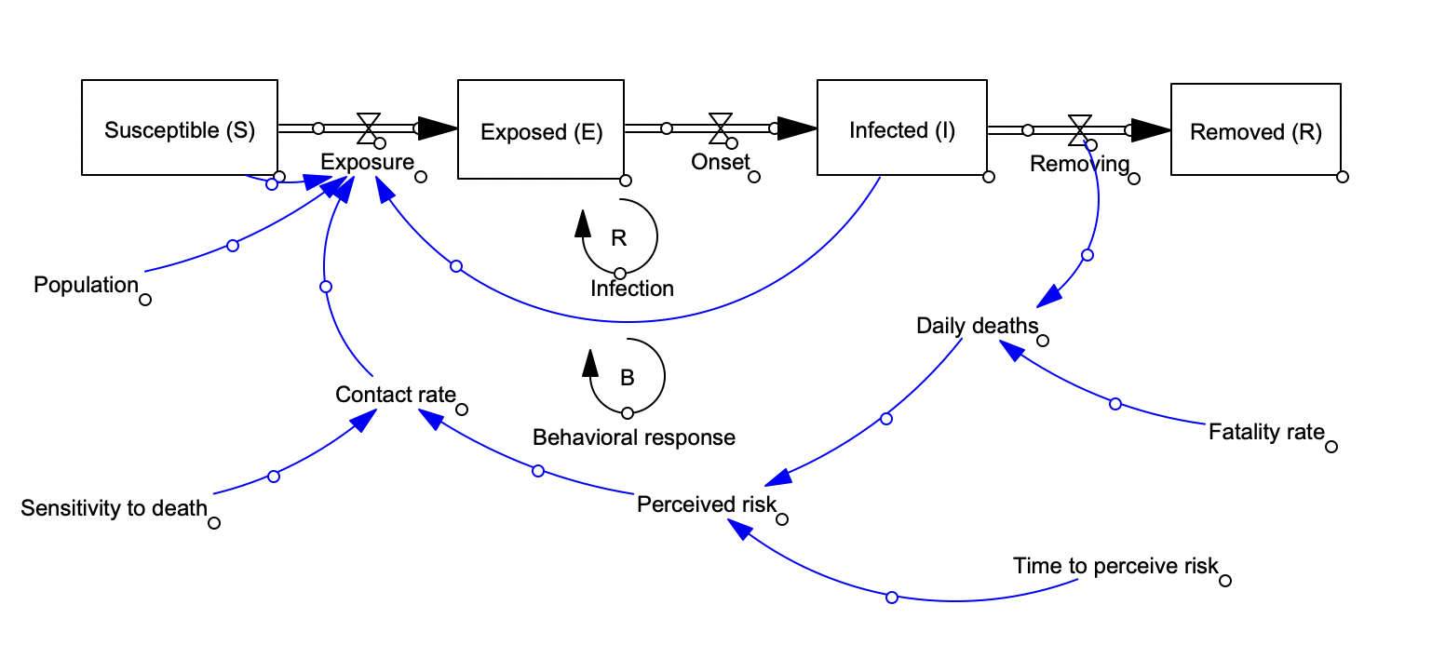
Figure 2. A simple representation of the SEIRb Model

      - Indirect disease information as a dynamic parameter
These models incorporate the behavioral changes that occur through information diffusion that may not be directly linked to the disease itself. To elaborate, these are decisions one makes based on a certain belief that may not correlate to how the disease is unfolding. Imagine a scenario where the risk of the disease is no longer existent, yet individuals continue using face masks due to a new belief in their risk perception that no longer correlates to the actual risk of the disease. Another example would be the case of fatigue; Although the number of cases and deaths is rising over a certain period, we may see individuals no longer adhering to preventative measures that should limit the disease. A great approach (Epstein et al., 2008) is to see the spread of information similar to the spread of the disease. The authors use an agent based modeling approach to see how fear, perhaps through misinformation (Wang et al., 2019), changes dynamically and affects our behavior and subsequently the onset of a pandemic. An example of this approach would be the fear of vaccination. This is a case of a belief-based information that does not correlate with the progression of disease. As misinformation spreads fear throughout the public, more people change their perception of risk of vaccination. This fear then spreads through friends or social media, further expanding the idea of risk. As this risk perception grows, fewer people vaccinate leading to higher infection rates, and therefore the disease continues to grow. This approach can also be applied through a system dynamics point of view, where information itself is modeled as an infectious disease, with compartments such as unaware, aware, or misinformed.
      - Individual Based Modeling (IBM)
These models are based on an economic objective function that each individual is trying to maximize, either through maximizing benefits or minimizing costs. In the sense of infectious diseases and how the link is seen with behavioral change, most models in this category assume the individual to adjust their preventative measures based on their objective function.
Models that introduce more heterogeneity and a focus on individuals and their rule assumptions use agent based modeling approaches.
In modeling meta populations, there can be game theory approaches for a certain class and how their objective function is affecting their behavior. The way models capture the behavioral changes over time is mostly based on the variation in risk perception of individuals. For instance, perceived probability of infection or perceived cost of infection are factors that can be influenced by information, both through the spread of the disease or the spread of belief-based information. Most of these models then go on to make a trade of zero or one decision making process, where if the risks outweigh the benefits, the individual will take the preventative action and if it doesn’t, no action is taken. More recently, these models are incorporating social factors that also affect the decision-making process. The idea that people compare their own prevention-related behavior with that of other individuals in society, and change their rule settings accordingly, outside their personal belief system and adapt to a new one, is driving new research in this category. (Chang et al., 2020)

Mixed
Changes in behavior and its coupled relationship with the disease involve numerous factors. The more components are seen endogenously the more complex the model becomes. Keeping the model simpler while providing new insight should be the goal. By drawing the boundaries of the model properly, the behavioral impact on disease can be seen endogenously, while some factors affecting this relationship are seen exogenously. This way these effects are captured without extra complications.
An example of this approach builds on the basic SERIb model where the disease behavioral change is considered endogenously, while adding the impact of weather on transmission intensity exogenously. (Rahmandad et al., 2022a; Xu et al., 2021)
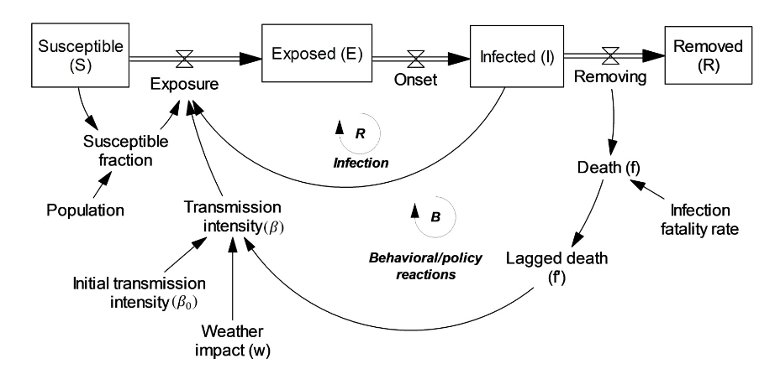
Figure 3. SEIRb model with the addition of weather impact as an exogenous factor

Discussion

Classifications and categorizations provided by previous review papers were highly influential in clarifying the bigger picture of approaches and guiding future research by indicating areas that may require extra work. However, there are certain limitations in these frameworks. Also, since the COVID-19 pandemic, much work has been added to the body of research, creating new ideas and approaches that may no longer fit in previous frameworks. Here, we discuss these limitations and argue why a new framework is needed and why we think our proposed classification can be a step forward in that desired direction.

Seeing behavior as set of actions in response to the changes in perceived information would not fully capture the way we make decisions. Usually, this perspective misses the interrelationships within components of behavior and considers different ‘reactions’ as behavior. Our first framework, the component-based classification, illustrates how segregating behavior into components, enables us to have systematic view and understanding of behavior formation. Through this framework, we can also capture governmental policies or non-pharmaceutical interventions in a more endogenous sense. Most previous frameworks, only focused on not imposed behavioral changes, disregarding the government induced effects on behavior. This limits our scope and understanding of policy decision making processes and its effects on the disease, which all are vital parts in the progression of a pandemic in today’s age. We argue that policy decisions can be indirectly captured if we consider them to be affected by the same mechanisms that governs individual decision making. In more detail, this process can be analyzed by seeing the links between risk perception, adherence fatigue, and compliance with preventative measures.

Economic assumptions and individual rule settings have not been able to successfully capture the dynamics of behavioral change based on actual data. The assumptions of rational decision-making and access to perfect information are not validated through real-world dynamics of the disease. The decision-making process for individuals itself is dynamic and an individual may have different behavioral responses to the same set of information at two different times. That is why it is suggested that mathematical models expand their assumptions regarding psychological aspects of decision-making.

Although we have seen an increase in models that validate their models based on real-world incidents thanks to the immense growth in the availability of high-quality data, the percentage of models that are conceptual and not validated still are in the majority. Areas in behavioral components, such as mobility, can benefit from the recent pandemic data with the goal of expanding the work that has been done with a focus on interrelationships of components rather than behavior in general. The COVID-19 pandemic provided a great opportunity for researchers to test their models and validate and calibrate them. Models are getting better in terms of their appliance to real-world data; however, we saw that only a few models were able to provide an acceptable long-term prediction of the disease. The fact that these successful models considered the interrelationship of behavior and disease is a testament to the necessity of incorporating behavioral change endogenously. One promising model is the SEIRb model which captures the behavioral feedback loop through implementing disease information in risk perception. However, we know that risk perception is not only a function of the disease as we sometimes observe paradoxical behaviors where disease is growing yet preventative measures are relaxed. These factors can be better analyzed by combining this model with the information diffusion model, where we see the spread of the information itself is endogenously captured, within a system dynamics model.

Having this feedback loop validated not only helps with better management of possible future epidemics, but also helps us in tackling other global concerns that are threatening the vision of an equitable and sustainable future for both people and ecosystems. As we realize how our behaviors are formed and how they alter the course of the world’s future, we can start incorporating behavioral change models into other domains, approaching problems with a new behavioral perspective.

Conclusion
We noticed the growth in the body of literature on infectious diseases in response to the prevalence of the recent pandemic. Different models from different backgrounds, including mathematics, physics, epidemiology, psychology, etc., have been applied to predict the onset of COVID-19. Most successful models included behavioral change in the dynamics of the disease prevalence. To summarize and synthesize different modeling approaches in incorporating the two-way interaction of behavior and disease, we conducted a scoping review where we searched for review articles that browsed different modeling approaches in multiple fields. After rounds of screening and forward and backward citation searching, we analyzed 14 review papers for full-text review. Based on our findings, we provided a fundamental background for how infectious disease modeling approaches have evolved through the years. As our results, we introduced two new classifications based on the interconnected components within behavior and transfer of information into behavioral change in epidemiology. We then discussed why we think these new frameworks are necessary to catch up to most recent advances in research, as some limiting assumptions from past classifications are no longer viable. We also provided some recommendations regarding how future research can move forward on the path to a validated modeling of disease-behavior feedback loop. Full understanding of human behavior may be impossible; however, moving towards a holistic view of interconnections of behavior, information, and the world around us, can be the key to solving several puzzles in today’s global concerns, not just limited to epidemiology.

References
Anderson, R. M., & May, R. M. (1991). Infectious diseases of humans: dynamics and control. Oxford university press.
Bedson, J., Skrip, L. A., Pedi, D., Abramowitz, S., Carter, S., Jalloh, M. F., Funk, S., Gobat, N., Giles-Vernick, T., Chowell, G., De Almeida, J. R., Elessawi, R., Scarpino, S. V., Hammond, R. A., Briand, S., Epstein, J. M., Hébert-Dufresne, L., & Althouse, B. M. (2021). A review and agenda for integrated disease models including social and behavioural factors. Nature Human Behaviour, 5(7), 834-846. https://doi.org/10.1038/s41562-021-01136-2
Brauer, F. (2011). A simple model for behaviour change in epidemics. BMC Public Health, 11(S1). https://doi.org/10.1186/1471-2458-11-s1-s3
Carlin, E. P., Allen, K. C., Morgan, J. J., Chretien, J. P., Murray, S., Winslow, D., & Zimmerman, D. (2021). Behavioral Risk Modeling for Pandemics: Overcoming Challenges and Advancing the Science. Health Secur, 19(4), 447-453. https://doi.org/10.1089/hs.2020.0209
Chang, S. L., Piraveenan, M., Pattison, P., & Prokopenko, M. (2020). Game theoretic modelling of infectious disease dynamics and intervention methods: a review. Journal of Biological Dynamics, 14(1), 57-89. https://doi.org/10.1080/17513758.2020.1720322
Epstein, J. M., Parker, J., Cummings, D., & Hammond, R. A. (2008). Coupled Contagion Dynamics of Fear and Disease: Mathematical and Computational Explorations. Plos One, 3(12), e3955. https://doi.org/10.1371/journal.pone.0003955
Fenichel, E. P., Castillo-Chavez, C., Ceddia, M. G., Chowell, G., Parra, P. A. G., Hickling, G. J., Holloway, G., Horan, R., Morin, B., Perrings, C., Springborn, M., Velazquez, L., & Villalobos, C. (2011). Adaptive human behavior in epidemiological models. Proceedings of the National Academy of Sciences, 108(15), 6306-6311. https://doi.org/10.1073/pnas.1011250108
Ferguson, N. (2007). Capturing human behaviour. Nature, 446(7137), 733-733. https://doi.org/10.1038/446733a
Funk, S., Bansal, S., Bauch, C. T., Eames, K. T. D., Edmunds, W. J., Galvani, A. P., & Klepac, P. (2015). Nine challenges in incorporating the dynamics of behaviour in infectious diseases models. Epidemics, 10, 21-25. https://doi.org/https://doi.org/10.1016/j.epidem.2014.09.005
Funk, S., Salathé, M., & Jansen, V. A. A. (2010). Modelling the influence of human behaviour on the spread of infectious diseases: a review. Journal of The Royal Society Interface, 7(50), 1247-1256. https://doi.org/10.1098/rsif.2010.0142
Jones, J. H., & Salathé, M. (2009). Early Assessment of Anxiety and Behavioral Response to Novel Swine-Origin Influenza A(H1N1). Plos One, 4(12), e8032. https://doi.org/10.1371/journal.pone.0008032
Joshi, H. R., Lenhart, S., Hota, S., & Augusto, F. B. (2015). Optimal control of an SIR model with changing behavior through an education campaign.
Kahneman, D. (2011). Thinking, fast and slow. macmillan.
Kermack, W. O., & McKendrick, A. G. (1927). A contribution to the mathematical theory of epidemics. Proceedings of the Royal Society of London. Series A, Containing Papers of a Mathematical and Physical Character, 115(772), 700-721. https://doi.org/10.1098/rspa.1927.0118
Li, M. Y., & Muldowney, J. S. (1995). Global stability for the SEIR model in epidemiology. Mathematical biosciences, 125(2), 155-164.
Perra, N. (2021). Non-pharmaceutical interventions during the COVID-19 pandemic: A review. Phys Rep, 913, 1-52. https://doi.org/10.1016/j.physrep.2021.02.001
Rahmandad, H., & Sterman, J. (2008). Heterogeneity and Network Structure in the Dynamics of Diffusion: Comparing Agent-Based and Differential Equation Models. Management Science, 54(5), 998-1014. https://doi.org/10.1287/mnsc.1070.0787
Rahmandad, H., Xu, R., & Ghaffarzadegan, N. (2022a). Enhancing long-term forecasting: Learning from COVID-19 models. PLoS Comput Biol, 18(5), e1010100. https://doi.org/10.1371/journal.pcbi.1010100
Rahmandad, H., Xu, R., & Ghaffarzadegan, N. (2022b). A missing behavioural feedback in COVID-19 models is the key to several puzzles. BMJ Glob Health, 7(10). https://doi.org/10.1136/bmjgh-2022-010463
Rubin, G. J., Amlot, R., Page, L., & Wessely, S. (2009). Public perceptions, anxiety, and behaviour change in relation to the swine flu outbreak: cross sectional telephone survey. BMJ, 339(jul02 3), b2651-b2651. https://doi.org/10.1136/bmj.b2651
Verelst, F., Willem, L., & Beutels, P. (2016). Behavioural change models for infectious disease transmission: a systematic review (2010–2015). Journal of The Royal Society Interface, 13(125), 20160820. https://doi.org/10.1098/rsif.2016.0820
Wang, Y., McKee, M., Torbica, A., & Stuckler, D. (2019). Systematic Literature Review on the Spread of Health-related Misinformation on Social Media. Social Science & Medicine, 240, 112552. https://doi.org/https://doi.org/10.1016/j.socscimed.2019.112552
Wang, Z., Andrews, M. A., Wu, Z.-X., Wang, L., & Bauch, C. T. (2015). Coupled disease–behavior dynamics on complex networks: A review. Physics of Life Reviews, 15, 1-29. https://doi.org/https://doi.org/10.1016/j.plrev.2015.07.006
Weston, D., Hauck, K., & Amlôt, R. (2018). Infection prevention behaviour and infectious disease modelling: a review of the literature and recommendations for the future. BMC Public Health, 18(1). https://doi.org/10.1186/s12889-018-5223-1
WHO. (2016). World Health Organization, Infectious diseases. . http://www. who.int/topics/infectious_diseases/en/.

Will, M., Groeneveld, J., Frank, K., & Müller, B. (2020). Combining social network analysis and agent-based modelling to explore dynamics of human interaction: A review. Socio-Environmental Systems Modelling, 2, 16325. https://doi.org/10.18174/sesmo.2020a16325
Willem, L., Verelst, F., Bilcke, J., Hens, N., & Beutels, P. (2017). Lessons from a decade of individual-based models for infectious disease transmission: a systematic review (2006-2015). BMC Infectious Diseases, 17(1). https://doi.org/10.1186/s12879-017-2699-8
Xiao, Y., Xu, X., & Tang, S. (2012). Sliding Mode Control of Outbreaks of Emerging Infectious Diseases. Bulletin of Mathematical Biology, 74(10), 2403-2422. https://doi.org/10.1007/s11538-012-9758-5
Xu, R., Rahmandad, H., Gupta, M., DiGennaro, C., Ghaffarzadegan, N., Amini, H., & Jalali, M. S. (2021). Weather, air pollution, and SARS-CoV-2 transmission: a global analysis. The Lancet Planetary Health, 5(10), e671-e680.

