Supporting Document for: An integrated supply chain analysis for cobalt and rare earth elements under global electrification and constrained resources
Authors: Michael H. Severson^{a*}, Ruby T. Nguyenª, John Ormerod^{b}, Sophie Williams^{c}
a: Critical Materials Institute, Idaho National Laboratory, Idaho Falls, ID 83415, USA
b: Critical Materials Institute, John Ormerod Consulting, Loudon, TN 37774, USA
c: University of Florida, Gainesville, FL 32611, USA
*: Corresponding author – Michael.Severson@inl.gov

- Additional information on the Methodology
  - Magnet Substitution Mechanism
The methodology operated by first calculating the MPR utilizing maximum energy product and density of the two magnets (Equation S1). The rationale of this methodology can be explained by unit conversion mathematics where (BH)_{max} and density are used to compute an output of energy per unit mass. Then, dividing both magnet’s energy per unit mass creates a ratio of performance between the two magnets. The equation used to derive MPR can be seen in Equation S1 - Equation S4). By using simple algebra, it is possible to yield an equation that solves for energy in the air gap based on volume of the magnet and magnetic flux density and magnetic field of the magnet. This creates a system that allows volume of a magnet to be changed to match the energy in the air gap o f another magnet. Next, by setting the energy equal to both sides (meaning equal energy stored in airgap), it’s possible to cancel the non-changing constant ($8π)$. This creates a system that allows volume of a magnet to be changed to match the energy in the air gap of another magnet.
$$Magnet Performance Ratio \left(MPR\right)= \frac{{{(BH)}_{max}Magnet}_{1} / {Density Magnet}_{1}}{({{BH)}_{max} Magnet}_{2} / {Density Magnet}_{2}}$$ | Equation S1
$$Magnet Cost Ratio=\frac{Cost {Magnet}_{1}*MPR}{Cost {Magnet}_{2}}$$ | Equation S2
$$E_{g}=\frac{ {H_{g}^{ 2}*V}_{g}}{8π}$$  Where:  $$E_{g}=Energy stored in air gap, joule$$  $V_{g}=Volume of air gap, {meter}^{3}$  $$H_{g}^{ }=Magnetic field of the air gap, \sqrt{\frac{joule}{{meter}^{3}}}$$ | Equation S3 (Cullity and Graham 2008)
$$H_{g}^{ 2}=\frac{B_{m}H_{m}V_{m}}{V_{g}}$$  Where:  $B_{m}=Magnetic flux density$, $\frac{kg}{{second}^{2}*ampere}$  $H_{m}=Magnetic field strength$, $\frac{ampere}{meter}$  $$V_{m}=Volume of magnet, {meter}^{3}$$  $V_{g}=Volume$ of air gap, ${meter}^{3}$ | Equation S4 (Cullity and Graham 2008)

Next, the magnetic cost ratio (Equation S2) was input into an assumed substitution curve that output a substitution percentage based on the cost ratio (Figure S1). An S-shaped curve was assumed based on principles associated with s-shaped growth (Bass 1969, Hula, Alson et al. 2014, Adner and Kapoor 2016). This is due to the lack of desire to substitute or change components when the cost comparison is marginally different. However, eventually increased substitution occurs due to the clear cost benefits. Finally, substitution slows at a certain point due to legacy component features or an asymptotic demand to substitute. Additionally, following the year of magnet deployment, an adoption curve over time in the form of an S-shaped curve (Figure S2) was implemented that again provided a dimensionless substitution ratio to be implemented into the substitution mechanism (Bass 1969, He, Wang et al. 2014, Hula, Alson et al. 2014). Lastly, the formula to describe the final output of magnet substitution can be seen in the supporting document by Equation S5.

$$CSR=SRBCR\left(Cost ratio\right)*TAR\left(Time\right)*MPR$$  Where:  $$CSR=Cumulative subsitution ratio, dmnl$$  $$SRBCR=Subsitution ratio as a function of dynamic cost ratio, dmnl$$  $$TAR=Time adoption ratio as a function of time, dmnl$$  $$MPR=Mass performance ratio, dmn$$ | Equation S5
  - REO and Cobalt Primary Production Modules
There were several differences between the cobalt and REO modules. First, the countries that were analyzed in each commodity’s module differed. The cobalt module focused on the Democratic Republic of the Congo (DRC) and the rest of the world (ROW) for mining and the DRC, ROW, and China for refining. The REO module focused on China and ROW for mining and China for refining. Additionally, the cobalt module did not incorporate the co-production of copper or nickel in its module explicitly as shown in our previous work. For simplicity, ROW mining capacity growth was constrained by an assumed nickel demand growth of 3% for the years 2005 to 2020 and a literature obtained rate of 5% for the years 2021 to 2050 (Group Research 2020). The DRC mining capacity growth was constrained by a copper growth rate value of 3.2% (S&P Global Market Intelligence 2020). Second, the REO module required implementation of the China production quota system set by the Ministry of Land and Resources (MLR)/Ministry of Industry and Information (MIIT). Production quotas for both mining and refining REO production limit the potential production in China. Historical quotas were used for the years prior to 2021, and a growth rate of 3% is utilized following 2021. When reserves of a particular mining company in China were depleted, that company’s quota was eliminated, and the ore composition of China was adjusted. Third, the REO module also accounted for illegal production of REOs in China. Historical illegal REO production data was utilized to until 2019, and following 2019, illegal production was reduced by a rate of 3% using 2019’s value as the initial value. A complete list of cobalt and REO reserves can be found in Table S1 and Table S2. A complete list of REO ore compositions varying by deposit and country can be found in Table S3 - Table S11.
Table S1: Cobalt reserves in the year 2021 broken down by country
Country | Cobalt Reserves 2021 (mt)
United States | 69,000
Australia | 1,400,000
Canada | 220,000
China | 80,000
Cuba | 500,000
Democratic Republic of the Congo (DRC) | 3,500,000
Indonesia | 600,000
Madagascar | 100,000
Morocco | 13,000
Papua New Guinea | 47,000
Philippines | 260,000
Russia | 250,000
Other Countries | 610,000

Table S2: REO reserves in the year 2021 and 2017 (China) broken down by country
Country | REO Reserves 2021 (mt) (USGS 2022); China REO Reserves 2017 (mt)
United States | 1,800,000
Australia | 4,000,000
Canada | 21,000,000
China | 63,800,000 (Roskill 2018)
Madagascar | 1,000,000
Russia | 1,000,000
Other Countries | 830,000
Burma | 1,500,000
India | 6,900,000
Thailand | 1,000,000
Brazil | 21,000,000
Vietnam | 22,000,000
Burundi | 1,000,000
South Africa | 790,000

Table S3: Bastnasite ore REO compositions; Lanthanum was adjusted to yield a sum of 100% (Zheng and Greedan 2003)
Bastnasite Ore Composition
Element | California (%) | China (%) | Average (%)
Y | 0.10% | 0.30% | 0.20%
La | 32.17% | 28.20% | 30.19%
Ce | 49.00% | 50.00% | 49.50%
Pr | 4.40% | 5.00% | 4.70%
Nd | 13.50% | 15.00% | 14.25%
Sm | 0.50% | 1.10% | 0.80%
Gd | 0.30% | 0.40% | 0.35%
Dy | 0.03% | 0.00% | 0.02%

Table S4: Various monazite deposit REO compositions and the average of all of the deposits; Lanthanum was adjusted to yield a sum of 100% (Kumari, Panda et al. 2015)
Monazite Ore Composition
Element | North Capel, West Australia (%) | North Stradbroke Island, Queensland, Australia (%) | Green cove Springs, USA (%) | Nangang, Guangdong, China (%) | East coast, Brazil (%) | Mount Weld, Australia (%) | Average (%)
Y | 2% | 3% | 3% | 2% | 1% | 0% | 2%
La | 24% | 22% | 18% | 28% | 24% | 27% | 24%
Ce | 46% | 46% | 44% | 43% | 47% | 51% | 46%
Pr | 5% | 5% | 5% | 4% | 5% | 4% | 5%
Nd | 17% | 19% | 18% | 17% | 19% | 15% | 17%
Sm | 3% | 3% | 5% | 3% | 3% | 2% | 3%
Gd | 1% | 2% | 7% | 2% | 1% | 1% | 2%
Dy | 1% | 1% | 1% | 1% | 0% | 0% | 1%

Table S5: Average ionic clay REO composition scaled to one used in the model (Moldoveanu and Papangelakis 2016)
Element | Scaled Average Ionic Clay Composition (%)
Y | 20.33%
La | 30.22%
Ce | 13.44%
Pr | 5.78%
Nd | 19.22%
Sm | 4.00%
Gd | 3.56%
Dy | 3.44%

Table S6: Average loparite REO composition scaled to one used in the model (Hedrick, Sinha et al. 1997)
Element | Scaled Average Loparite Composition (%)
Y | 1.32%
La | 25.33%
Ce | 51.17%
Pr | 5.07%
Nd | 15.20%
Sm | 0.71%
Gd | 0.61%
Dy | 0.61%

Table S7: Average xenotime composition scaled to 1 for desired REE (Zhang, Jia et al. 2015)
Element | Scaled average xenotime composition (%)
Y | 70.80%
La | 1.47%
Ce | 3.56%
Pr | 0.74%
Nd | 4.17%
Sm | 2.45%
Gd | 6.01%
Dy | 10.80%

Table S8: REO composition of Ilimaussaq complex in Greenland; Scaled to 100% (Kogarko and Nielsen 2021)
Element | Scaled composition (%)
Y | 21.89%
La | 19.74%
Ce | 27.04%
Pr | 3.86%
Nd | 16.31%
Sm | 3.43%
Gd | 3.43%
Dy | 4.29%

Table S9: REO composition of Mountain Pass deposit in the United States; Scaled to 100% (Hykawy, Thomas et al. 2010, Long, Gosen et al. 2012, Bleiwas and Gambogi 2013)
Element | Mountain Pass Ore Composition (%)
Y | 0.13%
La | 33.91%
Ce | 49.75%
Pr | 4.22%
Nd | 11.67%
Sm | 0.01%
Gd | 0.20%
Dy | 0.10%

Table S10: REO composition of Mt. Weld deposit in Australia; Scaled to 100% (Lynas Corporation Ltd 2018)
Element | Mount Weld Ore Composition (%)
Y | 7.124%
La | 31.343%
Ce | 61.230%
Pr | 0.000%
Nd | 0.299%
Sm | 0.000%
Gd | 0.000%
Dy | 0.004%

Table S11: REO composition of the major regions in China; Scaled to 100% (Roskill 2018)
Element | Baiyun Obo | Sichuan | Guangdong | Guangdong (High Eu) | Xunwu Jiangxi | Longnan Jiangxi | Guangdong
Y | 0.00% | 0.50% | 2.77% | 20.64% | 8.04% | 74.44% | 70.68%
La | 23.16% | 29.46% | 24.15% | 31.37% | 43.61% | 2.08% | 1.43%
Ce | 50.35% | 50.75% | 44.83% | 1.96% | 2.41% | 0.46% | 3.58%
Pr | 6.24% | 4.64% | 4.30% | 6.81% | 9.04% | 0.80% | 0.72%
Nd | 18.63% | 13.12% | 17.85% | 25.18% | 31.86% | 3.44% | 4.17%
Sm | 0.81% | 1.51% | 3.15% | 5.37% | 3.92% | 3.21% | 2.62%
Gd | 0.70% | 0.50% | 2.10% | 4.95% | 3.01% | 7.90% | 5.96%
Dy | 0.10% | 0.00% | 0.84% | 3.72% | 0.00% | 7.67% | 10.85%

  - EV Demand Module
For batteries, important variable considerations within this module included the cobalt content contained within an EV battery and battery capacity of a particular powertrain type. It was assumed that non-permanent magnet motor technologies would require increased battery mass to deliver similar performance to that of a rare earth permanent magnet traction motor. A high degree of uncertainty surrounds the differences in battery mass required for different traction motor types. To address some of the uncertainty a multiplier of 10% (base case) was applied to non-permanent magnet motor batteries formulated from obtained data (Schultz and Huard 2013). Although there are multiple, possible scenarios for cobalt content in EV batteries, the base case focused on a low cobalt scenario due to recent major auto manufacturers’ announcements, Tesla and Volkswagen, to focus on low cobalt content batteries for future production (Welch 2021). This meant that a distribution of 0, 0.1, and 0.9 were used for battery types NMC622, NCA, and NMC811, respectively, in the base case scenario. Additionally, different battery capacities were utilized for the type of vehicle and powertrain and can be seen in the supporting document (Table S15).
For magnets, important variable considerations included the composition of the permanent magnet used in the traction motor and the mass of the permanent magnet in the traction motor. In the model, an N42SH grade sintered Nd-Fe-B was utilized as the base case for all powertrain types with varying magnet masses used for vehicle and powertrain types which can been seen in the supporting document (Figure S7, Table S16). This grade was selected due to input from magnet industry experts and corroborated by sintered Nd-Fe-B magnet trends to reduce the content of Dy in the composition. Additionally, an N35AH grade sintered Nd-Fe-B magnet was considered as another scenario to highlight the impact of increased Dy composition in the magnet composition and decreased maximum energy product.
  - Demand adjustment and price calculation
The main buying behavior in this model is assumed to be a rational decision. Buyers will adjust their theoretical demand given market conditions including processing time (from placing an order to receiving materials) and prices. Actual processing time will be compared with standard processing time. If actual processing time takes longer than the standard time of six months, theoretical demand will be reduced accordingly to become adjusted theoretical demand (Equation S6). Actual demand is calculated based on this adjusted demand using Equation S7 by comparing current and previous prices and considering price elasticity of demand.
$$Q_{i,t}^{theo,adj}= \frac{Q_{i,t}^{theo}}{\frac{τ_{ac}-τ_{st}}{τ_{st}}} for τ_{ac}>τ_{st}$$  Where:  $Q_{i,t}^{theo,adj}$: adjusted theoretical demand based on processing time of material i, kt/year  $τ_{ac}$: actual processing time, month  $τ_{st}$: standard processing time, month | Equation S6
$$Q_{i,t}^{d}=Q_{i,t}^{theo, adj}*{\left(\frac{P_{i,t}}{P_{i,t-dt}}\right)}^{ε_{i}}$$  Where:  $Q_{i,t}^{d}$: demand of material i at time t, kt/year  $P_{i,t}$: price of commodity i at time t, $/kg  $P_{i,t-dt}$: expected price of commodity i at time t-dt, $/kg  $ε_{i}$: demand elasticity of commodity i, $ε$ < 0 because prices and demand go in opposite directions | Equation S7
The market price of each commodity changes with current supply and demand based on prices of the previous period, as shown in Equation S8. The ratio of supply and demand raised to the inverse of demand elasticity provides a factor of adjustment that can be multiplied by the expected price of the commodity. For example, when supply is greater than demand, the factor of adjustment is less than 1 which thereby decreases the price of the commodity from its expected price. The converse of this scenario is also true when supply is less than demand yielding an increase in commodity price.

$$P_{i,t}=P_{i,t-dt}*{\left(\frac{Q_{i,t}^{s}}{Q_{i,t}^{d}}\right)}^{1/ε_{i}}$$  Where:  P_{i, t} is the price of commodity i at time t, $/kg  P_{i,t−dt} is the expected price of commodity i at time t-dt, $/kg  Qs_{i,t} is the total supply of commodity i at time t, kt/year  Qd_{i,t} is the demand of material i at time t, kt/year | Equation S8

- Supplementary Figures
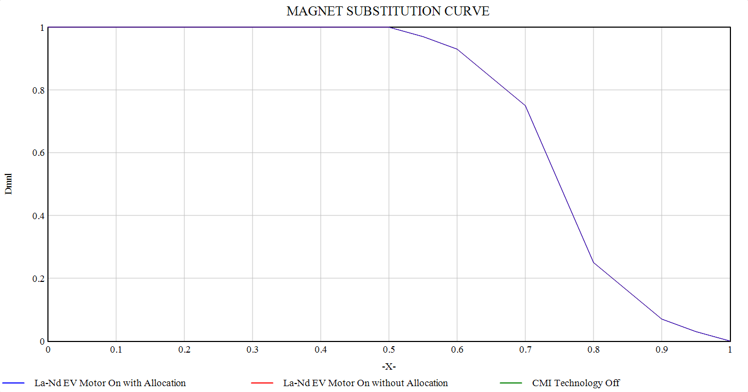
Cost Ratio (dmnl)
Substitution Ratio (dmnl)
Figure S1: Magnet substitution curve for calculating the substitution percentage of a magnet based on cost ratio
Substitution Ratio (dmnl)
Time (years)
Figure S2: Time adoption curve based on time since deployment and a resultant substitution ratio
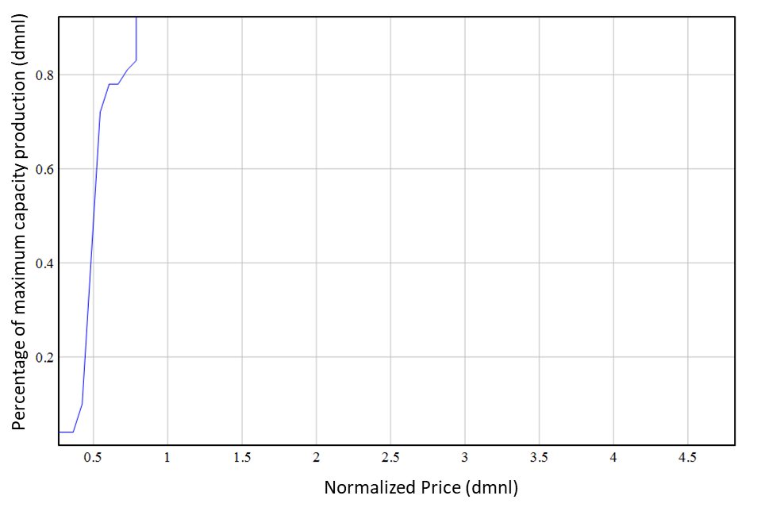
Figure S3: Primary supply curve for cobalt using normalized prices as the input and production utilization as the output
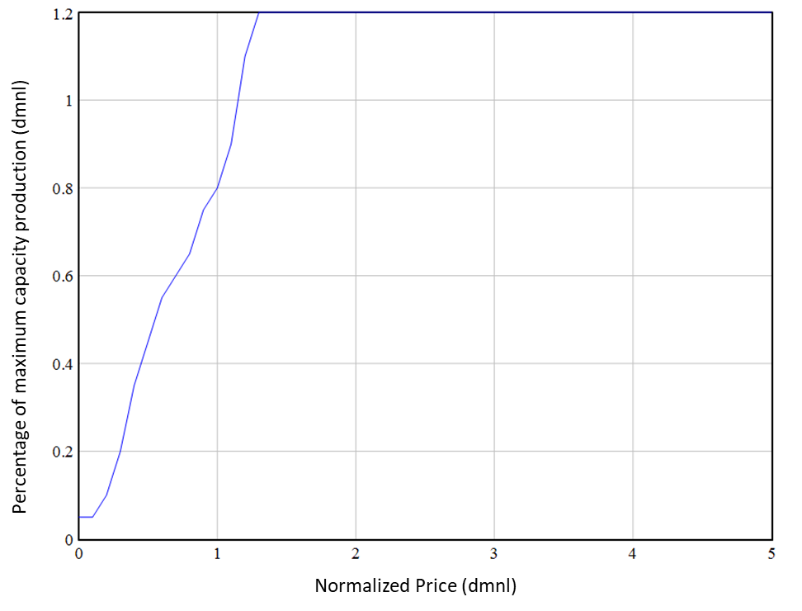
Figure S4: Primary supply curve for REEs using normalized prices as the input and production utilization as the output
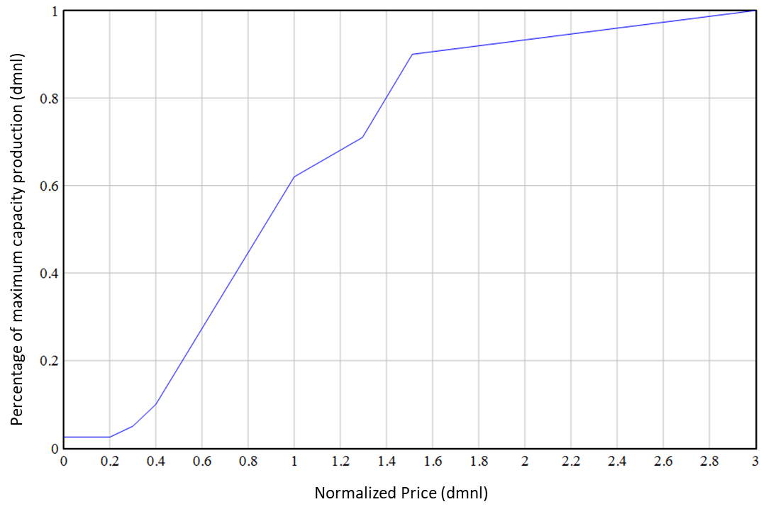
Figure S5: Secondary supply curve for cobalt and REEs using normalized prices as the input and production utilization as the output
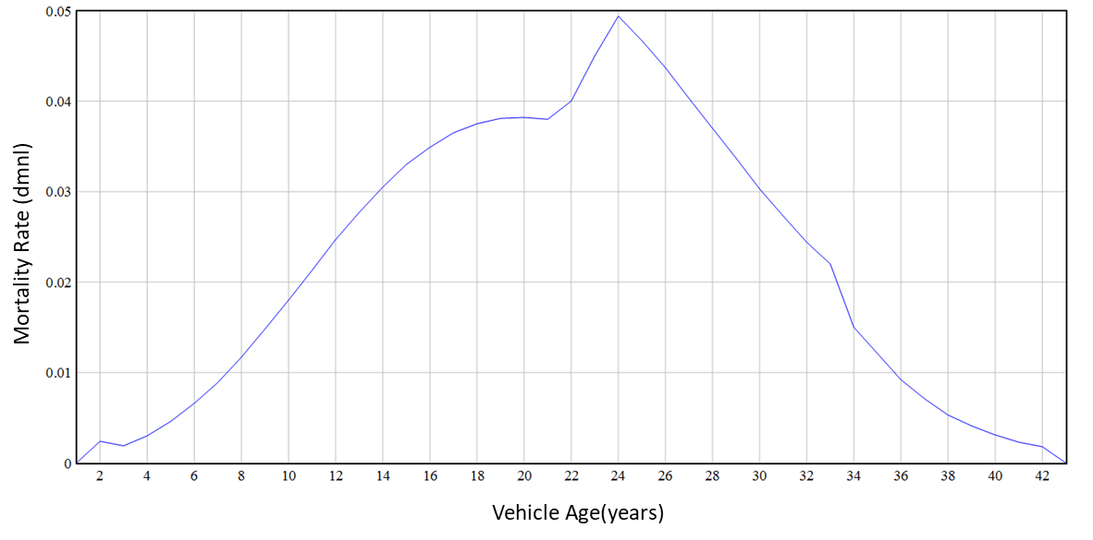
Figure S6: Annual mortality rate of vehicles as a function of age of the vehicle
Vehicle Age(years)

Figure S7: Battery capacity of different powertrain options for cars and vans
- Supplemental Tables

Table S12: Initial values used in the model for different commercial magnet technologies for applications other than EVs
Initial Values & Growth Rates | Commercial Magnet Technology
 | Al-Ni-Co | SmCo₅ | Sm₂Co₁₇ | Sintered Nd-Fe-B | Bonded Nd-Fe-B
Extrapolated Global Initial Value for 2005 (mt) (Benecki, Constantinides et al. 2020) | 7,050 | 503 | 2,848 | 30,000 | 8,000
2005-2009 Growth Rate (%) (Benecki, Constantinides et al. 2020) | -0.33% | 1.18% | 1.18% | 19.60% | 6.37%
2010-2014 Growth Rate (%) (Benecki, Constantinides et al. 2020) | -0.33% | 1.18% | 1.18% | 1.06% | 4.82%
2015-2019 Growth Rate (%) (Benecki, Constantinides et al. 2020) | -0.33% | 1.18% | 1.18% | 9.41% | 2.67%
2020-2024 Growth Rate (%) (Benecki, Constantinides et al. 2020) | -0.33% | 1.18% | 1.18% | 5.79% | 8.93%
2025-2029 Growth Rate (%) (Benecki, Constantinides et al. 2020) | -0.33% | 1.18% | 1.18% | 7.13% | 6.73%
2030-2050 Growth Rate (%) (Assumed) | 0% | 1.18% | 1.18% | 2% | 2%

Table S13: Initial values and growth rates used in the model for non-permanent magnet applications and non-EV battery applications of cobalt
Non-Permanent Magnet Cobalt Applications | Extrapolated Global Initial Value for 2005 (mt) (USGS 2005, Kapusta 2006) | 2005-2017 Growth Rate (%) (Fu, Beatty et al. 2020) | 2018-2027 Growth Rate (%) (Roskill 2018) | 2028-2050 Growth Rate (%) (Assumed)
Non-EV Batteries | 12,205 | 11.95% | 10.32% | 3.00%
Hard Materials | 5,674 | 2.61% | 0.28% | 0.28%
Catalysts | 5,943 | -0.2% | 2.56% | 2.56%
Pigments | 5,946 | -0.79% | 3.53% | 3.00%
Hard Facing Alloys | 2,976 | 2.05% | 0.28% | 0.28%
Other Applications | 7,560 | -1.45% | 0% | 0%

Table S14: Initial values and growth rates used in the model for non-permanent magnet applications of REOs
Non-Permanent Magnet REO Applications | Extrapolated Global Initial Value for 2005 (mt) (Chegwidden and Shaw n.d.) | 2005-2009 Growth Rate (%) (Chegwidden and Shaw n.d.) | 2010-2017 Growth Rate (%)(Roskill 2018, Chegwidden and Shaw n.d.) | 2018-2027 Growth Rate (%) (Roskill 2018) | 2028-2050 Growth Rate (%) (Assumed)
Catalysts | 20,867 | 2.38% | 3.18% | -0.65% | 0%
Batteries | 6,660 | 2.38% | 10.23% | -4.17% | 0%
Metallurgy | 11,366 | 2.38% | -0.60% | 0.08% | 2%
Polishing | 15,983 | 2.38% | -6.98% | 7.82% | 2%
Phosphors & Pigments | 6,660 | 2.38% | 3.34% | -12.52% | 0%
Glass | 8,702 | 2.38% | -8.66% | 10.99% | 2%
Ceramics | 5,328 | 2.38% | -14.37% | 11.67% | 2%
Others | 5,150 | 2.38% | 8.23% | 6.66% | 2%

Table S15: Battery capacity of different vehicle types and powertrain types
Type of EV | Battery Capacity (kWh)
Car BEV | Figure S7
Car PHEV | Figure S7
Bus BEV | 350 (Gao, Lin et al. 2017)
Bus PHEV | 70
Truck BEV | 500 (Lambert 2021)
Truck PHEV | 100
Van BEV | Figure S7
Van PHEV | Figure S7
*Where PHEV data could not be found, a value of 20% of the BEV battery capacity was used as the PHEV battery capacity
Table S16:Type of EV and the mass of the magnet contained within its traction motor
Type of EV | Mass of EV Traction Motor Magnet
Car BEV | 1.81 (Ormerod 2020)
Car PHEV | 0.69 (Ormerod 2020)
Bus BEV | 5.00 (Benecki, Constantinides et al. 2020)
Bus PHEV | 1.91
Truck BEV | 5.00 (Benecki, Constantinides et al. 2020)
Truck PHEV | 1.91
Van BEV | 1.81
Van PHEV | 0.69
*PHEV data for trucks and buses was obtained by applying the ratio of car BEV to PHEV magnet mass to the BEV magnet mass of the truck and bus. Additionally, van data was assumed to be the same as the car.
Table S17: Model validation results for cobalt world production and REO mining production
Year | Cobalt World Production Percent Difference (%) | Cobalt Two-Tailed P-value | Cobalt t-Test Significance | REO World Production Percent Difference (%) | REO Two-Tailed P-Value | REO t-Test Significance
2010 | -19% | 0.281 | Not Significant | -8% | 0.806 | Not Significant
2011 | -13% |  |  | 8%
2012 | -1% |  |  | 14%
2013 | -4% |  |  | 22%
2014 | -3% |  |  | 7%
2015 | -5% |  |  | 20%
2016 | 4% |  |  | 20%
2017 | -7% |  |  | 10%
2018 | -10% |  |  | -10%
2019 | -26% |  |  | -17%
2020 | ---- |  |  | -22%

Table S18: Input parameters for secondary supply of cobalt and REOs
Parameters | Value | Unit | Note | Source
Collection efficiency of Co products | Non-EV batteries: 30  Super alloys: 100  Hard materials: 50  Catalyst: 50  Pigments: 0  Hard facing alloys: 50  Magnets: 90  Others: 0  New Vehicle EV Batteries: 95  Replacement EV Batteries: 95 | % |  | Assumed & from (Harper, Kavlak et al. 2012) (Staudinger and Keoleian 2001, Daniels, Carpenter et al. 2004)
Co containing product lifetime | Non-EV batteries: 2.5  Super alloys: 5  Hard materials: 1  Catalyst: 5  Pigments: 1  Hard facing alloys: 1  Magnets: 15  Others: 1  New Vehicle EV Batteries: 15  Replacement EV Batteries: 15 | Year | Catalyst time is the average of 2 catalyst types. | (Harper, Kavlak et al. 2012, Shrivastava 2020)
Co recycling efficiency | Non-EV batteries: 90  Super alloys: 90  Hard materials: 75  Catalyst: 89  Pigments: 0  Hard facing alloys: 75  Magnets: 10  Others: 0  New Vehicle EV Batteries: 89  Replacement EV Batteries: 89 | % |  | (Dias, Blagoeva et al. 2018)  Table S10 (Richa 2016)
Maximum REO Collection Efficiency | 50 | % |  | Assumed
REO containing product lifetime | Permanent Magnets: 15  Rare Earth Catalysts: 10  RE Batteries: 2.5  RE Metallurgy: 10  RE Polishing: 10  RE Phosphors and Pigments: 10  RE Glass: 10  RE Ceramics: 10  Others: 10 | Year | Metallurgy, phosphors, and glass, polishing, & ceramics are assumed. | (Popely 2015, Shrivastava 2020)
EV battery lifetime | 15 | Year |  | (Cagatay 2019, Charluet and Van Barlingen 2021, True Car Advisor 2021)
EV battery recycling efficiency | Co: 89 | % |  | Table S10 (Richa 2016)
Collection time | 1 | Year |  | Assumed

Table S19: Magnet material composition data
Magnet Type | Key Material Composition (weight %) |  |  |  | Source
 | Nd | Pr | Dy | Co
Bonded Nd-Fe-B | 22% | 17% | 0.07% | 0.75% | (Önal, Dewilde et al. 2020)
Sintered N42SH Nd-Fe-B | 25.5% | 1.5% | 5% | 1% | (Ormerod 2021)
Sintered N35AH Nd-Fe-B | 20.5% | 1.5% | 10% | 1% | Assumed
Typical Sintered Nd-Fe-B | 20.5% | 10% | 1% | 0% | (Roskill 2018, Bunting 2021)
Wind Turbine Sintered Nd-Fe-B | 21.4% | 7.1% | 4.4% | 1% | (Alves Dias, Bobba et al. 2020)
La-Nd | 22.3% | 5.8% | 0% | 9.3% | CMI Researchers
SmCo₅ | 0% | 0% | 0% | 66.2% | (Ormerod 2021)
Sm₂Co₁₇ | 0% | 0% | 0% | 53% | (Ormerod 2021)

Table S20: The parameters used in the model and their values
Parameter | Value | Units | Source/Notes
Bonded NdFeB BH_{max} | 11 | MGOe | (Roskill 2018)
N42SH NdFeB BH_{max} | 42 | MGOe | N42SH grade magnet
N35AH Magnet NdFeB BH_{max} | 35 | MGOe | N35AH grade magnet
La-Nd BH_{max} | 32.4 | MGOe | Reported by CMI team.
Bonded NdFeB Production Cost | 25 | USD/kg | (Ormerod 2021)
Sintered EV NdFeB Production Cost (N42SH & N35AH) | 17.99 | USD/kg | (Ormerod 2021)
Wind Turbine Nd-Fe-B Production Cost | 17.99 | USD/kg | (Ormerod 2021)
La-Nd Production Cost | 17.99 | USD/kg | (Ormerod 2021)
Sm2Co17 Production Cost | 40-200 | USD/kg | Wide range due to varying raw material costs
Compression Bonded Nd-Fe-B Yield | 97 | % | (Ormerod 2021)
N42SH Raw Material Process Yield | 90 | % | (Ormerod 2021)
N42SH Production Process Yield | 75 | % | (Ormerod 2021)
N35AH Raw Material Process Yield | 90 | % | (Ormerod 2021)
N35AH Production Process Yield | 75 | % | (Ormerod 2021)
Wind Turbine Sintered Nd-Fe-B Raw Material Process Yield | 90 | % | (Ormerod 2021)
Wind Turbine Sintered Nd-Fe-B | 75 | % | (Ormerod 2021)
La-Nd Raw Material Process Yield | 90 | % | (Ormerod 2021)
La-Nd Production Process Yield | 75 | % | (Ormerod 2021)
Sm-Co Series Raw Material Process Yield | 90 | % | (Ormerod 2021)
Sm-Co Series Production Process Yield | 75 | % | (Ormerod 2021)
Secondary Cobalt Supply Shipping Time | 1 | Year | Assumed
Secondary REO Supply Shipping Time | 1 | Year | Assumed
Initial ROW Mining Production 2005 | 40,670 | mt | (USGS 2007, USGS 2009)
Initial DRC Cobalt Mining Capacity 2005 | 22,000 | mt | (USGS 2007)
DRC Artisanal Cobalt Growth Rate | 3.19% | % | (2021)
Initial Artisanal Cobalt Mining Capacity | 7,000 | mt | (Amnesty International 2016), Anecdotal sources say artisanal mining is 20% of DRC output
Initial DRC Cobalt Refining Capacity 2005 | 15,000 | mt | (USGS 2005)
Initial ROW Cobalt Refining Capacity 2005 | 48,080 | mt | (USGS 2005)
Initial China Cobalt Refining Capacity 2005 | 25,000 | mt | (USGS 2005)
Cobalt Refining Recovery Rate | 90% | % | (Harper, Kavlak et al. 2012, China Molybdenum 2018)
Cobalt Grinding and Beneficiation Recovery Rate | 80.00% | % | (China Molybdenum 2018)
Cobalt Refining Processing Time | 0.25 | Year | Assumed.
Cobalt Shipping Time | 0.25 | Year | Assumed.
Cobalt Expected Price | 43.05 | USD/kg | (ArgusMedia 2022) An average of Cobalt (Electrolytic metal) min 99.8% ex-works China USD/kg was taken from 2011-2020 to obtain an expected value for cobalt.
Cobalt Demand Elasticity | -0.46 | dmnl | (Fally and Sayre 2018)
Rare Earth Oxide Expected Prices |  |  | (ArgusMedia 2022) An average of available prices was used from Argus excluding years 2010-2012 to remove the price spike from the data.
Y | 9.04 | USD/kg
La | 3.25 | USD/kg
Ce | 2.83 | USD/kg
Pr | 42.04 | USD/kg
Nd | 31.77 | USD/kg
Sm | 3.88 | USD/kg
Gd | 14.62 | USD/kg
Dy | 168.75 | USD/kg
LREO Demand Elasticity | -0.5 | dmnl | (Pothen 2013)
HREO Demand Elasticity | -0.3 | dmnl | (Pothen 2013)
REO to Metal Price Conversion Factor
Y | 5.14641 | dmnl | (ArgusMedia 2022) Calculated averages were computed from historical Argus Media data.
La | 2.17262 | dmnl
Ce | 2.44148 | dmnl
Pr | 1.44887 | dmnl
Nd | 1.35441 | dmnl
Sm | 4.76136 | dmnl
Gd | 1.53426 | dmnl
Dy | 1.45716 | dmnl
Inflation Percentage | 1.89% | % | (OECD 2020)
Catalysts REO Composition |  |  | (Roskill 2018)
Y | 0% | %
La | 56% | %
Ce | 42% | %
Pr | 0% | %
Nd | 2% | %
Sm | 0% | %
Gd | 0% | %
Dy | 0% | %
Phosphors and Pigments REO Composition |  |  | (Roskill 2018)
Y | 53% | %
La | 11% | %
Ce | 15% | %
Pr | 18% | %
Nd | 1% | %
Sm | 0% | %
Gd | 3% | %
Dy | 0% | %
Metallurgy REO Composition |  |  | (Roskill 2018)
Y | 0% | %
La | 25% | %
Ce | 70% | %
Pr | 2% | %
Nd | 2% | %
Sm | 0% | %
Gd | 2% | %
Dy | 0% | %
Batteries REO Composition |  |  | (Roskill 2018)
Y | 0% | %
La | 82% | %
Ce | 16% | %
Pr | 1% | %
Nd | 2% | %
Sm | 0% | %
Gd | 0% | %
Dy | 0% | %
Polishing REO Composition |  |  | (Roskill 2018)
Y | 0% | %
La | 23% | %
Ce | 77% | %
Pr | 0% | %
Nd | 0% | %
Sm | 0% | %
Gd | 0% | %
Dy | 0% | %
Glass REO Composition |  |  | (Roskill 2018)
Y | 2% | %
La | 22% | %
Ce | 69% | %
Pr | 0% | %
Nd | 1% | %
Sm | 0% | %
Gd | 5% | %
Dy | 0% | %
Ceramics REO Composition |  |  | (Roskill 2018)
Y | 87% | %
La | 2% | %
Ce | 5% | %
Pr | 2% | %
Nd | 4% | %
Sm | 0% | %
Gd | 0% | %
Dy | 0% | %
Others REO Composition |  |  | (Roskill 2018)
Y | 3% | %
La | 17% | %
Ce | 74% | %
Pr | 2% | %
Nd | 1% | %
Sm | 0% | %
Gd | 3% | %
Dy | 0% | %
Cobalt Content Based on Battery Type |  |  | (International Energy Agency 2017)
NMC622 | 19.0% | %
NCA | 13.0% | %
NMC811 | 9.0% | %
Historical Battery Profile |  |  | (International Energy Agency 2017)
NMC622 | 90.0% | %
NCA | 10.0% | %
NMC811 | 0.0% | %
Percentage of EVs with Sintered Nd-Fe-B Magnets in Motors | 90% | % | (Roskill 2019)

Works Cited
(2021). "DR Congo Population (2021) - Worldometer." Retrieved 24 June 2021, from https://www.worldometers.info/world-population/democratic-republic-of-the-congo-population/.
Adner, R. and R. Kapoor (2016). "Innovation ecosystems and the pace of substitution: Re-examining technology S-curves." Strategic Management Journal 37(4): 625-648.
Alves Dias, P., S. Bobba, S. Carrara and B. Plazzotta (2020). "The role of rare earth elements in wind energy and electric mobility." European Commission: Luxembourg.
Amnesty International (2016). "This is what we die for": Human rights abuses in the Democratic Republic of the Congo power the global trade in cobalt. London, UK, Amnesty International Ltd: 90.
ArgusMedia. (2022). "Argus Metal Prices." Retrieved 20 June 2022, from http://www.argusmedia.com/metals/argus-metal-prices/.
Bass, F. M. (1969). "A New Product Growth for Model Consumer Durables." Management Science 15(5): 215-227.
Benecki, W. T., S. Constantinides, J. Ormerod and S. R. Trout (2020). The Global Permanent Magnet Industry 2020-2030.
Bleiwas, D. I. and J. Gambogi (2013). Preliminary estimates of the quantities of rare-earth elements contained in selected products and in imports of semimanufactured products to the United States, 2010, US Department of the Interior, US Geological Survey.
Bunting. (2021). "How magnets are made | Bunting - eMagnets." Retrieved Dec. 14, 2021, from https://e-magnetsuk.com/introduction-to-neodymium-magnets/how-neodymium-magnets-are-made/.
Cagatay, C. (2019). "How Long Should An Electric Car’s Battery Last? | MYEV.com." Retrieved 20 June 2022, from https://www.myev.com/research/ev-101/how-long-should-an-electric-cars-battery-last.
Charluet, C. and W. Van Barlingen. (2021). "How long do electric car batteries last? | EVBox." Retrieved 20 June 2022, from https://blog.evbox.com/ev-battery-longevity.
Chegwidden, J. and S. Shaw. (n.d.). "Rare Earths: the Uncertainties of Supply." Retrieved 21 July 2022, from https://www.parliament.uk/globalassets/documents/post/HoC-presentation-rev.pdf.
China Molybdenum. (2018). "2018 Annual Report." Retrieved December 19, 2019, from http://www.chinamoly.com/06invest/DOC/2019/E_03993_20190424.pdf.
Cullity, B. D. and C. D. Graham (2008). Hard Magnetic Materials. Introduction to Magnetic Materials: 477-504.
Daniels, E. J., J. A. Carpenter, C. Duranceau, M. Fisher, C. Wheeler and G. Winslow (2004). "Sustainable End-of-Life Vehicle Recycling: R&D Collaboration between Industry and the U.S. DOE." JOM: 28-32.
Dias, P. A., D. Blagoeva, C. Pavel and N. Arvanitidis (2018). Cobalt: demand-supply balances in the transition to electric mobility. Luxembourg, Publications Office of the European Union.
Fally, T. and J. Sayre (2018). Commodity Trade Matters, UC Berkeley: 34.
Fu, X., D. N. Beatty, G. G. Gaustad, G. Ceder, R. Roth, R. E. Kirchain, M. Bustamante, C. Babbitt and E. A. Olivetti (2020). "Perspectives on Cobalt Supply through 2030 in the Face of Changing Demand." Environmental Science & Technology 54(5): 2985-2993.
Gao, Z., Z. Lin, T. J. LaClair, C. Liu, J.-M. Li, A. K. Birky and J. Ward (2017). "Battery capacity and recharging needs for electric buses in city transit service." Energy 122: 588-600.
Group Research. (2020). "Nickel and Battery: A Paradigm Shift." Retrieved 7 Feb. 2022, from https://www.dbs.com/in/treasures/aics/templatedata/article/generic/data/en/GR/102020/201021_insights_nickel_battery.xml#.
Harper, E. M., G. Kavlak and T. E. Graedel (2012). "Tracking the Metal of the Goblins: Cobalt’s Cycle of Use." Environmental Science & Technology 46(2): 1079-1086.
He, L., M. Wang, W. Chen and G. Conzelmann (2014). "Incorporating social impact on new product adoption in choice modeling: A case study in green vehicles." Transportation Research Part D: Transport and Environment 32: 421-434.
Hedrick, J. B., S. P. Sinha and V. D. Kosynkin (1997). "Loparite, a rare-earth ore (Ce, Na, Sr, Ca)(Ti, Nb, Ta, Fe+3)O3." Journal of Alloys and Compounds 250(1): 467-470.
Hula, A., J. Alson, A. Bunker and K. Bolon (2014). Analysis of technology adoption rates in new vehicles, SAE Technical Paper.
Hykawy, J., A. Thomas and G. Casasnovas (2010). "The Rare Earths-Pick your spots carefully." Publication, Securities Division, Byron Capital Markets.
International Energy Agency (2017). Global EV Outlook 2018: Towards cross-modal electrification, IEA: 144.
Kapusta, J. P. T. (2006). "Cobalt production and markets: A brief overview." JOM 58(10): 33-36.
Kogarko, L. N. and T. F. D. Nielsen (2021). "Compositional Variation of Eudialyte-Group Minerals from the Lovozero and Ilímaussaq Complexes and on the Origin of Peralkaline Systems." Minerals 11(6): 548.
Kumari, A., R. Panda, M. K. Jha, J. R. Kumar and J. Y. Lee (2015). "Process development to recover rare earth metals from monazite mineral: A review." Minerals Engineering 79: 102-115.
Lambert, F. (2021, 2021-02-12). "Elon Musk reveals surprisingly small battery pack in Tesla Semi electric truck." Retrieved 25 May 2022, from https://electrek.co/2021/02/12/elon-musk-reveals-tesla-semi-battery-pack-electric-truck/.
Long, K. R., B. S. V. Gosen, N. K. Foley and D. Cordier (2012). The principal rare earth elements deposits of the United States: a summary of domestic deposits and a global perspective. Non-renewable resource issues, Springer: 131-155.
Lynas Corporation Ltd (2018). Lynas announces a 60% increase to Mt Weld Ore Reserves, one of the world's richest sources of Rare Earths. Lynas Rare Earths, Lynas Rare Earths.
Moldoveanu, G. and V. Papangelakis (2016). "An overview of rare-earth recovery by ion-exchange leaching from ion-adsorption clays of various origins." Mineralogical Magazine 80: 63-76.
OECD. (2020). "Global value chains and trade - OECD." 2020, from https://www.oecd.org/trade/topics/global-value-chains-and-trade/.
Önal, M. A. R., S. Dewilde, M. Degri, L. Pickering, B. Saje, S. Riaño, A. Walton and K. Binnemans (2020). "Recycling of bonded NdFeB permanent magnets using ionic liquids." Green Chemistry 22(9): 2821-2830.
Ormerod, J. (2020). Personal Communication with John Ormerod. M. H. Severson.
Ormerod, J. (2021). Magnet Substitution and Prices. M. H. Severson.
Popely, R. (2015). "How Often Should I Replace My Catalytic Converter?" Retrieved 23 June 2021, from https://www.cars.com/articles/how-often-should-i-replace-my-catalytic-converter-1420683869829/?form=MY01SV&OCID=MY01SV#:%20:text=The%20catalytic%20converter%2C%20which%20converts,be%20replaced%20only%20when%20needed.&text=It%20can%20become%20clogged%2C%20physically,by%20oil%20or%20engine%20coolant.
Pothen, F. (2013). Discussion Paper Number 14-005, Centre for European Economic Research/Leibniz Universita¨t Hannover—Institute for Environmental Economics and World Trade.
Richa, K. (2016). Sustainable management of lithium-ion batteries after use in electric vehicles. f Doctor of Philosophy in Sustainability Dissertation, Rochester Institute of Technology.
Roskill (2018). Cobalt: Global Industry, Markets and Outlook, 2018.
Roskill (2018). "Rare Earths: Global Industry, Markets and Outlook, 2018." Roskill 18th Ed.
Roskill. (2019, 2019-05-16). "Rare Earths: Tesla extends EV range using permanent magnets — Roskill." 2020, from https://roskill.com/news/rare-earths-tesla-extends-ev-range-using-permanent-magnets/.
S&P Global Market Intelligence. (2020). "Copper supply faces struggle to keep up with growing demand." Retrieved 23 May 2022, from https://www.spglobal.com/marketintelligence/en/news-insights/latest-news-headlines/copper-supply-faces-struggle-to-keep-up-with-growing-demand-60471925.
Schultz, J. W. and S. Huard (2013). Comparing AC Induction with Permanent Magnet motors in hybrid
vehicles and the impact on the value proposition. Parker Hannifin, Parker Hannifin.
Shrivastava, R. (2020, 2020-05-30). "Electric Motor Life Expectancy: How Long do Electric Car Motor Last - Vehiclesuggest." Retrieved 23 June 2021, from https://www.vehiclesuggest.com/electric-motor-life-expectancy/.
Staudinger, J. and G. A. Keoleian (2001). Management of End-of-Life Vehicles (ELVs) in the US. Ann Arbor, MI, Center for Sustainable Systems, University of Michigan: 67.
True Car Advisor. (2021, 2021-12-08). "How Long Do Electric Car Batteries Last?" Retrieved 20 June 2022, from https://www.truecar.com/blog/how-long-do-electric-car-batteries-last/.
USGS. (2005). "2005 Mineral Yearbook: Cobalt." Retrieved 24 June 2021, from https://s3-us-west-2.amazonaws.com/prd-wret/assets/palladium/production/mineral-pubs/cobalt/cobalmyb05.pdf.
USGS. (2007). "Cobalt." Retrieved 24 June 2021, from https://s3-us-west-2.amazonaws.com/prd-wret/assets/palladium/production/mineral-pubs/cobalt/cobalmcs07.pdf.
USGS. (2009). "2009 Mineral Yearbook: Cobalt." Retrieved 24 June 2021, from https://s3-us-west-2.amazonaws.com/prd-wret/assets/palladium/production/mineral-pubs/cobalt/myb1-2009-cobal.pdf.
USGS. (2022). "Rare Earths Statistics and Information | U.S. Geological Survey." Retrieved 18 Apr. 2022, from https://www.usgs.gov/centers/national-minerals-information-center/rare-earths-statistics-and-information.
Welch, D. (2021, 2021-06-04T11:16:56.588Z). "Hyperdrive Daily: A Cheaper, Cobalt-Free Battery." Retrieved 6 July 2021, from https://www.bloomberg.com/news/newsletters/2021-06-04/hyperdrive-daily-a-cheaper-cobalt-free-battery.
Zhang, Z., Q. Jia and W. Liao (2015). Chapter 277 - Progress in the Separation Processes for Rare Earth Resources. Handbook on the Physics and Chemistry of Rare Earths. J.-C. Bünzli and V. K. Pecharsky, Elsevier. 48: 287-376.
Zheng, Z. and J. E. Greedan (2003). Rare Earth Elements and Materials. Encyclopedia of Physical Science and Technology (Third Edition). R. A. Meyers. New York, Academic Press: 1-22.

