# Appendix A

**Table.1. Model’s Endogenous Claims and Assumptions**

|  |  |  |  |  |
| --- | --- | --- | --- | --- |
| Model Variables | Claim/  Assumption | # | Description | Reference |
| Personal Values | Claim | 1 | Individuals’ values have their roots in the societies’ culture, religion, social media, rules, and normative structure | (Bicchieri, 2006; T. Parsons & Shils, 1951; Schwartz, 1992; Zaidise, 2004) (Cline, 1975) |
| Personal Value | Assumption | 2 | Contesting norm affects personal Value. | Logical Extension of Claim #1 |
| Personal Value | Assumption | 3 | Dominant norm affects personal Value. | Logical Extension of Claim #1 |
| Personal Norm | Claim | 4 | Personal values shape personal norms; norm is a tool to achieve goals | (Dechesne et al., 2011; Vickers, 1973) |
| Pro- Group Emotion | Claim | 5 | Personal norm shape personal emotion | (Mercer, 2014) |
| Pro- Group Emotion | Assumption | 6 | Violation of a norm causes pro-category emotion | Logical extension of claim |
| Pro- Group Emotion | Claim | 7 | Group Violation cause pro-emotion among others | (Yang, 2000) |
| Personal Identity | Claim | 8 | Personal norm shapes personal identity | (Winston, 2018) |
| Violators Group Formation | Claim | 9 | Perception of similarity based on shared interest shapes a new group | (Granovetter, 1987) |
| Risk Taking | Claim | 10 | anger increases risk taking | (Campos-Vazquez & Cuilty, 2014) (Tversky & Kahneman, 1992) |
| Risk Taking | Claim | 11 | Pro-group emotion increases risk-taking | (Campos-Vazquez & Cuilty, 2014) (Nguyen & Noussair, 2014) |
| Risk Taking | Claim | 12 | Fear decreases risk taking | (Wake, Wormwood, & Satpute, 2020) |
| Risk Taking | Assumption | 13 | Peer-pressure decreases risk taking | Logical extension of claim # |
| Likelihood of Feeling Angry | Assumption | 14 | Punishment might cause anger among people who perceive the same grievances |  |
| Feeling of Fear | Claim | 15 | Punishment causes fear as it challenges individuals’ interest | (Granovetter, 1987; Posner & Rasmusen, 1999) |
| Peer-Pressure | Claim | 16 | Individuals feel in-group peer pressure to behave based on the group norm when they do not do so | (Turner, 1991;(Salimi, Frydenlund, Padilla, Haaland, & Wallevik, 2018)) |
| Behavior | Claim | 17 | Normative context affects the personal behavior | (Mead, Rimal, Ferrence, & Cohen, 2014) |
| Peer-Pressure | Assumption | 18 | Dominant norm affects perception of peer pressure |  |
| Peer-Pressure | Assumption | 19 | New Norm affects perception of peer pressure |  |
| Perceiving Similarity Based on Shared Interest | Claim | 20 | Personal Identity Shapes personal interests and their perception of similarity |  |
| Perceiving Similarity Based on Shared Interest | Assumption | 21 | The pro-group emotion makes others perceive the similarity with violators based on their shared interests |  |
| Likelihood of defining Incompatible Goal | Claim | 22 | There is always a probability that individuals find their initial goals are not incompatible with a group norm | (Posten & Mussweiler, 2013) |
| Doing Dissimilarity Focused Compression | Claim | 23 | Distrust awakens the dissimilarity comparison | (Posten & Mussweiler, 2013) |
| Emergence of distrust toward category norm | Claim | 24 | Incompatible goals cause distrust | (Posten & Mussweiler, 2013) |
| Learn & Assign norm of the group | Claim | 25 | Each group has its own norm and by joining the distinct category, group members will learn about the norm and start assigning the group norm | (Turner, 1984)(Turner et al, 1987) |
| Depersonalization | Claim | 26 | The more members assign the group norm, the more they depersonalize and self-stereotype | (Turner et al., 1987) |
| Internalization of the Norm | Claim | 27 | The more individuals’ self-stereotype, the more they internalize the norm | (Turner et al., 1987) |
| Group Behavior | Claim | 28 | Group members behave because of norm internalization | (Turner et al., 1987) |
| Emergence of New Norm | Claim | 29 | Group behavior will become normative after a while | (Turner et al, 1987) |
| Group Behavior | Claim | 30 | Punishment decreases the group violating behavior | (Posner & Rasmusen, 1999; Villatoro, 2010) |
| Group Behavior | Claim | 31 | Risk Taking increases group members’ riskier behavior or more violating behavior | (Forsyth, 1990) |
| Dominant norm/Legal norm | Assumption | 32 | Contesting a norm weakens the legal norm (the population size of either contesting or legal norm balance each other) |  |
| Emergence of new norm | Assumption | 33 | legal norm weakens the contesting norm/social norm (see assumption # 32) |  |
| Punishment | Assumption | 34 | Dominant norm population decreases government punishment (government power is considered as a population who support them. Thus, when huge population follow and obey them government has more power to punish and vice versa. |  |
| Punishment | Assumption | 35 | New Norm population increases government punishment (see assumption # 34) |  |
| Punishment | Assumption | 36 | Violators group population increases government punishment |  |
| Punishment | Assumption | 37 | Norm internalize group population increases government punishment |  |

**Table.2. Model’s Exogenous Claims and Assumptions**

|  |  |  |  |  |
| --- | --- | --- | --- | --- |
| Model Variables | Claim/  Assumption | # | Description | Reference |
| Pro-category emotion | Assumption | 38 | Violation of a dominant norm trigger pro-category emotion |  |
| Extreme Behavior | Claim | 39 | It is always possible that members lose their awareness and show extreme behavior | (Forsyth, 1990) |
| Punishment | Assumption | 40 | Extreme behavior increases government punishment |  |
| Likelihood to trigger anti-category norm emotion | Claim | 41 | Extreme behavior causes negative emotions among members | (Forsyth, 1990) |
| Group Violating Behavior | Claim | 42 | Anti-category emotion reduce group violating behavior |  |

**Figure.1. Causal Loop Diagram**



Table.3. Perception of Similarity Sub Model’s Parameters Report

|  |  |  |  |
| --- | --- | --- | --- |
| Variables | Description and Formulation | Type | Unit |
| Dominant/Old Norm Population | INTEG ("Stage 3. Dissimilarity Rate"-Transfer Rate, Total Population*P1)  People who believe in the old norm and are the potential population to learn a new norm | Stock | Person |
| Transfer Rate | Transfer Rate: Effect of Perception of Similarity on Transfer Rate*Dominant Norm Population/AD Time to Transfer  Change in number of populations who perceive the similarity and join the violators group | Rate | Person/Year |
| First Violation | First Violation =STEP (0.5, 10)  This shows the effect of people or group of people who initially observe the old norm harmful and violated it on other members of society | Auxiliary | Dmnl |
| "Pro-Category Emotion" | "Pro-Category Emotion" = SMOOTH ((Personal Norm*"Effect of Group Violating Behaviors on Pro-Category Emotion”) +First Violation, "AT for Pro-Category Emotion")  It shows when population emotion is in favor of the violating behavior | Auxiliary | Dmnl |
| Look Up similarity | S-shaped or logistic growth  relation between the potential population who self-categorize themselves as violators and perception of similarity | Auxiliary | Dmnl |
| Lookup Group Violating Behaviors on Pro Emotion | This graphical function shows how increase in group members violating behavior leads to increase of emotion in favor of the group | Auxiliary | Dmnl |
| Personal Value | Personal Value: SMOOTH (New to Old Population Ratio, AT for Value)  This variable shows the change in value among population | Auxiliary | Dmnl |
| Personal Norm | Personal Norm: SMOOTH (Personal Values, AT for Norm)  Affected by value, this variable shows the change in norm among population. | Auxiliary | Dmnl |
| Personal Identity | Personal Identity: SMOOTH (Personal Norm, AT for Identity)  Affected by norm, this variable shows the change in identity among population | Auxiliary | Dmnl |
| Perception of Similarity | This shows the change of perceive similarity based on the share interest among population to join the violators    Perception of Similarity: SMOOTH (MAX (“Pro-Category Emotion” +Personal Identity, 0), AT Similarity) | Auxiliary | Dmnl |

Table.4. Perception of dissimilarity and New Norm Internalization Sub Models’ Parameters Report

|  |  |  |
| --- | --- | --- |
| Variables | Description | Unit |
| "Depersonalization and Self-Stereotyping" | This stock shows population who are depersonalized.  ("Stage 2. Increase in Collective Belief", 0) | Person |
| Learning and Assigning Norm | This stock shows population who are learning and assigning a new norm.  ("Stage 1. Adapting Rate", 0) | Person |
| Perceived Incompatible Goal | Population who realizes they have a different goal and interest than the group norm  ("Stage 1. Increase Rate", 0) | Person |
| Emergence of Distrust Toward Category Norms | Having different goal results in emergence of distrust among group members  ("Stage 2. Distrust Increase Rate", 0) | Person |
| Violators Group Population | Population who disobeys a dominant norm  (Transfer Rate-"Stage 3. Internalization Rate"-"Stage 3. Dissimilarity Rate", Total Population*P2) | Person |
| Internalized the Contesting Norm Population | Population who internalizes the new norm  ("Stage 3. Internalization Rate"-Emergence of Contesting Norm Rate, Total Population*P3) | Person |
| "Stage 1. Adapting Rate" | "Stage 1. Adapting Rate" = (Potential Population who learning-Learning and Assigning Norm)/ (Adjustment Time to Internalization/3)  Change in number of populations who learn and assign the group norm | Person/Year |
| "Stage 1. Increase Rate" | "Stage 1. Increase Rate" = (Potential Population who perceived incompatible goal-Perceived Incompatible Goal)/ (Adjustment Time to Dissimilarity/3)  Change in number of populations who perceive their interests dissimilar to other members | Person/Year |
| "Stage 2. Increase in Collective Belief" | "Stage 2. Increase in Collective Belief" = (Learning and Assigning Norm-"Depersonalization and Self-Stereotyping")/ (Adjustment Time to Internalization/3)  Change in number of populations who have a shared believe in the group norm | Person/Year |
| "Stage 2. Distrust Increase Rate" | "Stage 2. Distrust Increase Rate" = (Perceived Incompatible Goal-Emergence of Distrust Toward Category Norms)/ (Adjustment Time to Dissimilarity/3)  Change in number of populations who lose their trust to the group norm | Person/Year |
| "Stage 3. Internalization Rate" | "Stage 3. Internalization Rate" = ("Depersonalization and Self-Stereotyping"-Internalized the Contesting Norm Population)/ (Adjustment Time to Internalization/3)  Change in the number of populations who internalize the norm through time | Person/Year |
| "Stage 3. Dissimilarity Rate" | "Stage 3. Dissimilarity Rate" = Emergence of Distrust Toward Category Norms/ (Adjustment Time to Dissimilarity/3)  Change in number of populations who perceive the dissimilarity | Person/Year |
| Potential Population Learning the Norm | Those part of violators population who learn the norm  Learning Coefficient*Violators Group Population | Person |
| Potential Population Who Perceived Incompatible Goal | Potential Population who Perceived Incompatible Goal = Potential Population who learning* Likelihood of defining incompatible goal  Those part of violators population who realize their goal and interest are different than the groups | Person |
| Percentage of Dissimilarity | Percent of violators who after learning a group norm perceive dissimilarity between their interest and group interest | Person |
| Learning Coefficient | Potential Population who Perceived Incompatible Goal = Potential Population who learning* Likelihood of defining incompatible goal  An exogenous variable which shows the percent of violators who will be educated in favor of a new norm | Person |

Table.5. New Norm Emergence Sub Models’ Parameters Report

|  |  |  |
| --- | --- | --- |
| Variables | Description | Unit |
| New Norm Population | Population who accepts and behave base on the new norm  New Norm Population = INTEG (Emergence of Contesting Normative Context Rate-Exit Rate, Total Population*P4) | Person |
| Emergence of Contesting Normative Context Rate | Change in number of populations who behave based on the new norm  Emergence of Contesting Normative Context Rate = MIN (Internalized the Contesting Norm Population, Internalized the Contesting Norm Population*Effect of Group Violating Behaviors on Emergence of Contesting Normative Context Rate)/AD Time to Emergence of New Norm | Person/Year |
| Group Violating Behaviors | This auxiliary shows the increase in group violating behavior  Group Violating Behaviors = (Risk Taking*Effect of Peer Punishment on Group Violating Behaviors)/ (Extreme Behavior Punishment* "Anti- category Emotion"*Effect of Punishments on Group Behavior) | Dmnl |
| Extreme Behavior Punishment | Punishment which executed by government to suppress extreme behavior during collective action  Extreme Behavior Punishment = SMOOTH (Likelihood of Extreme Behaviors*1.2, AT for Punishment) | Dmnl |
| Likelihood of Extreme Behaviors | This is a likelihood of unacceptable behavior such as breaking public goods | Dmnl |
| Risk Taking | It shows population’s risk taking based on their cost and benefit calculation  Risk Taking = MIN (Benefit/Cost, 1) | Dmnl |
| Cost | Variable shows the loss and expense of violating behavior. Negative feeling include feeling of disgust and/or shame from peer and feeling of fear of the government’s punishment, which could be fear of being arrested, losing job , economic lose, are the two main associated cost that reduce risk taking  Cost = Negative Feelings | Dmnl |
| Benefit | Variable shows gain and advantage of violating behavior    Benefit = Positive Feeling | Dmnl |
| Positive Feeling | Feeling which increase the benefit of risk taking  SMOOTH3I("Pro-Category Emotion"*Feeling of Anger, AT for Feeling, 0.1) | Dmnl |
| Negative Feeling | Feeling which increase the cost of risk taking  Negative Feelings = SMOOTH (Effect of Fear on Negative Feeling + Effect of Disgust on Negative Feelings, AT for Feeling) | Dmnl |
| "Anti- category Emotion" | The emotion which is triggered by extreme behavior and decline the group behavior  "Anti- category Emotion" = SMOOTH (Likelihood of Extreme Behaviors due to Deindividuation, AT for Anti Emotion) | Dmnl |
| Look Up Punishment | This one shows the punishment which executed by government to suppress norm violators, which is the ratio of new to old norm population. We define it this way and assume that government gain their power from their supporters’ populations and as the number of their supporter/followers’ decrease compare to contesters’ population they have less power to punish norm violators.  [(0,0)- (20,1)], (0,0.1), (0.1,0.15), (0.25,0.3), (0.5,0.5),  (0.75,0.8), (1,1), (1.3,0.8), (2,0.5), (4,0.3), (10,0.15), (20,0.1) | Dmnl |
| Feeling of Anger | The feeling which violators perceive due to government severe and/or unjustified punishment  SMOOTH(Effect of punishment on Anger(Contesters to Old Ratio)* Max Effect, AT for Anger) | Dmnl |
| Feeling of Fear | The feeling which violators perceive due to government punishment to lose job or being arrested  SMOOTH(Effect of Punishment on Fear(Contesters to Old Ratio)*Maxim Eff, AT for Fear) | Dmnl |
| Lookup Group Violating Behaviors | This shows the relationship between group violating behavior on transferring from internalize to new norm | Dmnl |
| Feeling of Disgust | The feeling which violators perceive due to peer pressure  SMOOTH (Peer Punishment (New to Old Population Ratio) *Maximum Effect, AT for Disgust) | Dmnl |
| Exit Rate | Change in the new norm population due to not anymore behave based on that norm  Exit Rate = (New Norm Population*Percentage)/Time Delay | Person/Year |

**Figure.3. Sub Model Perception of Similarity**

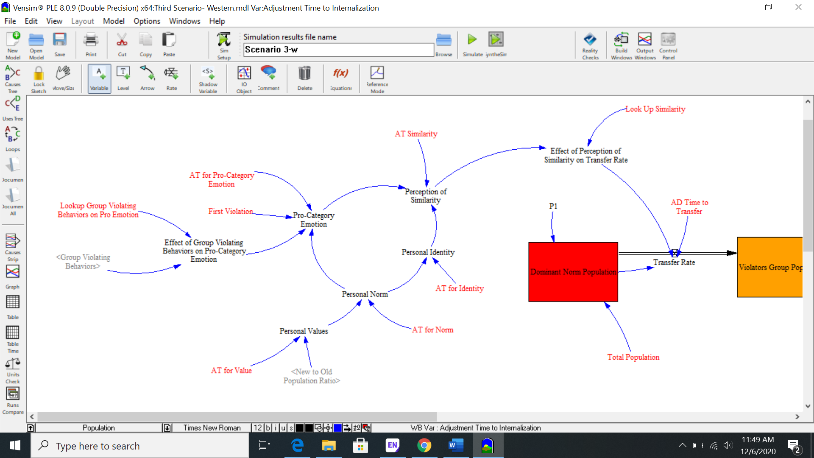

**Figure.4. Sub Model Perception of Dissimilarity and New Norm Internalization**

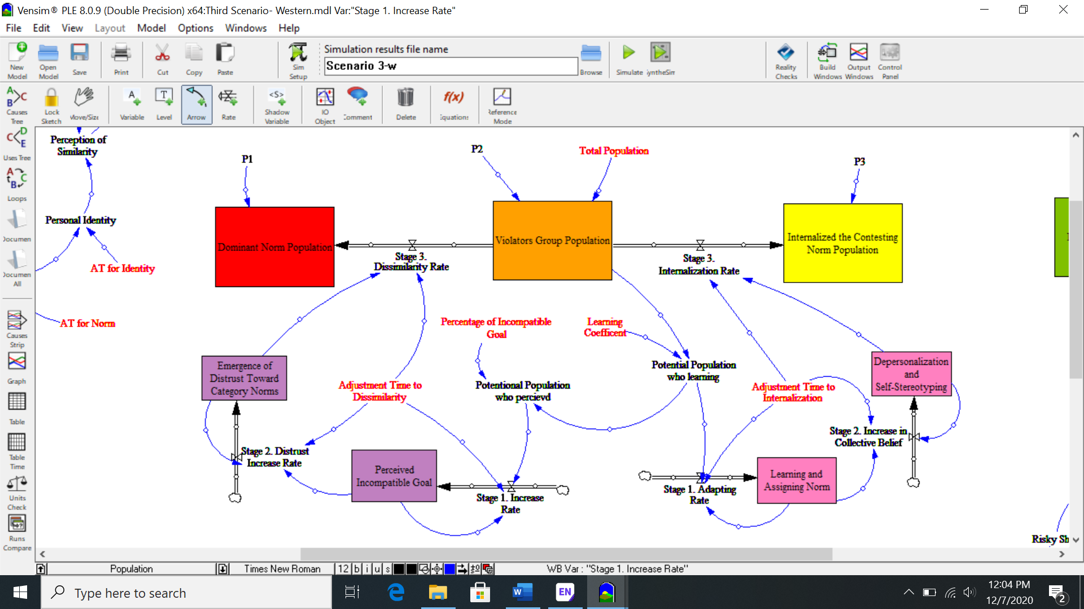

**Figure.5. Sub Model New Norm Emergence Report**



**Table.6. Summary of Sensivity Test**

|  |  |  |  |
| --- | --- | --- | --- |
| Variable | Number of Runs | Range | Results |
| Learning Coefficient | 200 Random Uniform | 0.3-0.8 | Figure.6 |
| Percentage of Dissimilarity | 200 Random Uniform | 0.02-0.2 | Figure.7 |
| Likelihood of Extreme behaviour | 200 Random Uniform | 0.05-0.8 | Figure.8 |

**Figure.6. Sensitivity Test for Learning Coefficient on New Norm Population**



**Figure.7. Sensitivity Test for Percentage of Dissimilarity on New Norm Population**



**Figure.8. Sensitivity Test for Likelihood of Extreme Behavior on New Norm Population**

