Was the Atomic Bomb Necessary to End the Pacific War?
Thayer School of Engineering at Dartmouth College

1. INTRODUCTION:
In 1945, President Truman and the United States dropped the atomic bomb on Japan in both Hiroshima and Nagasaki. The mission resulted in mass civilian casualties, totaling between 100,000 to 200,000 deaths and creating lasting detrimental nuclear effects such as starvation and poor health conditions. In the few days after the second bomb was dropped, the Japanese surrendered. Despite ending in a surrender and ending the Pacific War, many still ask the question whether the bomb was the best approach in trying to induce a surrender, and more importantly, if this action was the direct cause for surrender. The focus of this study is to better understand the dynamics between the Japanese population, the United States’ soldier population, and Japan’s wartime supply chain to identify which of the alternative strategies that were either viable or taking place at the same time of the atomic bomb would have been effective in increasing pressure to surrender and Japan’s military vulnerability, if at all. Using a system dynamics analysis of the Japanese population and supply chain, the study analyzes the effect of a continued U.S. blockade and a Soviet Invasion of Manchuria.

2. METHODS:
For this study, a system dynamics model was built to capture the effects of a U.S. blockade and a Soviet Invasion of Manchuria on Japanese and U.S. population/soldier dynamics and the Japanese supply chain. This model was based on data comprised of annual Japanese imports of key strategic wartime materials such as oil, coal, and iron, death rates, sourcing and delivering raw materials, and consumption rates from seven different studies, surveys, and reports.
3. RESULTS AND DISCUSSION:
3.1 Control and Blockade Effect
With no blockade or Soviet invasion, the Japanese supply chain flow of delivering raw materials reaches a steady state. As the blockade effect is entered into the system, the amount of constriction of the delivery of raw materials into Japan differs at different constriction points. At zero, thirty, sixty, and eighty percent constriction of raw materials entering Japan, the supply chain flow sees an initial downward spike in resource exhaustion, but recovers over time due to not enough material being blocked as the Japanese readjust and recover. As the constriction reaches a tipping point of 90% of all raw material delivered to Japan, the supply chain starts to deteriorate and fall apart as they cannot reach any semblance of the flow of resources it was able to have when no blockade took place despite adjustments, but the constriction does not cause the flow of delivery to hit zero.
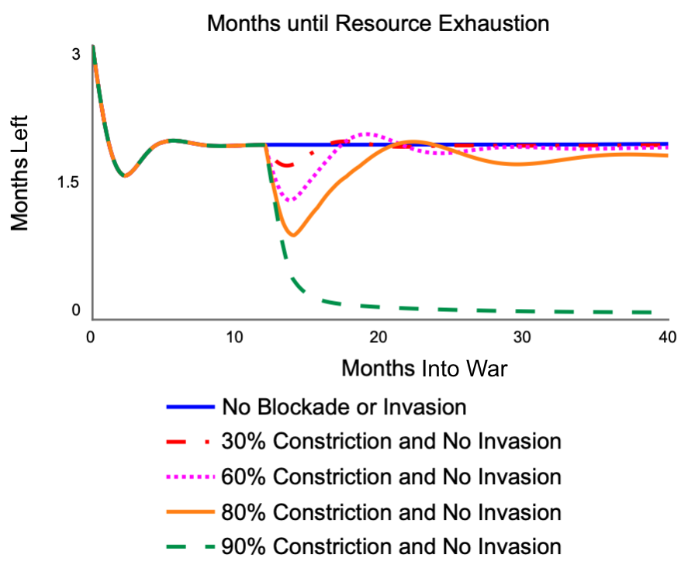
Figure 1. Resource supply (in months left) due to U.S. blockade, 1943-1946
3.2 Soviet Invasion of Manchuria Effect
When taking into account only the Soviet Invasion of Manchuria without the U.S. blockade, the results show that the Japanese supply chain immediately starts to decline and reaches zero flow of resources quite quickly.
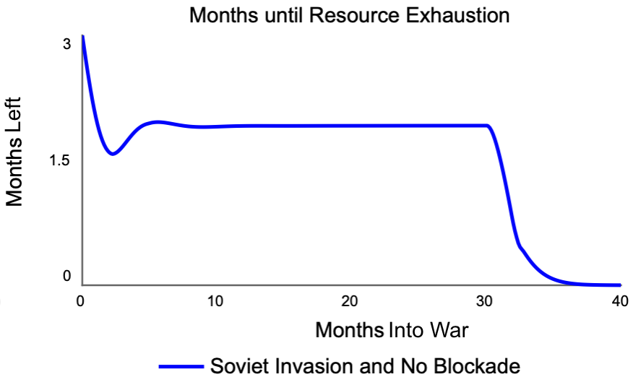
Figure 2. Resource supply (in months left) due to Soviet Invasion of Manchuria, 1943-1946
3.3 Combination of Blockade and Soviet Invasion
The Combination of both the 90% constriction by blockade and the Soviet Invasion of Manchuria yield a similar result to just the blockade effect. But unlike the blockade effect, at 30 months (August 1945), Japan’s flow of resources is zero, and pressure is extremely high as they are completely militarily vulnerable.
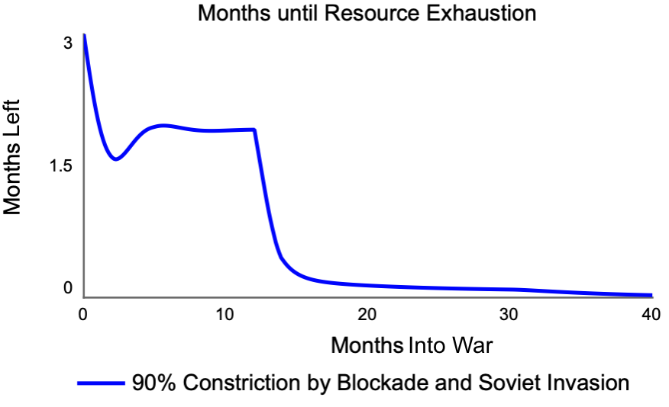
Figure 3. Resource supply (in months left) due to U.S. blockade at 90% constriction and Soviet Invasion of Manchuria, 1943-1946
3.4 Pressure to Surrender
Looking at all of the different policy options, the 90% constriction by blockade and Soviet Invasion of Manchuria are the most effective of all the different options available. Starting from a pressure level of 20, the combination of the blockade and the invasion The Soviet Invasion ensures the complete demolition of the Japanese supply chain, increasing the pressure to 218. This destruction of the supply chain sourcing shows that Japan would only have 0.048 months left of resources, rendering them completely militarily vulnerable in days. The blockade at 90% constriction itself is quite effective increasing pressure to 216. The Soviet Invasion of Manchuria is also effective, by increasing pressure to 37.2 by itself in a short span of four months.
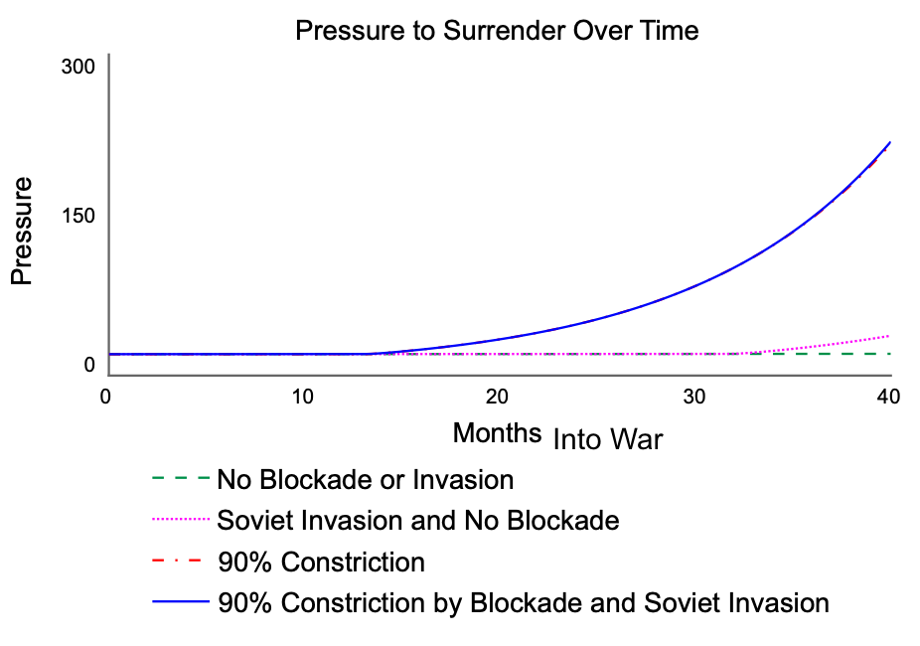
Figure 4. Pressure to surrender due to combinations of U.S. blockade at 90% constriction and Soviet Invasion of Manchuria, 1943-1946

4. Conclusion:
From these results, this study shows that on a macro scale, any island nation relies heavily on two flows for a healthy supply chain: Its sourcing of raw materials and its rate of delivering raw materials. On a micro scale, this study also shows that the atomic bomb was not necessary to cause immense amounts of pressure to surrender for two reasons. First, if the blockade was effective enough to cause 90% constriction, this would have been enough to devastate the Japanese supply chain and cause over ten times the amount of pressure to surrender than when the simulation started. Second, if the U.S. was not confident in its blockade, a Soviet Invasion of Manchuria is needed to lead to sufficient military vulnerability and greater pressure to surrender as a Soviet Invasion of Manchuria effectively brings flow of resources to zero.

Works Cited
Marston, Daniel. The Pacific War: From Pearl Harbor to Hiroshima. Osprey, 2006.
“Memorandum on the Supply of Raw Materials in Japan.” Memorandum (Institute of Pacific
Relations, American Council), vol. 3, no. 2, Jan. 1934. Crossref, doi:10.2307/3024725.
Military Production of Japan. | WW2 Weapons.
https://ww2-weapons.com/military-production-of-japan/amp/
Pape, Robert A. “Why Japan Surrendered.” International Security, vol. 18, no. 2, 1993, p. 154.
Crossref, doi:10.2307/2539100.
Pike, Francis. Hirohito’s War: The Pacific War, 1941-1945. Bloomsbury Academic, an imprint of
Bloomsbury Publishing PLC, 2015.
Stewart, John R. “Manchuria as Japan’s Economic Life-Line.” Far Eastern Survey, vol. 4, no. 23,
Nov. 1935, pp. 182–86. Crossref, doi:10.2307/3022242.
Young, Louise. Japan’s Total Empire: Manchuria and the Culture of Wartime Imperialism. First
paperback printing, University of California Press, 1999.

