From competition to collaboration: Bringing organizations’ vision and interests together to enable an integrated strategy for a child- and adolescent-focused system of care
Short Abstract
Background. Georgia’s Interagency Directors Team (IDT) was formed to design and implement an integrated child and adolescent system of care. It comprises over 20 state agencies and NGOs serving children with behavioral health needs. Problem. In its first year, the IDT failed to gel as a team, hampered by siloed thinking, competition, and lack of shared vision. Approach. Through a participatory process, the team built three system dynamics maps that reflected and facilitated a transition from competition to collaboration. Models. The first map reflects a service-oriented system, lacking vision and appearing to validate competitiveness. The second shows the desired outcome that all IDT members share: children with mental health needs growing into adults with maximum quality of life. Organizations see their own and others’ roles in moving children toward the desired future. The third illustrates ten types of strategic opportunities for improvement. Impact. Members of the IDT moved to a new mental model of a system in which all play important roles. Inspired by their shared, larger vision, they worked together on a statewide strategic plan. They continue to use their maps - enlarged and laminated and becoming dog-eared - for internal and external conversations.
Long Abstract
Background
The Interagency Directors Team (IDT) was created by Georgia’s Department of Behavioral Health and Developmental Disabilities (DBHDD) in order to design, manage, facilitate, and implement an integrated approach to a child and adolescent system of care that informs policy and practice and shares resources and funding. IDT comprises over 20 representatives from state agencies and non-governmental organizations that serve children with behavioral health needs.
Problem
In its first year of operation, the IDT had trouble gelling as a team and making any forward progress. As in many assemblages of organizations, members tended to focus on their own institutions’ interest and mission, and to see each other as potential competitors for funding rather than collaborators toward a shared vision. Overcoming this pattern and building a child-focused, functional, collaborative team was important in order to generate and implement a truly integrated strategic plan for a child and adolescent system of care.
Approach
The GHPC and its consultant, Chris Soderquist, launched a participatory system dynamics intervention to help members of the IDT get their mental models out into the open, move toward a shared vision, and find a way forward toward collective, strategic thinking. Through individual interviews and group work, the team built three system dynamics maps that reflected and facilitated this transition.
Models
The first model reflected participants’ initial shared idea of the system in which they operate. A service-oriented model, it lacks a vision for an inspiring, ultimate outcome that participating organizations could join together behind. Instead, it shows a system in which children are served in one setting and then “pushed” to another; and it appears to justify the competitiveness among many of the groups.
The second model is child- and adolescent-focused, with the desired outcome that all IDT members share plainly visible: children with mental health needs growing into adulthood with maximized quality of life. By depicting the population served across an aging chain broken into seven stages, from prenatal to adult, organizations can see the role they play in moving clients toward the long-term vision. Likewise, they can see and value other organizations’ roles.
The third model simplifies the aging chain and adds enough causal structure to highlight 10 types of strategic opportunities for systemic improvement.
Impact
Over the course of their participatory system dynamics engagement, members of the IDT moved from siloed, self-interested perspectives to a new, shared mental model of a system in which all play important roles. They were inspired by their shared, larger vision and motivated to work together on strategic plans for advancing it. They laminated an enlargement of the third map and use it frequently in discussions among themselves, in bringing in new members, and in illustrating their strategic plan to outside stakeholders.
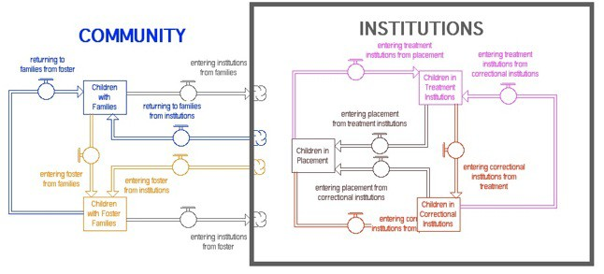
Service-Focused Map

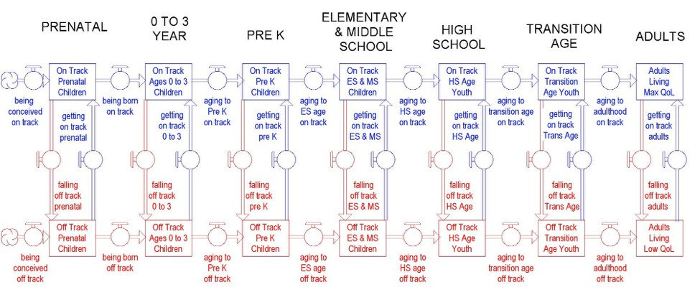
Vision-Focused Map

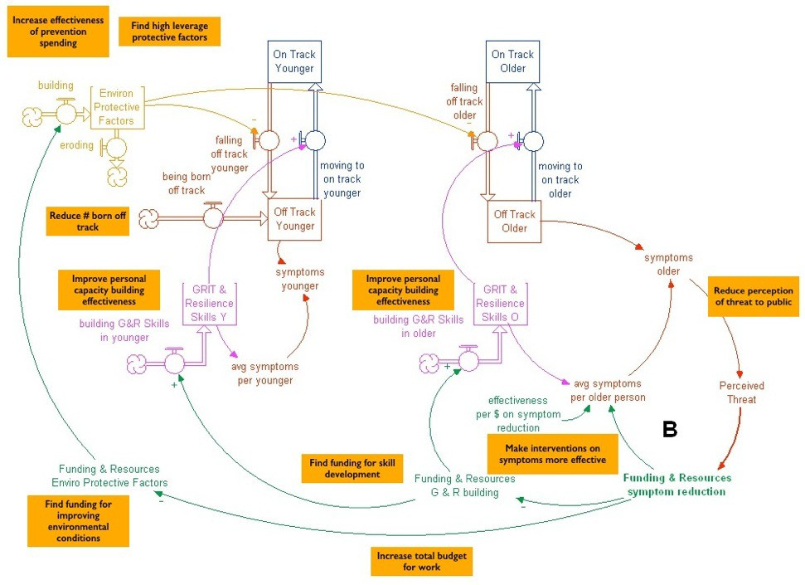
Strategy-focused map

