Abstract
Year 2022 marks the 38th anniversary of System Dynamics Review (SDR), which was launched in April 1985. An analysis of SDR bibliometrics between 1985 and 2022 is the goal of this study. A Scopus database is used to collect and analyze SDR's publications. The authors reviewed 617 documents using Bibilioshny of RStudio , VOSviewer, and Microsoft Excel. SDR's publication performance has remained stable over the last two decades, but its citations have declined. According to network analysis, topics including "system analysis," "modelling," and "numerical modelling" have become more popular. According to a bibliographic coupling analysis, the key issues covered by SDR fall into four broad groups: modelling approach, computer simulations, and numerical model; teaching, research, and performance evaluation; Optimization, parameterization and algorithm; and Eurasia and Europe. In addition to providing an overview of SDR publication and citation trends, this study also provides a detailed thematic description of SDR publications.
Keywords: System dynamics, bibliometric analysis, system dynamics review

Introduction
A quarterly peer-reviewed journal, System dynamics Review (SDR) began issuing publication in 1984. In addition to advancing the discipline of system dynamics worldwide, SDR has been a valuable journal to attend. Its objective is to publish original, in-depth research on the recently developed topics of "system dynamics" and "system dynamics modeling." The primary aim of SDR is to provide a forum for discussion on the shift toward a more responsible system dynamics domain to solve the complex problems of the world.
In line with its statement of objectives and purpose, SDR primarily focuses on the areas of social science, technology, management, business, economics, health, biology, ecology, and the environment. SDR has been productive in publishing influential research in contrast to being perhaps the first journal that specializes in system dynamics. This accomplishment will be discussed in more detail in the next portion of this article.
The journal will mark its 38th anniversary in 2022. Therefore, this bibliometric analysis of SDR between 1985 and 2022 is carried out to honour the prestige of SDR that journals devoted to the system dynamics domain. The retrospective analysis of the journal's content sheds light on the present and future patterns (Gholami and Al Tahoo 2021). Such sort of research is a standard method utilized in various journals as well as publications in other sectors to acquire knowledge about the journal's evolution, productivity, and content and to give readers comprehensive information about the journal. Many top-rated publications have regularly published this kind of study.
The main objective of this study is to investigate the impact of SDR on SD research as well as the most important topic included in SDR from its foundation in 1985 to 2022. Researchers who study system dynamics should find this work interesting and important. A review of SDR should be beneficial for readers first because it will give them a summary of publications, citations, authors, and interesting subjects. Second, this evaluation offers advice on the most referenced content, interesting themes, sources, and writers for those who have written articles on system dynamics or are considering doing so. A new system dynamics researcher who is still learning the intricacies of the field will find this knowledge useful. Furthermore, the study intends to identify areas where system dynamics may offer potential topics of interest for further.
The remainder of this study is laid out as follows – Section 1 starts with a brief introduction to SDR; research methodology is presented in Section 2. The data analysis and findings of the bibliometric study are presented in Section 3; Each cluster's content analysis is presented in Section 4, and the last conclusions are given in Section 5.
2. Research methodology
Bibliometrics is the use of statistical techniques and numerical tools to analyze bibliographical data (Pritchard 1969). It is employed in the study of countries (Sweileh et al. 2014; Sisaye, 2021) as well as institutions, sources (like journals), disciplines, and themes (Malhotra and Thakur 2020). Large amounts of data can be investigated, classified, orchestrated, and analyzed using bibliometric analysis.
A bibliometric technique consists of (i) quantitative measures to gauge productivity, (ii) qualitative indicators to gauge the effect and (iii) structural measures to gauge the relationship and interactions between the scientific players (Valerie Durieux, 2010).
Similar to this, Cobo et al. (2011) point out that there are often two approaches to bibliometric analysis: performance analysis and science mapping analysis. Performance analysis discusses descriptive analysis, the output of scientific work, while science mapping analysis is concerned with showing the structural and dynamic elements of the research cycle or scientific inquiry. In conclusion, the use of both approaches together yields a comprehensive picture of a particular actor's profile in the research domain.
A top database for high-quality indexing journals in the humanities and social sciences is Scopus, which has indexed SDR since its debut issue in 1985 (Archambault et al. 2009).
The study uses VOS viewer to examine SDR publications published between 1985 and 2022 based on bibliographic coupling and keyword cooccurrences. Additionally, the average number of citations per article is another measure, which incorporates both publications and citations; it uses bibliometric indicators for determining productivity and impact, such as the number of publications and citations.

3. Findings and discourse
617 articles published in SDR between 1985 and July 2022 were found in the Scopus database. These publications are broken down into 554 articles,7 conferences, 14 editorials, 7 erratums, 10 letters, 13 notes, and 12 reviews. It is clear that only 0.162 percent of the articles are reviewed. So SDR concentrates on more review articles as they often receive more reads, impacts, and citations count than a typical research piece (Weale, Bailey, and Lear 2004). Additionally, over the previous 65 years, SDR has maintained a solid performance, demonstrating its rising popularity. In terms of citations, during the past 65 years, SDR has amassed 16424 citations via its published publications. The year average of publication of the document is 17.4 and the average citation per document is 35.24, and the average citation per year per document is 1.979, showing a robust performance of the SDR.
By doing a multidimensional study of the journal performance utilizing VOS viewer, Excel tools that create editable graphs and tables, and RStudio, this part provides pertinent information for the journal stakeholders.
[Insert table 1 here]
3.1 Analysis of publications trend
This section gives readers important details about the journal's annual publishing schedule as well as a description of the pertinent writers, their linked institutions, and the countries in which they live. Additionally, this section provides a rating performance SDR in the domain.
3.1.1 SDR output trend by year
Figure 1 displays SDR’s output direction as assessed by the number of papers released every year and Figure 2 displays SDR’s output trend and citation count. Particularly, between 1985 and 2022, 617 papers have been published, averaging 9.49 articles per year. Further subsequently, the number of research article publications significantly changed from 9 in 1985 to 20 in 2020, it is also shown that in 2021 only 16 papers were published but in 2022 only 8 papers were published till July 2022. Furthermore, the number of articles in 2007 represented the all-time peak in the number of papers (29). released in a year that is a new milestone for the SDR journal. This tremendous rise is likely to trust the SDR to a new extreme if the publication retains its exacting quality for screening/selection methods. The publishing expansion demands specific focus on enhancing the journal categorization style. For instance, the publication may categorize its articles by themes rather than by problems to boost the end-user finding efficiency. However, the number of articles exhibits modest up and down, the rising trend demonstrates the increased output of SDR.
Figure 1 displays SDR’s output trend

Figure 2 displays SDR’s output trend as assessed by the number of papers released each year and citation count
3.1.2 Most impactful authors, influential affiliations, and productive countries
This section of the study provides a detailed analysis of the most impactful authors, influential affiliations, and productive countries. The top 20 authors with the most popular papers are listed in Table 2. Out of the 805 authors that have contributed to the SDR, Sterman J.D. a researcher who attends the MIT Sloan School of Management in the US and focuses on System Dynamics is the top contributor with 23 papers in the SDR. Richardson G.P. is the second-highest contributor He is from the University of Albany in the US, with 23 publications published, and his areas of specialization in the study are strategy, simulation modeling, group decision support, and public policy. Barlas Y, having 13 published works, from Istanbul, Turkey's Bogazici University, comes in third.
[Insert table 2 here]

Author’s production
We used Lotka's law, which is depicted in Figure 3, to explain the frequency of publications by authors in SD research. According to Lotka's law, there is an inverse association between the number of articles published and the frequency with which authors are produced (Sun J, 2021). Mathematically, it may be written as follows:
x2y = C (Lotka AJ, 1926)
where y is the frequency of authors making x contributions each and C is a constant.
The results of Lotka's law indicate that 78.7 percent of authors contributed one article, 10.7 percent of authors contributed two articles, 4.1 percent contributed three articles, and 1.7 percent four articles. None of the previous bibliometric studies on SDR applied Lotka's law. The results confirm that in SDR literature, as shown in other research in several domains (Miau, and Yang, 2018; Kushairi and Ahmi 2021). Flippedsummarised in Table 3, as the number of publications by a single author increase, the number of contributions in a field by two, three, and four authors declines.

Figure 3 Frequency Distribution of scientific Productivity
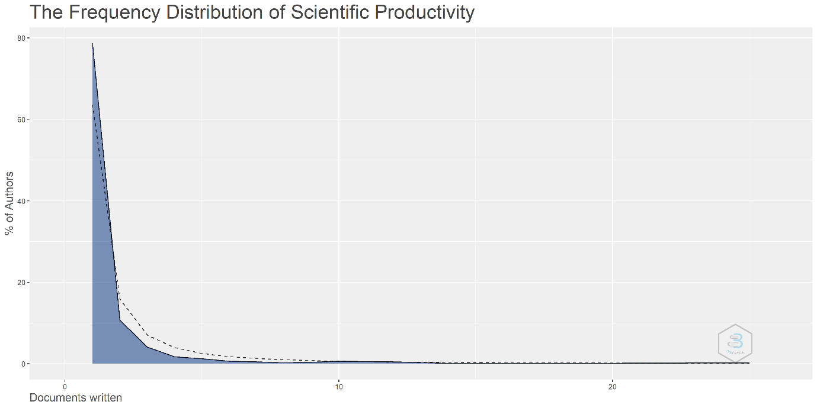

[Insert table 3 here]

Most Productive Author(s) (citation bases)
The ranking of the most cited writers is that of the top publishing authors. It shows that the most cited authors have higher H, G, and M indexed values. The most cited author is Sterman J. D. who has 2926 citations, an average of 127.21 citations per article, the H index 18, and is the top publisher. Richardson G.P. is next, with 1893 citations, an average of 79.95 citations, and an H index of 16. Barlas Y, which has 1218 citations, an average of 93.69 citations per publication, and an H index of 10, places third. Looking at other metrics such as H-index, G-index, and M-index, Sterman J. D.is again placed at the top, in addition to being ranked first in terms of the number of citations and number of publications, demonstrating his important presence and effect on SDR at the worldwide level.
Most relevant country
Table 4 lists the top countries that contribute to research on system dynamics. The country's activities that prioritize research are essential to its growth and advancement. Table 6 lists the top ten contributing and productive nations based on Scopus databases. The USA is placed first among the top ten nations' databases, with the UK coming in second and Germany coming in third, according to the Scopus database. 53.16 percent of the total number of articles chosen for the research, or 328 articles, were from the top three contributing nations: the United States, the United Kingdom, and Germany. The majority of industrialized nations are the top system dynamics research sites in the database. The production of papers in the field of system dynamics has also started in developing nations including Iran, India, Mexico, and Chile. The highest-ranking Asian contributor is Iran, with 5 articles. And 61.66% of all publications on system dynamics in SDR are from the top 5 industrialized nations. The dominance of European nations in the publication was also mentioned. 289 single country papers (SCP) from the top 3 nations make up 46.83 percent of the total, according to the research. The SCPs show that the USA is still in the lead. 39 multi-country papers (MCP) were also published (6.32 percent). According to the MCPs, as shown, the USA is once again at the top with 25 MCP, and the UK is displaced as the second-best country by Germany.

[Insert table 4 here]
Figure 4. Represents the Top contributing Corresponding countries to System Dynamics Review journal
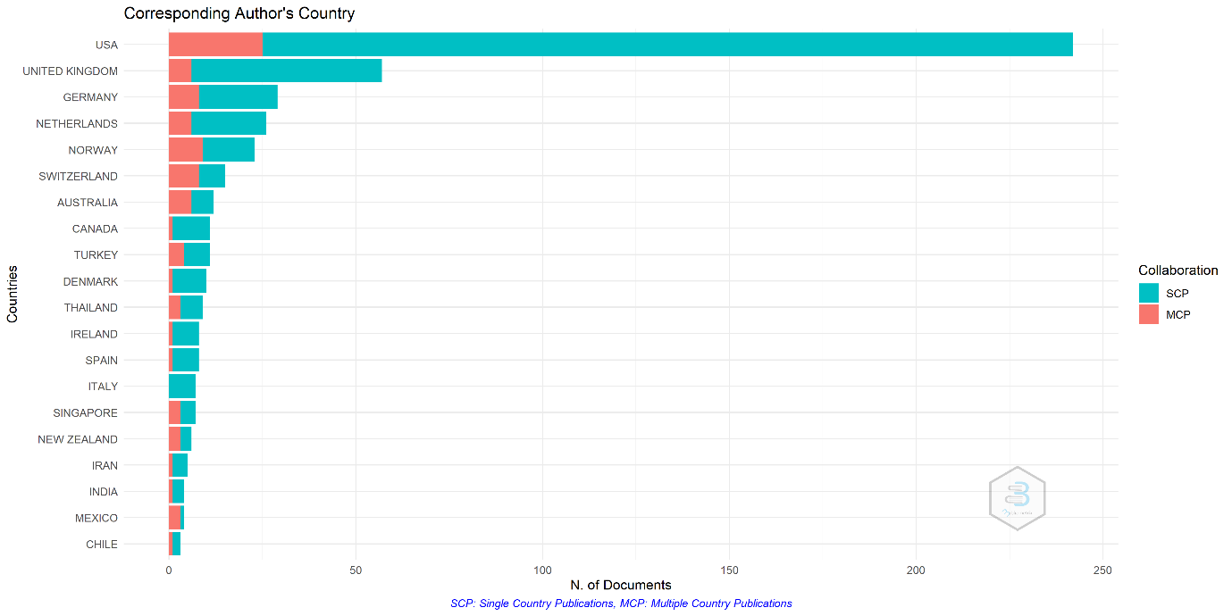

Source: Authors' elaboration using Biblioshiny
3.2 Citation analysis
Citations are still one of the finest methods to gauge an article's effect or quality, and they are increasingly employed as performance metrics (Tsay 2009; Wallin 2005). The most frequent citation papers, the source impact, and the journal's citation growth trend are all shown in this section.
3.2.1 Citation trend
Notably, Figure 5 shows how the performance of SDR is Showing the inverted U-shaped pattern. The 9 documents got 147 citations in the first ever year of publication and it got the peak in the year 1994 with the highest 2032 citation and zero citations in the years 2021 and 2022. but if showing the pattern of the number of articles published in fond that the highest document published in the year 2007 it is also clear that the document publication trend is increasing in the last two decades, but new articles have got low citations. It is typical for newer articles to get fewer citations than older ones, nonetheless.
Figure 5 displays SDR’s output trend of papers released each year

Source: Authors' elaboration using Biblioshiny
3.2.3. Countries in terms of citation
With 11413 and 1893 citations, respectively, the US and the UK also rank as the best two most influential countries. The Netherlands, which ranks as the third most influential nation with 1224 citations, joins them. The 4 articles that writers from Mexico have contributed to the field have the greatest average number of citations, at 53.50. The top 10 producing nations are dominated by American and European nations, although there is a noticeable Asian presence, including Thailand, India, Iran, and Korea, which are all in Asia. The majority of system dynamics research continues to be centered on America and Europe despite this representation, with only small articles drawing samples from Asian countries. On closer examination, we observe that system dynamics research in Asian countries has seen an increasing number of publications in the last decade (2012–2021) and it will continue to do so.
[Insert table 5 here]
3.2.4 Most cited documents
According to Scopus citation metrics, Table 6 lists the most popular SDR publications. With more citations than the following 20 significant papers combined, the most referenced article is " Formal aspects of model validity and validation in system dynamics."
one cause may be identified for this. There was no clear evidence of consistent and widespread use of even the basic established validity tools (Peterson and Eberlein 1994 and Scholl 1995) till 1997, and Barlas Y, (1996) addressed validation of the system dynamics model, which is regarded as one of the key issues in the model building.
[Insert table 6 here]
3.2.5. Keyword analysis
Figure 6 represents Word TreeMap displays the keywords with the highest proportion of occurrence. Systems analysis comes in first on the list (occurrences totaling 77, or 12 percent), followed by modelling (occurrences totaling 73, or 11. percent), numerical modelling (occurrences totaling 51, or 8 percent), and computer simulation (occurrences totaling 4) in fourth place (32 times representing 5 percent) It is clear from the author's keyword usage that SDR concentrates on writing articles looking into system analysis, modelling, and computer simulation of that model. However, the subject trends provide more in-depth explanations and a greater grasp of the new themes that are always evolving.

Figure 6. Represents a word tree diagram
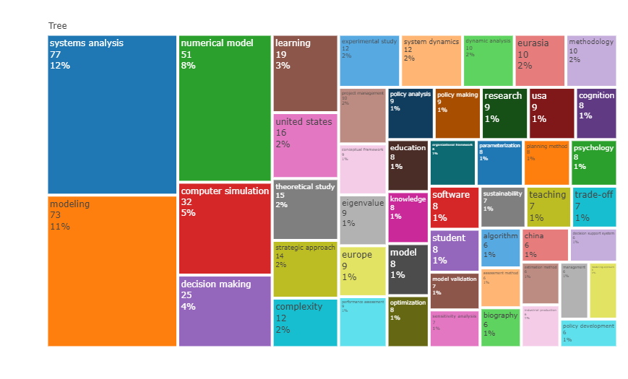
Source: Authors' elaboration using Biblioshiny
3.2.6. Trend topic
Figure 7 shows the topic's development over time. Notably, since 2012, interest in "systems analysis," which has been a popular topic since 2006, has significantly decreased. On the other hand, "modelling," which was popular in 2008, has significantly decreased after 2016. At the moment, academics are not very interested in this subject. Similar to this, since 2017, less publications have been written about the "numerical model." Additionally, the "computer simulation" motif has lost some of its appeal, continuing the downward trend.
Figure 7 represent the trend topics in the SDR publications
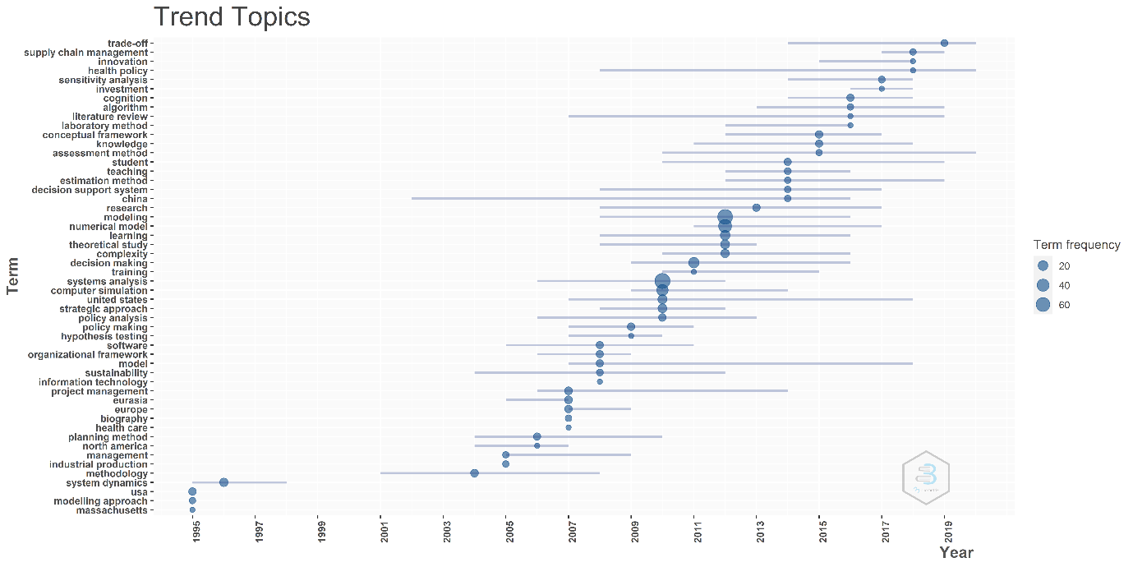
Source: Authors' elaboration using Biblioshiny
3.3 Network analysis of SDR using VOS viewer and R Studio
Network for published studies in SDR from 1985 to 2022
Figure 8 Represent the network of articles coupling. By analyzing the size of a node and the links that appear when bibliographic coupling occurs, we can determine how many citations an article has Despite “Formal aspects of model validity and validation in system dynamics” (Barlas Y. 1996) being the most cited (898) article in SDR, and “Learning in and about complex systems” (Sterman J.D., 1994) is the second most cited document with 684 citations, and “System dynamics, systems thinking, and soft OR” (Forrester J.W., 1994) is the third highest cited document with 566 citations. Groesser S.N. (2012b) With 1170 bibliographic couplings, (2012b) has the greatest level of bibliographic coupling in SDR, and Ghaffarzadegan N. (2018) With 1052 bibliographic linkages, ranks second-highest degree of connectivity. Lane D. C. (2007) has the third-highest coupling (1051), while Barlas, 1996 has the lowest coupling (412 linkages). This degree of bibliographic coupling is most likely caused by the fact that group model building is a large issue that links various research streams, from model stimulus through applied modeling of various organizational issues.
Figure 8. Represent the network of articles coupling
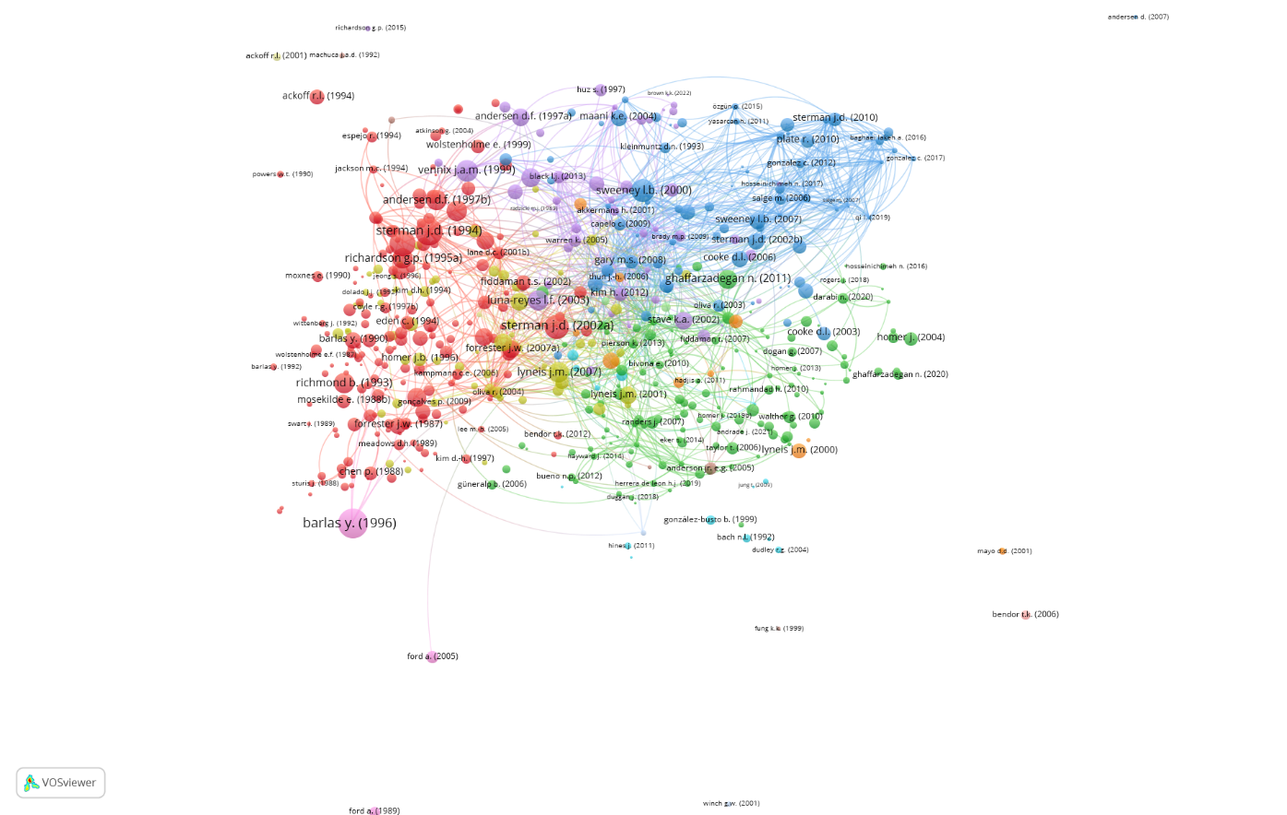

Source: Authors' elaboration using Biblioshiny
Networks analysis between country published in SDR between 1985 and 2022
As shown in Figure 9, an analysis of SDR's bibliographic coupling by country is presented. Despite the fact that the US has 296 articles in SDR and the UK and Switzerland have 71 and 23 articles respectively, this analysis shows the number of countries of an article based on the size of a node and the links that appear when bibliographic coupling occurs. On the basis of the citation the US, UK, and Netherlands have 13205, 2282, and 1494 citations respectively. and link strength in the network the US is first with 62697 couplings and followed by the UK and Switzerland with the network strength of 20580 and 13308 respectively.
Figure 9. Represents the network coupling by country

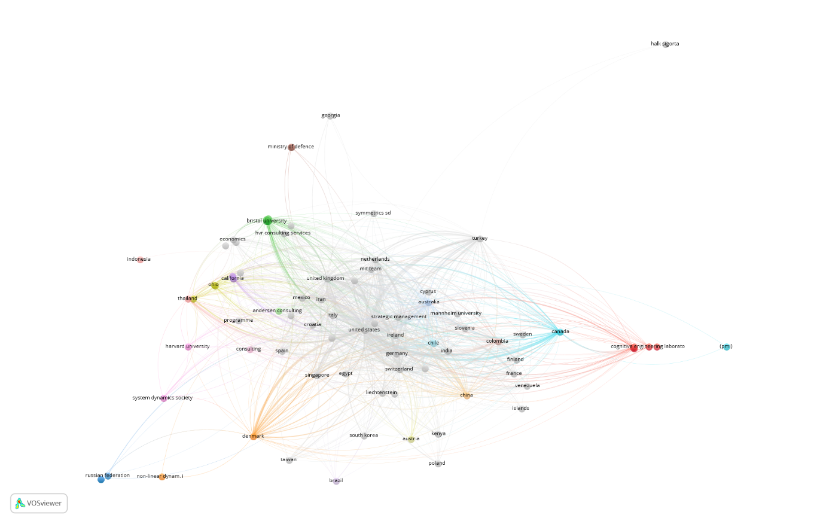
Source: Authors' elaboration using Biblioshiny
Coupling by the organization
As shown in Figure 10, an analysis of SDR's bibliographic coupling by institutions is presented. By analyzing the size of nodes and links that appear when bibliographic coupling occurs, the institution can be identified. However, despite Dartmouth college, the United States has the highest number of citations and articles produced, as well as the highest number of strong networks, 838, 8 and 1704. It’s also clear that the top three institutes on the basis of the article, citation, and network coupling are from the US.
Figure 10 Represents bibliographic coupling analysis of SDR by institutions

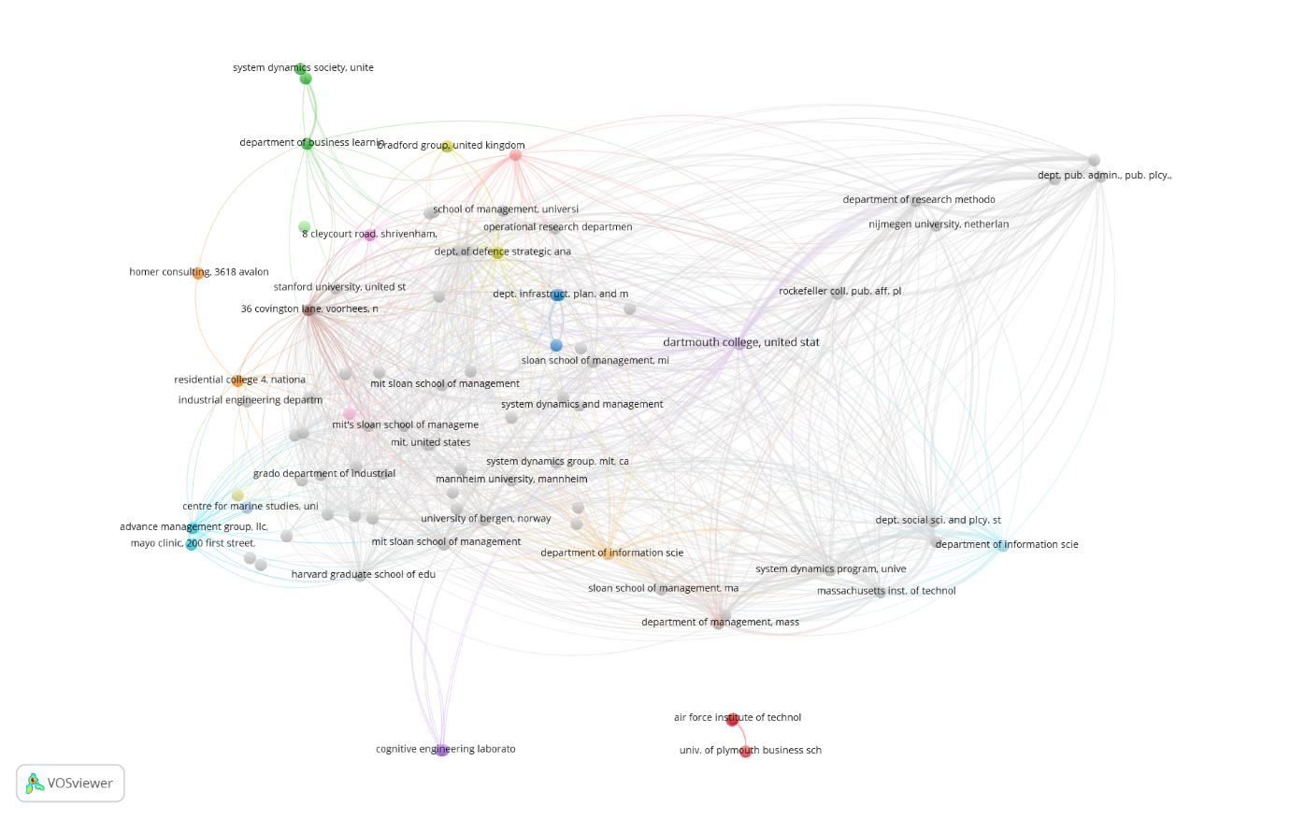
Source: Authors' elaboration using Biblioshiny
Coupling by authors
Figure 11 shows the network coupling by the author it found that the Sterman J.D. has the strongest network link with the 10954 couplings, followed by the Richardson G.P., and Sterman J. D with the network coupling 7151, and 5510 respectively. It also shows that the Sterman J. D. has the highest 2926 citations on the 25 documents published and followed by the Richardson G.P. and Ford D.N. with the 1893 and 1296 citations respectively.
Figure 11. Represents bibliographic coupling analysis of SDR by Authors
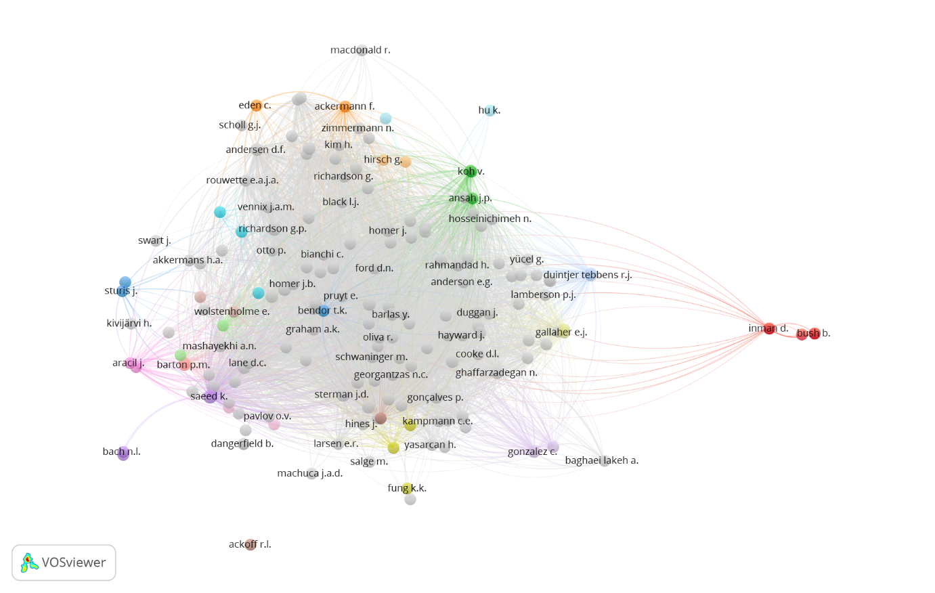 It is also clear that Saeed k published 18 documents and Ford D.N published 12 documents, but Ford D.N have more citations than Saeed K, it is clear that the citation count depends on the interest of the researchers, not on the number of the published document.
4. Content analysis
(Cluster analysis)
The journal's content is examined in this part by cluster. Figure 12 provides a graphic representation of the conceptual framework that divides SDR articles into four clusters. The first cluster (in rad) has to do with "modelling approach," "industrial production," "computer simulations," "numerical model," and "stakeholder." The second cluster (in blue) includes the terms "teaching," "psychology," "research," "performance evaluation," and "student." 'Optimization' and 'parameterization' are covered in the third cluster (in purple), along with 'eigenvalue' and 'algorithm', while 'Eurasia' and 'Europe' are covered in the last cluster (in green).
Figure 12 shows the conceptual structure map
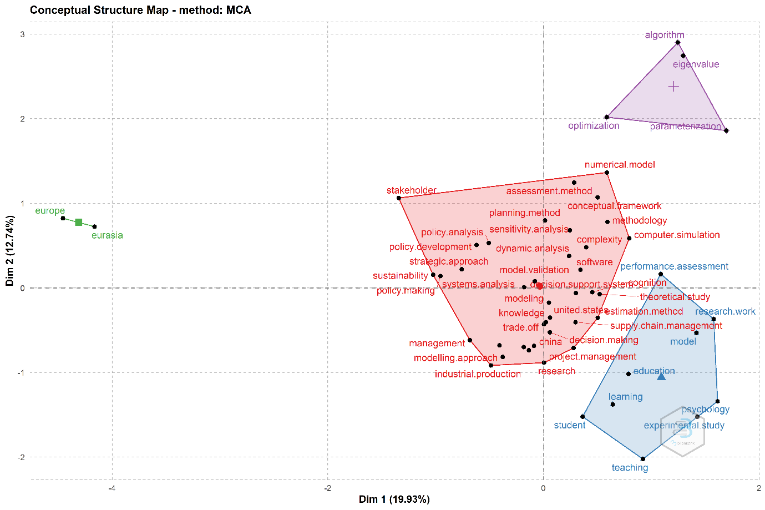

Cluster 1: Modelling approach, computer simulations, and numerical model
Cluster 2: Teaching, research, and performance evaluation
Cluster 3: Optimization, parameterization and algorithm
Cluster 4: Eurasia and Europe
5. Conclusion took from SDR review
Ramos-Rodriguez and Ruiz-Navarro (2004) argued that research articles largely reveal the intellectual underpinnings of a discipline. Despite several studies analyzing the current and development of system dynamics research, only one (Torres, J. P. 2019) bibliometric study has analysis the architecture of system dynamics research articles.
The most often cited works have significantly advanced three important fields: group model building, model testing, model validity, and formal methods, and modeling dynamic issues with large applicability. The SDR role is very crucial and the development of the system dynamics discipline is emphasized in this bibliometric study. Modeling dynamic challenges of general interest, with uses in Environment, finance (Koley M, 1991), ecosystems, supply chains, health care, transportation, waste management, energy, and climate change, is the primary topic of study and a recurring subject in SDR publications. Modeling dynamic challenges has been useful in conveying the reasoning for system dynamics models to non-SDR audiences in addition to establishing the cause and feedback mechanisms underpinning "real" world dynamic events (Morecroft, 1985; Richardson, 1986). Modeling unambiguous policy guidelines or standards that direct decision-making has become simpler because of this stream (Forrester, 1992).
Despite the fact that the study carried out here was based on a specific bibliometric assumption, the bibliometric results demonstrate substantial links between core foundational system dynamics publications and applications (References provide an accurate representation of what data sources these authors rely upon in their work). There are three topics that appear to be worthy of further investigation and future study.
Behavioral research:
The most often mentioned issue in SDR has been an examination of the reasons behind and methods by which People frequently misinterpret and misjudge how a feedback system is functioning. According to Sterman (1989), when humans monitor and manage such systems, they misunderstand the structures underlying the dynamics. Even though articles in SDR have suggested ways to reduce misperceptions in a variety of systems, including markets (Kampmann and Sterman, 2014), rivalry among different stakeholders (Moxnes, 2000), human-computer interfaces (Howie et al., 2000) or processing information (Kleinmuntz, 1993), A farther comprehensive understanding of the intrinsic pathways or routines that lead to misperceptions among policy maker and decision makers should be undertaken in the future. The study of this topic will help system dynamics research as well as the ongoing discussion of dynamic capacities in the field of strategy (Teece, 2007; Helfat and Peteraf, 2015). Additionally, system dynamics research has the capacity of provide light on currently discussion around micro-foundations of dynamic capacities at both the personal and organizational levels (Helfat and Peteraf, 2015). (Barreto, 2010). The study of misperceptions in managers' feedback, for example, may benefit from the use of contributions from cognitive neuroscience, which system dynamics researchers should and should look into and integrate.
System dynamics capacity to measuring the effects of interventions in the long spam:
According to (Scholz et al., 2015) SDR research, system dynamics models created group-building interpose that help with the study of organizational learning approaches. As a result, system dynamics research may and should assess these procedures' success by looking at how decision-makers behave both promptly after intervention and after some time has elapsed. The effectiveness of system dynamics interventions utilizing simulations has only been briefly established in SDR research (Morecroft et al., 1991; Scott et al., 2013). In the Future, studies can identify critical triumph variables for intervention facilitation, including the design configuration, the duration of interventions, the history, knowledge, the language of the facilitator, age of participants, the group members' emotional states, and the procedures followed pre, during, and post interventions.
Improving elicitation methods for people that are novices to system dynamics:
In the majority of system dynamics initiatives, professionals immediately use computer software or a whiteboard to represent the causal link, delay, and feedback effects after consulting with management teams (Ackermann et al., 2010). In the future, researchers should focus on how decision makers (such as executives, and managers teams) can create scenarios based on their business assumptions and stock and flow diagrams that are compliant with system dynamics modeling concepts (Forrester, 1994). According to Kampmann and Sterman (2014), interactive modeling has been shown to be effective in preventing the progression of linear and stationary perspectives in system dynamics. Although little evidence exists to show how decision makers without engineering or systemic backgrounds can produce their self-staunch simulation models (Andersen et al., 2012).
The present work has several constraints linked to the bibliometric methodology and research design. The study of data from a single database (Scopus) that was published online and data that was not published online excluded, is the research design's key flaw. Due to the fact that this sample only includes a subset of all system dynamics papers, the possible breadth of the results produced is constrained. Additionally, a thorough systematic literature review and thorough bibliometric analysis might be performed on the publishing articles, potentially producing distinct networks and bibliometric connections in other dimensions.

Reference:
Ackermann F, Andersen DF, Eden C., & Richardson, GP. 2010. Using a group decision support system to add value to group model building. System Dynamics Review, 26(4): 335-346.
Akkermans HA, & Vennix, JA. 1997. Clients' opinions on group model‐building: an exploratory study. System Dynamics Review: The Journal of the System Dynamics Society, 13(1): 3-31.
Ahmad A & Abu-Ghunmi D. 2021. Have Investors in the Banking Sector Become More Conservative in the Long Run? Jordan Journal of Business Administration, 17(2): 217-235.
Al-Afifi AA. 2019. Factors affecting decision makers preference of MSMEs in financing sources choice. International Journal of Business Ethics and Governance, 2(2): 16-29.
Alfaraz P & Calviño A. 2004. Bibliometric study on food science and technology: Scientific production in Iberian-American countries (1991-2000). Scientometrics, 61(1): 89-102.
Al Kurdi OF. 2021. A critical comparative review of emergency and disaster management in the Arab world. Journal of Business and Socio-economic Development, 1(1): 24-46.
Alrayyes Y & Al Khaldy N. 2019. The impact of governance rules on earnings management: Applied study on industrial and service companies listed on Palestine stock exchange. International Journal of Business Ethics and Governance, 2(3): 104-13.
Andersen DL, Luna‐Reyes LF, Diker VG, Black L, Rich E & Andersen, DF. 2012. The disconfirmatory interview as a strategy for the assessment of system dynamics models. System Dynamics Review, 28(3): 255-275.
Archambault É, Campbell D, Gingras Y & Larivière V. 2009. Comparing bibliometric statistics obtained from the Web of Science and Scopus. Journal of the American Society for Information Science and Technology, 60(7): 1320-1326.
Awad IM, Al-Jerashi GK, & Alabaddi ZA. 2021. Determinants of private domestic investment in Palestine: time series analysis. Journal of Business and Socio-economic Development, 1(1): 71-86.
Barlas Y. 1996. Formal aspects of model validity and validation in system dynamics. System Dynamics Review, 12(3): 183-210.
Barlas Y & Carpenter S. 1990. Philosophical roots of model validation: two paradigms. System Dynamics Review, 6(2): 148-166.
Barreto I. 2010. Dynamic capabilities: A review of past research and an agenda for the future. Journal of Management, 36(1): 256-280.
Brennan LK, Kemner AL, Donaldson K & Brownson RC. 2015. Evaluating the implementation and impact of policy, practice, and environmental changes to prevent childhood obesity in 49 diverse communities. Journal of Public Health Management and Practice, 21: S121-S134.
Broadus RN. 1987. Toward a definition of “bibliometrics”. Scientometrics, 12(5): 373-379.
Boyer CM & Boulatoff C. 2017. What is the impact of Private and Public R&D on Clean Technology Firms’ Performance? An International Perspective. Journal of Sustainable Finance & Investment, 7(2): 147-168.
Caldecott B. 2017. Introduction to special issue: stranded assets and the environment. Journal of Sustainable Finance & Investment, 7(1): 1-13.
Cancino CA, Merigó JM & Coronado FC. 2017. A bibliometric analysis of leading universities in innovation research. Journal of Innovation & Knowledge, 2(3): 106-124.
Carolina Rezende de Carvalho Ferreira M, Amorim Sobreiro V, Kimura H & Luiz de Moraes Barboza F. 2016. A systematic review of literature about finance and sustainability. Journal of Sustainable Finance & Investment, 6(2): 112-147.
Cooke DL. 2003. A system dynamics analysis of the Westray mine disaster. System Dynamics Review, 19(2): 139-166.
Coyle G. 2000. Qualitative and quantitative modelling in system dynamics: some research questions. System Dynamics Review, 16(3): 225-244.
Coyle RG & Alexander MDW. 1997. Two approaches to qualitative modelling of a nation's drugs trade. System Dynamics Review, 13(3): 205-222.
Diehl E & Sterman JD. 1995. Effects of feedback complexity on dynamic decision making. Organizational Behavior and Human Decision Processes, 62(2): 198-215.
Durieux V & Gevenois PA. 2010. Bibliometric indicators: quality measurements of scientific publication. Radiology, 255(2): 342-351.
Dyson B & Chang NB. 2005. Forecasting municipal solid waste generation in a fast-growing urban region with system dynamics modeling. Waste Management, 25(7): 669-679.
Feng YY, Chen SQ & Zhang LX. 2013. System dynamics modeling for urban energy consumption and CO2 emissions: A case study of Beijing, China. Ecological Modelling, 252: 44-52.
Fernández JM & Selma MAE. 2004. The dynamics of water scarcity on irrigated landscapes: Mazarrón and Aguilas in south‐eastern Spain. System Dynamics Review, 20(2): 117-137.
Ford A & Bull M. 1989. Using system dynamics for conservation policy analysis in the Pacific Northwest. System Dynamics Review, 5(1): 1-16.
Forrester JW. 1987. Nonlinearity in high-order models of social systems. European Journal of Operational Research, 30(2): 104-109.
Forrester JW. 1992. Policies, decisions and information sources for modeling. European Journal of Operational Research, 59(1): 42-63.
Forrester JW. 1994. System dynamics, systems thinking, and soft OR. System Dynamics Review, 10(2‐3): 245-256.
Forrester JW. 2007. System dynamics—a personal view of the first fifty years. System Dynamics Review, 23(2‐3): 345-358.
Forrester JW. 2007. System dynamics—the next fifty years. System Dynamics Review, 23(2‐3): 359-370.
Gardiner LK & Shreckengost RC. 1987. A system dynamics model for estimating heroin imports into the United States. System Dynamics Review, 3(1): 8-27.
Gholami, M., & Al Tahoo, L. 2021. Investigating the Influence of Entrepreneurship on Entrepreneur's Life. International Journal of Business Ethics and Governance, 4(2): 69-95.
Grosser SN & Schaffernicht M. 2012. Mental models of dynamic systems: taking stock and looking ahead. System Dynamics Review, 28(1): 46-68.
Harich J. 2010. Change resistance as the crux of the environmental sustainability problem. System Dynamics Review, 26(1): 35-72.
Guan J & Ma N. 2007. A bibliometric study of China’s semiconductor literature compared with other major Asian countries. Scientometrics, 70(1): 107-124.
Hassanzadeh E, Zarghami M & Hassanzadeh Y. 2012. Determining the main factors in declining the Urmia Lake level by using system dynamics modeling. Water Resources Management, 26(1): 129-145.
Helfat CE & Peteraf MA. 2015. Managerial cognitive capabilities and the microfoundations of dynamic capabilities. Strategic Management Journal, 36(6): 831-850.
Hjorth P & Bagheri A. 2006. Navigating towards sustainable development: A system dynamics approach. Futures, 38(1): 74-92.
Homer JB. 1993. A system dynamics model of national cocaine prevalence. System Dynamics Review, 9(1): 49-78.
Homer JB & Hirsch GB. 2006. System dynamics modeling for public health: background and opportunities. American Journal of Public Health, 96(3): 452-458.
Howie, E., Sy, S., Ford, L., & Vicente, K. J. (2000). Human–computer interface design can reduce misperceptions of feedback. System Dynamics Review, 16(3): 151-171.
Kampmann CE & Sterman JD. 2014. Do markets mitigate misperceptions of feedback?. System Dynamics Review, 30(3): 123-160.
Kleinmuntz DN. 1993. Information processing and misperceptions of the implications of feedback in dynamic decision making. System Dynamics Review, 9(3): 223-237.
Kushairi, N., & Ahmi, A. 2021. Flipped classroom in the second decade of the Millenia: a Bibliometrics analysis with Lotka’s law. Education and information technologies, 26(4): 4401-4431.
Kolsi MC & Attayah OF. 2018. Environmental policy disclosures and sustainable development: Determinants, measure and impact on firm value for ADX listed companies. Corporate Social Responsibility and Environmental Management, 25(5): 807-818.
Lane DC. 2007. The power of the bond between cause and effect: Jay Wright Forrester and the field of system dynamics. System Dynamics Review, 23(2‐3): 95-118.
Lane DC. 2008. The emergence and use of diagramming in system dynamics: a critical account. Systems Research and Behavioral Science, 25(1): 3-23.
Lotka, A. J. 1926. The frequency distribution of scientific productivity. Journal of the Washington academy of sciences, 16(12): 317-323.
Luna‐Reyes LF & Andersen DL. 2003. Collecting and analyzing qualitative data for system dynamics: methods and models. System Dynamics Review, 19(4): 271-296.
Madani K & Mariño MA. 2009. System dynamics analysis for managing Iran’s Zayandeh-Rud river basin. Water resources management, 23(11): 2163-2187.
Malhotra G & Thakur KS. 2020. Evolution of green finance: A bibliometric approach. Gedrag & Organisatie Review, 33(2): 583-594.
Martinez‐Moyano IJ & Richardson GP. 2013. Best practices in system dynamics modeling. System Dynamics Review, 29(2): 102-123.
Merigó JM, Mas-Tur A, Roig-Tierno N & Ribeiro-Soriano D. 2015. A bibliometric overview of the Journal of Business Research between 1973 and 2014. Journal of Business Research, 68(12): 2645-2653.
Miau, S., & Yang, J. M. 2018. Bibliometrics-based evaluation of the Blockchain research trend: 2008–March 2017. Technology Analysis & Strategic Management, 30(9): 1029-1045.
Moon J. 2007. The contribution of corporate social responsibility to sustainable development. Sustainable Development, 15(5): 296-306.
Morecroft JD. 1985. The feedback view of business policy and strategy. System Dynamics Review, 1(1): 4-19.
Morecroft JD, Lane DC & Viita PS. 1991. Modeling growth strategy in a biotechnology startup firm. System Dynamics Review, 7(2): 93-116.
Moxnes E. 2000. Not only the tragedy of the commons: misperceptions of feedback and policies for sustainable development. System Dynamics Review, 16(4): 325-348.
Naill RF, Belanger S, Klinger A & Petersen, E. (1992). An analysis of the cost effectiveness of US energy policies to mitigate global warming. System Dynamics Review, 8(2): 111-128.
Nguyen NC, Bosch OJ & Maani KE. 2011. Creating ‘learning laboratories’ for sustainable development in biospheres: a systems thinking approach. Systems Research and Behavioral Science, 28(1): 51-62.
Oliva R. 2004. Model structure analysis through graph theory: partition heuristics and feedback structure decomposition. System Dynamics Review, 20(4): 313-336.
Oliva R & Sterman JD. 2001. Cutting corners and working overtime: Quality erosion in the service industry. Management Science, 47(7): 894-914.
Owens BD, Leveson NG & Hoffman JA. 2011. Procedure rework: a dynamic process with implications for the “rework cycle” and “disaster dynamics”. System Dynamics Review, 27(3): 244-269.
Paich M & Sterman JD. 1993. Boom, bust, and failures to learn in experimental markets. Management Science, 39(12): 1439-1458.
Paule-Vianez J, Gómez-Martínez R & Prado-Román, C. 2020. A bibliometric analysis of behavioural finance with mapping analysis tools. European Research on Management and Business Economics, 26(2): 71-77.
Peterson, D. W. and R. L. Eberlein. 1994. Reality Check A Bridge between Systems Thinking and System Dynamics. System Dynamics Review lO(2-3): 159-174.
Pham L. 2016. Is it risky to go green? A volatility analysis of the green bond market. Journal of Sustainable Finance & Investment, 6(4): 263-291.
Qudrat-Ullah H & Seong BS. 2010. How to do structural validity of a system dynamics type simulation model: The case of an energy policy model. Energy policy, 38(5): 2216-2224.
Ramos‐Rodríguez A. R & Ruíz‐Navarro J. 2004. Changes in the intellectual structure of strategic management research: A bibliometric study of the Strategic Management Journal, 1980–2000. Strategic Management Journal, 25(10): 981-1004.
Repenning N P & Sterman JD. 2002. Capability traps and self-confirming attribution errors in the dynamics of process improvement. Administrative Science Quarterly, 47(2): 265-295.
Richardson GP & Andersen DF. 1995. Teamwork in group model building. System Dynamics Review, 11(2): 113-137.
Rouwette EA, Vennix JA & Mullekom TV. 2002. Group model building effectiveness: a review of assessment studies. System Dynamics Review, 18(1): 5-45.
Rouwette EA, Korzilius H, Vennix JA & Jacobs E. 2011. Modeling as persuasion: the impact of group model building on attitudes and behavior. System Dynamics Review, 27(1): 1-21.
Scholl G J. 1995. Benchmarking the system dynamics community: research results. System Dynamics Review, 11(2): 139-155.
Scholz G, Austermann M, Kaldrack K & Pahl‐Wostl, C. 2015. Evaluating group model building exercises: a method for comparing externalized mental models and group models. System Dynamics Review, 31(1-2): 28-45.
Scott RJ, Cavana RY & Cameron D. 2013. Evaluating immediate and long‐term impacts of qualitative group model building workshops on participants' mental models. System Dynamics Review, 29(4): 216-236.
Sedlacko M, Martinuzzi A, Røpke I, Videira N & Antunes P. 2014. Participatory systems mapping for sustainable consumption: Discussion of a method promoting systemic insights. Ecological Economics, 106: 33-43.
Sterman JD. 1989. Modeling managerial behavior: Misperceptions of feedback in a dynamic decision making experiment. Management Science, 35(3): 321-339.
Sterman JD. 2002. All models are wrong: reflections on becoming a systems scientist. System Dynamics Review, 18(4): 501-531.
Sterman JD. 2006. Learning from evidence in a complex world. American Journal of Public Health, 96(3): 505-514.
Sterman J. 2018. System dynamics at sixty: the path forward. System Dynamics Review, 34(1-2): 5-47.
Sterman JD & Sweeney LB. 2002. Cloudy skies: assessing public understanding of global warming. System Dynamics Review, 18(2): 207-240.
Sterman JD & Sweeney LB. 2006. Cloudy Skies: Assessing public understanding of global warming. Reflections, 7(3).
Struben J & Sterman, JD. 2008. Transition challenges for alternative fuel vehicle and transportation systems. Environment and Planning B: Planning and Design, 35(6): 1070-1097.
Sun, J. 2021. The mental health of refugees in the USA: changes and the unchanged. Journal of Public Health, 1-8. DOI: 10.1007/s10389-020-01458-x.
Sweileh WM, Zyoud SEH, Al-Jabi SW & Sawalha AF. 2014. Bibliometric analysis of diabetes mellitus research output from Middle Eastern Arab countries during the period (1996–2012). Scientometrics, 101(1): 819-832.
Teece DJ. 2007. Explicating dynamic capabilities: the nature and microfoundations of (sustainable) enterprise performance. Strategic Management Journal, 28(13): 1319-1350.
Torres, J. P. 2019. System Dynamics Review and publications 1985–2017: analysis, synthesis and contributions. System Dynamics Review, 35(2): 160-176.
Uzun A. 1996. A bibliometric analysis of physics publications from Middle Eastern countries. Scientometrics, 36(2): 259-269.
Van Eck N & Waltman L. 2010. Software survey: VOSviewer, a computer program for bibliometric mapping. Scientometrics, 84(2): 523-538.
Vennix JA 1999. Group model‐building: tackling messy problems. System Dynamics Review, 15(4): 379-401.
Warren K. 2004. Why has feedback systems thinking struggled to influence strategy and policy formulation? Suggestive evidence, explanations and solutions. Systems Research and Behavioral Science, 21(4): 331-347.
Wallin JA. 2005. Bibliometric methods: pitfalls and possibilities. Basic & Clinical Pharmacology & Toxicology, 97(5): 261-275.
Waygood S. 2011. How do the capital markets undermine sustainable development? What can be done to correct this?. Journal of Sustainable Finance and Investment, 1(1): 81-87.
Weale AR, Bailey M & Lear PA. 2004. The level of non-citation of articles within a journal as a measure of quality: a comparison to the impact factor. BMC Medical Research Methodology, 4(1): 1-8.
Weber O. 2014. The financial sector's impact on sustainable development. Journal of Sustainable Finance & Investment, 4(1): 1-8.
Wolstenholme EF. 1999. Qualitative vs quantitative modeling: the evolving balance. Journal of the Operational Research Society, 50(4): 422-428.

Table 1. Characteristics of data
Description | Results
MAIN INFORMATION ABOUT DATA
Timespan | 1985:2022
Sources (System Dynamics Review) | 1
Documents | 617
Average years from publication | 17.4
Average citations per document | 35.24
Average citations per year per doc | 1.979
References | 16424
DOCUMENT TYPES
article | 554
conference paper | 7
editorial | 14
erratum | 7
letter | 10
note | 13
review | 12
AUTHORS
Authors | 805
Author Appearances | 1311
Authors of single-authored documents | 140
Authors of multi-authored documents | 665
AUTHORS COLLABORATION
Single-authored documents | 260
Documents per Author | 0.766
Authors per Document | 1.3
Co-Authors per Documents | 2.12
Collaboration Index | 1.86

Table 2. Represents the most productive author in the SDR journal

Author | h_index | g_index | m_index | TC | NP | PY_start
STERMAN JD | 18 | 23 | 0.474 | 2926 | 23 | 1985
RICHARDSON GP | 16 | 23 | 0.421 | 1893 | 23 | 1985
BARLAS Y | 10 | 13 | 0.303 | 1218 | 13 | 1990
FORD DN | 10 | 12 | 0.4 | 1226 | 12 | 1998
RAHMANDAD H | 10 | 11 | 0.714 | 365 | 11 | 2009
VENNIX JAM | 10 | 10 | 0.303 | 1133 | 10 | 1990
ANDERSEN DF | 9 | 14 | 0.257 | 1116 | 14 | 1988
LANE DC | 9 | 9 | 0.281 | 368 | 9 | 1991
SAEED K | 9 | 14 | 0.243 | 206 | 16 | 1986
FORD A | 8 | 9 | 0.235 | 389 | 9 | 1989
FORRESTER JW | 8 | 8 | 0.222 | 1175 | 8 | 1987
GRLER A | 7 | 12 | 0.304 | 205 | 12 | 2000
MOSEKILDE E | 7 | 7 | 0.184 | 230 | 7 | 1985
STERMAN J | 7 | 9 | 0.389 | 381 | 9 | 2005
GHAFFARZADEGAN N | 6 | 10 | 0.462 | 296 | 10 | 2010
HOMER J | 6 | 10 | 0.261 | 310 | 10 | 2000
HOMER JB | 6 | 7 | 0.158 | 250 | 7 | 1985
CAVANA RY | 5 | 6 | 0.208 | 164 | 6 | 1999
GONALVES P | 5 | 7 | 0.278 | 155 | 7 | 2005
GONZALEZ C | 5 | 6 | 0.313 | 169 | 6 | 2007

TC: total citation; NP: number of papers; PY: publication year
Source: Authors' elaboration using Biblioshiny

Table 3. Authors` production through Lotka's law

Documents written | N. of Authors | Proportion of Authors
1 | 633 | 0.787
2 | 86 | 0.107
3 | 33 | 0.041
4 | 14 | 0.017
5 | 10 | 0.012
6 | 5 | 0.006
7 | 4 | 0.005
8 | 2 | 0.002
9 | 3 | 0.004
10 | 5 | 0.006
12 | 4 | 0.005
14 | 1 | 0.001
15 | 1 | 0.001
18 | 1 | 0.001
25 | 2 | 0.002

Table 4. Represents the Top contributing countries to System Dynamics Review journal
Country | Articles | Freq | SCP | MCP | MCP _Ratio
USA | 242 | 0.4566 | 217 | 25 | 0.1033
UNITED KINGDOM | 57 | 0.10755 | 51 | 6 | 0.1053
GERMANY | 29 | 0.05472 | 21 | 8 | 0.2759
NETHERLANDS | 26 | 0.04906 | 20 | 6 | 0.2308
NORWAY | 23 | 0.0434 | 14 | 9 | 0.3913
SWITZERLAND | 15 | 0.0283 | 7 | 8 | 0.5333
AUSTRALIA | 12 | 0.02264 | 6 | 6 | 0.5
CANADA | 11 | 0.02075 | 10 | 1 | 0.0909
TURKEY | 11 | 0.02075 | 7 | 4 | 0.3636
DENMARK | 10 | 0.01887 | 9 | 1 | 0.1
THAILAND | 9 | 0.01698 | 6 | 3 | 0.3333
IRELAND | 8 | 0.01509 | 7 | 1 | 0.125
SPAIN | 8 | 0.01509 | 7 | 1 | 0.125
ITALY | 7 | 0.01321 | 7 | 0 | 0
SINGAPORE | 7 | 0.01321 | 4 | 3 | 0.4286
NEW ZEALAND | 6 | 0.01132 | 3 | 3 | 0.5
IRAN | 5 | 0.00943 | 4 | 1 | 0.2
INDIA | 4 | 0.00755 | 3 | 1 | 0.25
MEXICO | 4 | 0.00755 | 1 | 3 | 0.75
CHILE | 3 | 0.00566 | 2 | 1 | 0.3333
Source: Authors' elaboration using Biblioshiny

Table 5 Most prolific countries in terms of citation
Country | Total Citations | Average Article Citations
USA | 11413 | 47.16
UNITED KINGDOM | 1893 | 33.21
NETHERLANDS | 1224 | 47.08
NORWAY | 1045 | 45.43
GERMANY | 573 | 19.76
CANADA | 385 | 35.00
SWITZERLAND | 284 | 18.93
NEW ZEALAND | 265 | 44.17
DENMARK | 248 | 24.80
MEXICO | 214 | 53.50
ITALY | 197 | 28.14
AUSTRALIA | 188 | 15.67
SPAIN | 158 | 19.75
THAILAND | 150 | 16.67
TURKEY | 121 | 11.00
SINGAPORE | 112 | 16.00
INDIA | 110 | 27.50
IRAN | 81 | 16.20
PORTUGAL | 69 | 23.00
KOREA | 58 | 19.33
Source: Authors' elaboration using Biblioshiny

Table 6 represents the most cited documents
Paper | Title | TC | TCY | NTC
BARLAS Y, 1996, | Formal aspects of model validity and validation in system dynamics | 898 | 33.2593 | 8.7982
John D. Sterman (1994). | Learning in and about complex systems. | 684 | 23.5862 | 7.5202
FORRESTER JW, 1994 | System dynamics, systems thinking, and soft OR | 566 | 19.5172 | 6.2229
John D. Sterman (2002) | All models are wrong: reflections on becoming a systems scientist | 515 | 24.5238 | 5.7827
SWEENEY LB, 2000 | Bathtub dynamics: initial results of a systems thinking inventory | 388 | 16.8696 | 5.0043
VENNIX JAM, 1999 | Group model‐building: tackling messy problems. System Dynamics Review | 353 | 14.7083 | 6.5562
RICHMOND B, 1993 | Systems thinking: Critical thinking skills for the 1990s and beyond | 300 | 10 | 8.4577
ANDERSEN DF, 1997 | Scripts for group model building | 296 | 11.3846 | 4.128
DOYLE JK, 1998 | Mental models concepts for system dynamics research | 282 | 11.28 | 4.4112
LYNEIS JM, 2007 | System dynamics applied to project management: a survey, assessment, and directions for future research | 266 | 16.625 | 5.6554
RICHARDSON GP, 1995 | Teamwork in group model building | 265 | 9.4643 | 7.8843
LUNA-REYES LF, 2003 | Collecting and analyzing qualitative data for system dynamics: methods and models | 256 | 12.8 | 3.518
ROUWETTE EAJA, 2002, | Group model building effectiveness: a review of assessment studies | 250 | 11.9048 | 2.8071
RICHARDSON GP, 2011, | Reflections on the foundations of system dynamics | 224 | 18.6667 | 6.4175
GHAFFARZADEGAN N, 2011, | . How small system dynamics models can help the public policy process | 210 | 17.5 | 6.0164
FORD DN, 1998, |  | 205 | 8.2 | 3.2067
COYLE G, 2000, | Qualitative and quantitative modeling in system dynamics: some research questions | 204 | 8.8696 | 2.6311
ANDERSEN DF, 1997, S |  | 199 | 7.6538 | 2.7752
STAVE KA, 2002, | Using system dynamics to improve public participation in environmental decisions | 192 | 9.1429 | 2.1559
FORRESTER JW, 2007, | System dynamics—the next fifty years | 188 | 11.75 | 3.9971
TC: Total Citations; TCY: Total Citations per Year; NTC: Normalised total citation Source: Authors' elaboration using Biblioshiny

